The Nature of Science
“If we don’t have curiosity, we don’t have science!”
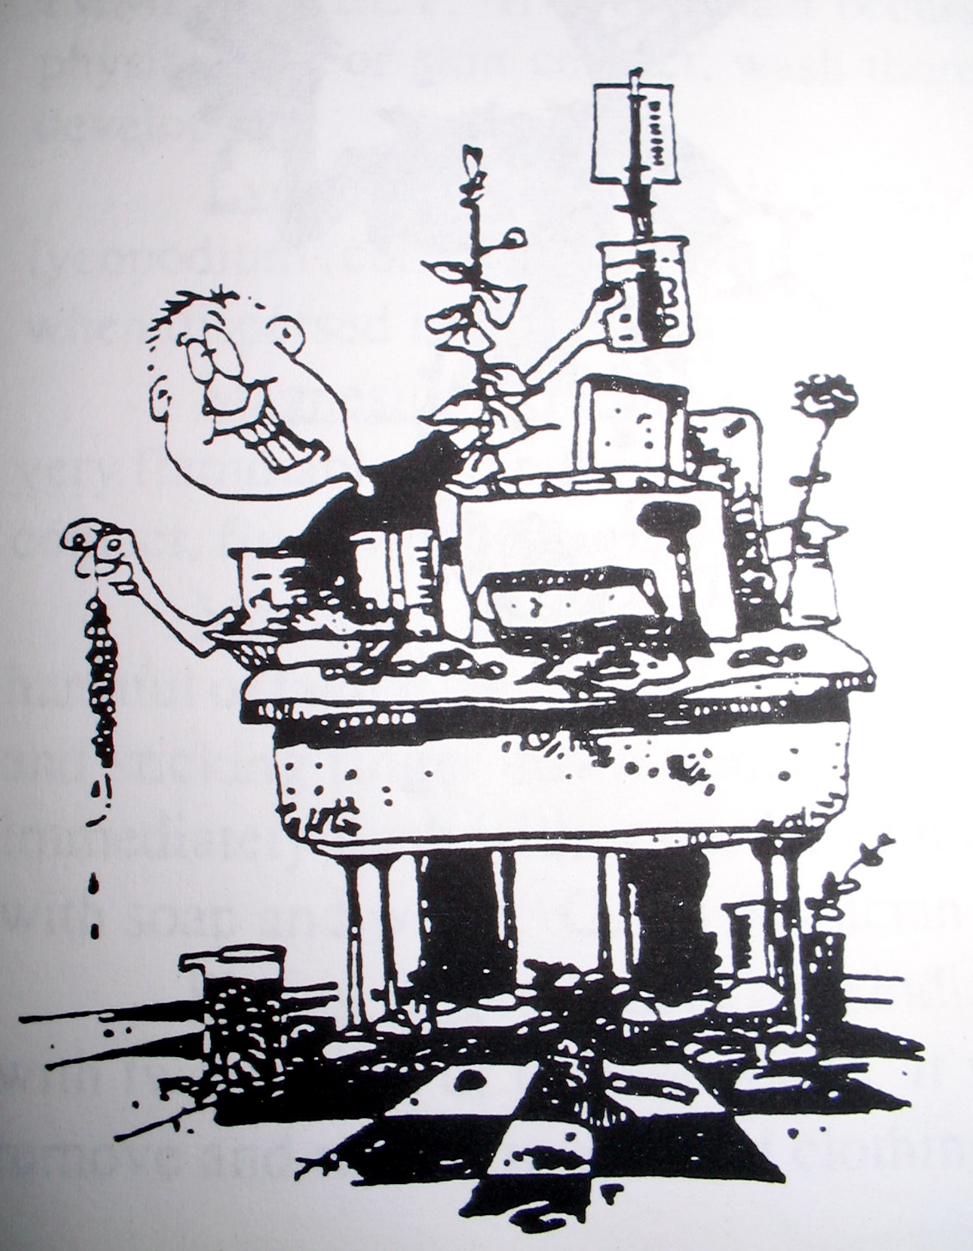
- Gertrude Elion, inventor

In this unit, we will address the following Maine Learning Results for science and technology:
- B1 (a – f): Students plan, conduct, analyze data from, and communicate results of investigations, including simple experiments.
- C1 (a – c). Students describe how scientists use varied and systematic approaches to investigations that may lead to further investigations.
- C2b. Explain how constraints and consequences impact scientific inquiry and technological design.

**********************************************************************
Key Terms

metric units: metric prefixes: scientific method:
meter micro- observation
liter milli- inference
gram centi- opinion
deci- hypothesis
deka- experiment
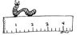
other useful words hekto- control
meniscus kilo- independent variable
graduated cylinder dependent variable
x and y axes
**********************************************************************
Key Skills
> Use a ruler to measure length.
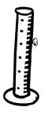
> Use a graduated cylinder to measure liquid volume.
> Explain why most nations use the metric system of measurement.
> Convert measurements from one unit to another
> Make observations, inferences, and opinions. Tell the difference between them.
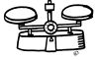
> Conduct and write up a scientific experiment.
> Identify controls, independent and dependent variables.
> Explain the role of controls and variables in an experiment.
> Graph data in a useful way.

