DNA Technology
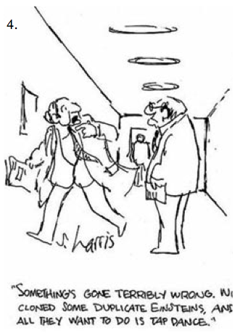
In this unit, we will address the following Maine Learning Results standards:
A2a. Compare different types of models that can be used to represent the same thing (including models of chemical reactions, motion, or cells) in order to match the purpose and complexity of a model to its use.
A2b. Propose changes to models and explain how those changes may better reflect the real thing.
C3a. Describe how science and technology can help address societal challenges related
to population, natural hazards, sustainability, personal health and safety, and environmental
quality.
C3b. Identify personal choices that can either positively or negatively impact society including
population, ecosystem sustainability, personal health, and environmental quality.
C4a: describe how men and women of various backgrounds, working in teams or alone and communicating about their ideas extensively with others, engage in science, engineering, and related fields.
C4c: Describe and provide evidence that illustrate that science is a human endeavour that generates explanations based on verifiable evidence that are subject to change when new evidence does not match existing explanations

…and take a stab at these new Next Generation Science Standards:
MS-LS3-1. Develop and use a model to describe why structural changes to genes (mutations) located on chromosomes may affect proteins and may result in harmful, beneficial, or neutral effects to the structure and function of the organism.
MS-LS4-5. Gather and synthesize information about the technologies that have changed the way humans influence the inheritance of desired traits in organisms.
------------------------------------------------------------------------------------------------------------
Key Terms
DNA Adenine Thymine Cytosine Guanine
Deoxyribose Phosphate protein cloning DNA Identification
mutation Genetically Modified Organism (GMO)
------------------------------------------------------------------------------------------------------------
By the end of this unit, you should be able to…
- Describe the structure of DNA
- Explain the connection between DNA and proteins and traits
- Explain DNA identification and give an example of its use
- Differentiate between cloning facts and myths
- Describe what a GMO is, and give pros and cons of their use
- Present results of an in-depth investigation of a DNA technology, its uses, and its possible consequences, both good and bad

