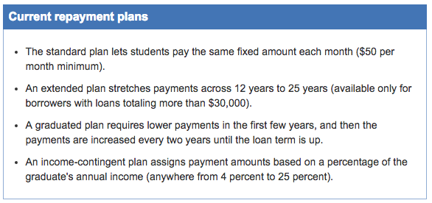

Ten years is the standard repayment period for a student loan, but that doesn’t mean you have to make equal payments every month for all 10 years. The federal government currently offers four basic types of repayment plans:

But how much can you afford to pay each month? That depends on how much money you make:

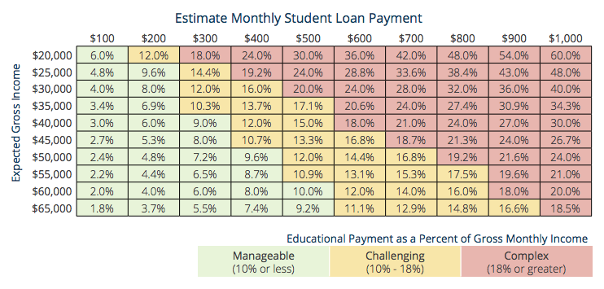
So how long will it take to pay off your student loan? Again, it depends on the minimum amount you can pay each month.

Choose one of the two institutions you identified on your Comparing Colleges exercise from last class as the college you will be attending. Multiply the “Estimated Net Price” by 4 to get the total amount it would cost you to attend this institution for four years.

Go to http://www.finaid.org/calculators/loanpayments.phtml to access a loan payment calculator

At the bottom of the page you will see this:
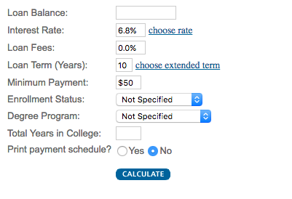
The “Loan Balance” will be the total amount you would have to pay for college for four years (cost of the college for 1 year x 4 years).

Leave all the other fields as they appear (6.8% interest, 10-year loan term, etc.).

Click “Calculate” and use the information to complete the chart below:

Name of Institution
from “Comparing Colleges” exercise
Loan Balance (total $ you would borrow): | $
Loan Interest Rate: | $
Loan Term (how long you have to pay it): | $
Monthly loan payment: | $
Number of payments: | $
Cumulative payments: | $
Total interest paid: | $

