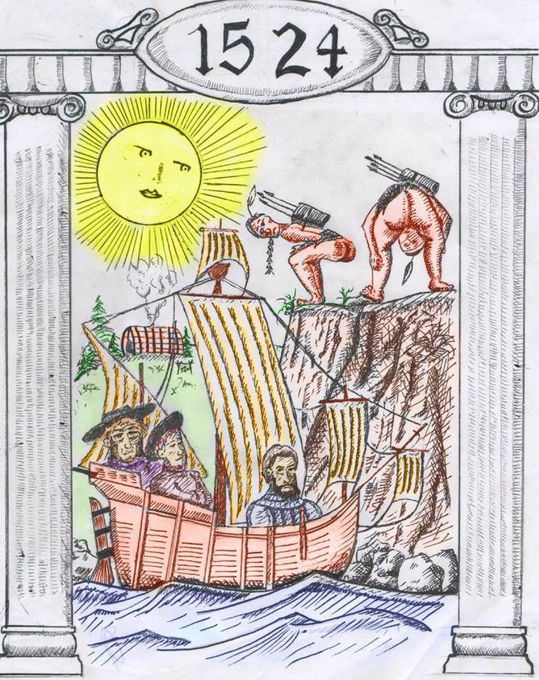
I’m happy to report that our culture now frowns upon the idea of slavery and kidnapping. Unfortunately for Maine’s native population, the early explorers did not share our modern sensibilities.

George Weymouth explored Maine in 1605. When he went back to Europe, he took along five Indians that he had forcefully abducted. One can assume that these natives were seen as curiosities or specimens, rather than human beings. How they felt as they crossed the ocean and landed on a foreign continent is anybody’s guess. Fortunately, two of them were later returned to Maine by Fernando Georges.

Captain Harlow of the Popham Colony captured several natives on Monhegan Island and took them back to England. And according to John Smith, one of his shipmasters kidnapped twenty four Indians in New England and sold them into slavery.
“Verrazzano Mooned by Abenakis,” drawing by Zac McDorr

Understandably, this behavior caused a lack of trust between the natives and the Europeans. It also caused one of the more amusing events in Maine History.

Giovanni Da Verrazzano was an Italian explorer who came to New England in 1524. After discovering New York Bay and kidnapping a young Indian boy, he sailed north. Some of the tribes he met traded furs, but he did not receive a warm welcome in Maine. In Casco Bay the Abenakis had grown weary of Europeans, and shot arrows at Verrazzano’s boat when he tried to land. Eventually the Indians agreed to trade a few items using baskets lowered from a cliff, but they would not meet with the Europeans.

As Verrazzano started to leave, several natives stood on top of the cliff and mooned the departing explorers. Offended by their “barbarous” behavior, Verrazzano named this part of the coast “Onde la Male Gente,” or “Land of the Bad People.”

Thus the first recorded “mooning” in American history took place on the Maine coast.

Source: “Collections of the Maine Historical Society, Vo. VII,” 1876. 1491, by Charles Mann, 2011.

