Name: ____________________ PrepUS History Date: __________
Unit 2 - The Constitution
Article 1: Legislative Branch Questions
Directions:
Use the Constitution handout to complete the information in the boxes. The locations of answers have been given in a letter/number code format; for example, A1S2=Article One, Section Two. You may also find some answers in the shaded text.

Office | Term  (# of years in office once elected) | Age Requirement  (must be at least..) | Citizenship Requirement  (must be a citizen for at least..) | Residency Requirement  (must be a resident of...) | Name of the Chief Officer  (what is the position called) | How Numbers Are Determined (what does it depend on?) | Total Number  (in this house of Congress) | Role in Impeachment
Representative to the House of Representatives
(A1S2)

Office | Numbers Of Members From Each State | Term  (# of years in office once elected) | Age Requirement  (must be at least..) | Citizenship Requirement  (must be a citizen for at least..) | Residency Requirement  (must be a resident of...) | Leader of the Senate  (who has this position) | Other Leader of the Senate  (who takes over if the leader is absent)* | Role in Impeachment
Senator
(A1S3)

* this information will be found under #5 in the shaded text on the left side of page 3
Directions:
Use the Constitution handout to find the answers to the following questions. When you find the answer, highlight the text that answers the question and write the number of the questions next to the highlighted text. You may also find some answers in the shaded text.

1. A1S1 What are the two houses of Congress?

2. A1S2: How does the Speaker of the House of Representatives get his or her job?
this information will be found under #5 in the shaded text on the left side of page 2

3. A1S4 What is the minimum number of times a year Congress has to meet? When does that meeting have to take place?
this information will be found under #2 in the shaded text on the left side of page 4

4. A1S5 Where could you read about the proceedings of the Congress?

5. A1S7 In which house of Congress do tax and spending bills originate (start/begin)?

6. A1S7 How can a bill become a law without the President’s signature?

7. A1S7 What happens to a bill that is not returned by the President within 10 days?

8. A1S7 What happens if Congress adjourns (ends their session) in less than 10 days after sending a bill to the President and he does not
return it with his signature? What is this called?

9. A1S8 What does Clause 18, also known as the Elastic Clause, permit the Congress to do?

10. A1S9 What is a Writ of Habeas Corpus?

11. A1S9 What is a Bill of Attainder?

12. A1S9 What is an Ex Post Facto law?

13. A1S10 What are some of the things states cannot do?
14. Label each of the four boxes below with the correct step in the process of How A Bill Becomes A Law.

A. Citizens develop or suggest an idea for a bill.

B. If the bill is vetoed, another vote can be taken. If more than 2/3rds of the House and Senate votes to approve the bill, it becomes a law.

C. Members of the House of Representatives or the Senate propose the bill.

D. The House and Senate vote to approve the bill.

E. The President signs the bill. If he or she chooses not to sign the bill, it is called a veto.
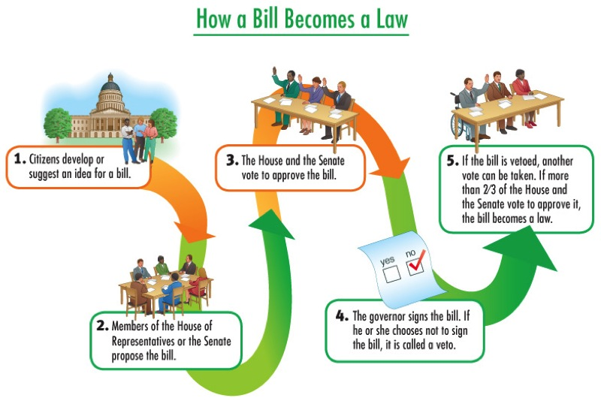

15. A1S8 Of the 18 Congressional powers listed, what do you think are the THREE most important powers of Congress? Why do you think
they are the most important?

Important power of Congress | Why it is an important power?

