Name: ___________________ Economic Skills Date: ____________

Unit 2 - Independent Living

Healthy Eating On A Budget

Take Charge of Your Health: A Guide for Teenagers
As you get older, you’re able to start making your own decisions about a lot of things that matter most to you. You may choose your own clothes, music, and friends. You also may be ready to make decisions about your body and health.

Making healthy decisions about what you eat and drink, how active you are, and how much sleep you get is a great place to start. Here you’ll learn:

how your body works.

how your body uses the food and drinks you consume and how being active may help your body “burn” calories.

how to choose healthy foods and drinks.

how to get moving and stay active.

how getting enough sleep is important to staying healthy.

how to ease into healthy habits and keep them up.

how to plan healthy meals and physical activities that fit your lifestyle.

Choose Healthy Foods and Drinks
Healthy eating involves taking control of how much and what types of food you eat, as well as the beverages you drink. Try to replace foods high in sugar, salt, and unhealthy fats with fruits, vegetables, whole grains, low-fat protein foods, and fat-free or low-fat dairy foods.

Fruits and Vegetables
Make half of your plate fruits and vegetables . Dark green, red, and orange vegetables have high levels of the nutrients you need, like vitamin C, calcium, and fiber. Adding tomato and spinach—or any other available greens that you like—to your sandwich is an easy way to get more veggies in your meal.

Grains
Choose whole grains like whole-wheat bread, brown rice, oatmeal, and whole-grain cereal, instead of refined-grain cereals, white bread, and white rice.

Protein
Power up with low fat or lean meats like turkey or chicken, and other protein-rich foods , such as seafood, egg whites, beans, nuts, and tofu.

Dairy
Build strong bones with fat-free or low-fat milk products. If you can’t digest lactose—the sugar in milk that can cause stomach pain or gas—choose lactose-free milk or soy milk with added calcium. Fat-free or low-fat yogurt is also a good source of dairy food.

Fats
Fat is an important part of your diet. Fat helps your body grow and develop, and may even keep your skin and hair healthy. But fats have more calories per gram than protein or carbs, and some are not healthy.

Some fats, such as oils that come from plants and are liquid at room temperature, are better for you than other fats. Foods that contain healthy oils include avocados, olives, nuts, seeds, and seafood such as salmon and tuna fish.

Solid fats such as butter, stick margarine, and lard, are solid at room temperature. These fats often contain saturated and trans fats, which are not healthy for you. Other foods with saturated fats include fatty meats, and cheese and other dairy products made from whole milk. Take it easy on foods like fried chicken, cheeseburgers, and fries, which often have a lot of saturated and trans fats. Options to consider include a turkey sandwich with mustard or a lean-meat, turkey, or veggie burger.

Your body needs a small amount of sodium, which is mostly found in salt. But getting too much sodium from your foods and drinks can raise your blood pressure, which is unhealthy for your heart and your body in general. Even though you’re a teen, it’s important to pay attention to your blood pressure and heart health now to prevent health problems as you get older.

Try to consume less than 2,300 mg, or no more than 1 teaspoon, of sodium a day. This amount includes the salt in already prepared food, as well as the salt you add when cooking or eating your food.
Processed foods, like those that are canned or packaged, often have more sodium than unprocessed foods, such as fresh fruits and vegetables. When you can, choose fresh or frozen fruits and veggies over processed foods. Try adding herbs and spices instead of salt to season your food if you make your own meals. Remember to rinse canned vegetables with water to remove extra salt. If you use packaged foods, check the amount of sodium listed on the Nutrition Facts label. To the right is an updated food label, which the U.S. Food and Drug Administration (FDA) has approved for use on most packaged foods beginning in 2018.

Limit added sugars
Some foods, like fruit, are naturally sweet. Other foods, like ice cream and baked desserts, as well as some beverages, have added sugars to make them taste sweet. These sugars add calories but not vitamins or fiber. Try to consume less than 10 percent of your daily calories from added sugars in food and beverages. Reach for an apple or banana instead of a candy bar.

Control your food portions
A portion is how much food or beverage you choose to consume at one time, whether in a restaurant, from a package, at school or a friend’s, or at home. Many people consume larger portions than they need, especially when away from home. Ready-to-eat meals—from a restaurant, grocery store, or at school—may give you larger portions than your body needs to stay charged up. The Weight-control Here are a few tips to help you eat and drink a suitable amount of food and beverages for you, whether you are at home or somewhere else:

Don’t skip meals
Skipping meals might seem like an easy way to lose weight, but it actually may lead to weight gain if you eat more later to make up for it. Even if you’re really busy with school and activities, it’s important to try not to skip meals. Follow these tips to keep your body charged up all day and to stay healthy:

Eat breakfast every day.
Breakfast helps your body get going. If you’re short on time in the morning, grab something to go, like an apple or banana.

Pack your lunch on school days.
Packing your lunch may help you control your food and beverage portions and increases the chances that you will eat it because you made it.

Eat dinner with your family.
When you eat home-cooked meals with your family, you are more likely to consume healthy foods. Having meals together also gives you a chance to reconnect with each other and share news about your day.

Get involved in grocery shopping and meal planning at home.
Going food shopping and planning and preparing meals with family members or friends can be fun. Not only can you choose a favorite grocery store, and healthy foods and recipes, you also have a chance to help others in your family eat healthy too.

Healthy Eating Tips

Try to limit foods like cookies, candy, frozen desserts, chips, and fries, which often have a lot of sugar, unhealthy fat, and salt.

For a quick snack, try recharging with a pear, apple, or banana; a small bag of baby carrots; or hummus with sliced veggies.

Don’t add sugar to your food and drinks.

Drink fat-free or low-fat milk and avoid sugary drinks. Soda, energy drinks, sweet tea, and some juices have added sugars, a source of extra calories. The 2015-2020 Dietary Guidelines call for getting less than 10 percent of your daily calories from added sugars.

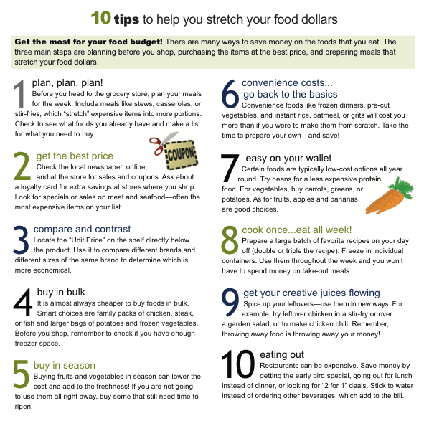

The best time to go shopping is
a. when you’re hungry
b. after you’ve eaten
c. when you have nothing to do

A planned shopping list is primarily to help you
a. shop faster
b. think on your feet
c. avoid impulse buying

You save money by going to the store
a. every day
b. once a week with daily visits for fresh food
c. when you run out of everything

A food that is advertised as “natural” is
a. always free of fat, salt, and sugar
b. always free of additives and preservatives
c. derived from plant and animal sources

A “cholesterol-free” product
a. is always free of fats that raise cholesterol
b. is free of animal products
c. requires careful reading of the label

The “Giant” size product is
a. always the best buy for everyone
b. not the best choice if you rarely use the item or have insufficient storage space
c. not good for people who don’t like to carry heavy bags

