Name: __________________ Honors World Studies II Date: ____________
Unit 2 — Exploration Leads to Discovery
Europeans Begin to Explore

DIRECTIONS: Read the following handout thoroughly, using a highlighter to highlight any important vocabulary/terms/names/events that you think might be historically important. Be sure to write notes in the margins next to any highlighted text to help you understand and remember the information.
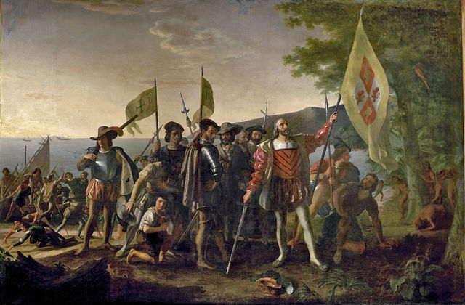

The Age of Exploration led to great cultural and economic changes, both in Europe and throughout the world. The European explorers of the fifteenth and sixteenth centuries pioneered new trade routes that would link regions previously isolated. New global political and economic relations developed, and a new interconnected world began to emerge. However, this large-scale European expansion often had negative side effects for the indigenous peoples, including war, disease, and cultural devastation.

For “God, Glory, and Gold”
By the early 1400s, Europeans were ready to venture beyond their borders, encouraged by the new spirit of adventure and curiosity born during the Renaissance. These explorations began a long process that would bring together the peoples of many different lands and permanently change the world.

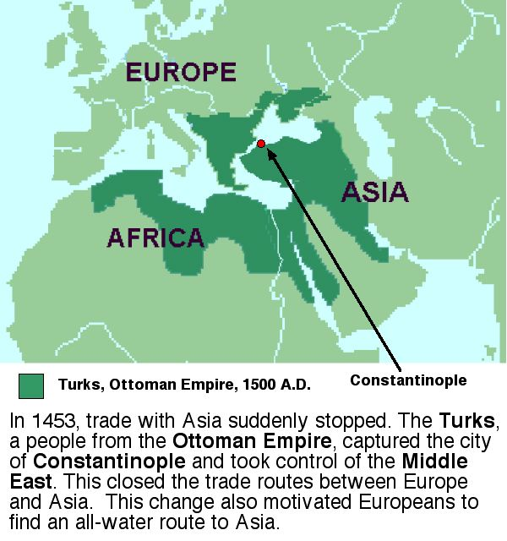
The desire for new sources of wealth was the main reason for European exploration. Through overseas exploration, merchants and traders hoped ultimately to benefit from what had become a profitable business in Europe: the trade of spices and other luxury goods from Asia. The people of Europe had been introduced to these items during the Crusades, fought between Christians and Muslims from 1096 to 1270. After the Crusades ended, Europeans continued to demand such spices as nutmeg, ginger, cinnamon, and pepper, all of which added flavor to the bland foods of Europe. Because demand for these goods was greater than the supply, merchants could charge high prices and thus make great profits.

The Muslims and the Italians controlled trade from East to West. Muslims sold Asian goods to Italian merchants, who controlled trade across land routes of the Mediterranean region. The Italians then resold the items at increased prices to merchants throughout Europe.

Traders from other regions of Europe did not like this arrangement, as paying such high prices to the Italians severely cut into their own profits. By the 1400s, European merchants - as well as the new monarchs of England, Spain, Portugal, and France - sought to bypass the Italian merchants.
Europeans were stifled by conquests by the Ottoman Turks in the fourteenth century, reducing their ability to travel by land to the East. This meant finding a sea route directly to Asia.

The Spread of Christianity
The desire to spread Christianity also motivated Europeans to explore. The Crusades had left Europeans with a taste for spices, but more significantly with feelings of hostility between Christians and Muslims. European countries believed that they had a sacred duty not only to continue fighting Muslims, but also to convert non-Christians throughout the world.

Europeans hoped to obtain popular good directly from the peoples of Asia. They also hoped to Christianize them. Bernal Díaz del Castillo, an early Spanish explorer, explained his motives: “To serve God and His Majesty, to give light to those who were in darkness and to grow rich as all men desire to do.”

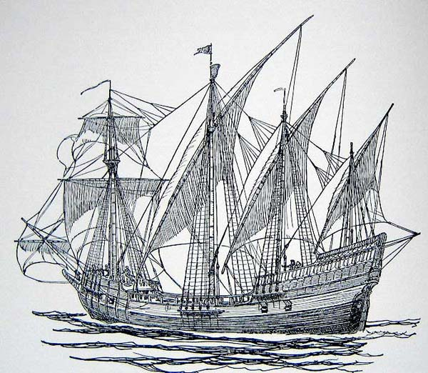
Technology Makes Exploration Possible
While “God, glory, and gold” were the primary motives for exploration, advances in technology made the voyages of discovery possible. During the 1200s, it would have been nearly impossible for a European sea captain to cross 3,000 miles of ocean and return again as European ships could not sail against the wind. In the 1400s, shipbuilders designed a new vessel, the caravel The caravel was sturdier than earlier vessels and triangular sails adopted from the Arabs allowed it to sail effectively against the wind.
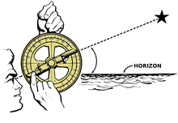
Europeans also improved their navigational techniques. To better determine their location at sea, sailors used the Muslim astrolabe, a brass circle with carefully adjusted rings marked off in degrees, used to sight the stars, and calculate latitude, or how far north or south of the equator the ship was. Explorers were also able to more accurately track direction by using a magnetic compass; a Chinese invention.

