Name: ___________________ Honors World Studies II Date: ____________

Unit 1 – Renaissance and Reformation

The English Reformation

DIRECTIONS: Read the following handout thoroughly, using a highlighter to highlight any important vocabulary/terms/names/events that you think might be historically important. Be sure to write notes in the margins next to any highlighted text to help you understand and remember the information.

Sixteenth century England was a land of contrasts. Much less urban than either Germany or the Netherlands, it nevertheless possessed a thriving international trade center in London and two universities of outstanding reputation, Oxford and Cambridge. Henry VIII turned to the finest theologians of these universities in his early campaigns against the growing threat of Lutheran heresy. In 1521 Pope Leo X conferred the title of Defender of the Faith on Henry for his book 'Assertio Septem Sacramentorum', which affirmed the supremacy of the Pope in the face of the reforming ideals of the German theologian, Martin Luther.

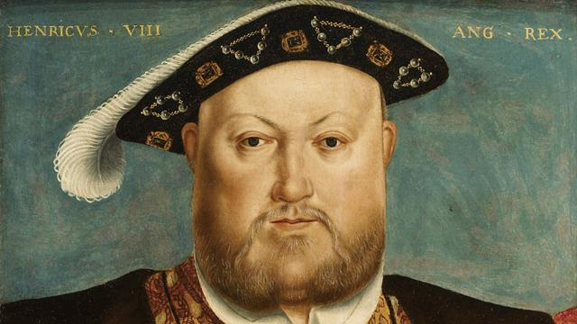
When King Henry VII of England died in 1509, his son Henry, the popular eighteen-year-old prince known for his love of hunting and dancing, became King Henry VIII. Soon after becoming king Henry obtained the papal dispensation required to allow him to marry his brother's widow, Catherine of Aragon.

In the first years of his reign Henry VIII effectively relied on the advise and counsel of Cardinal Thomas Wolsey, his father’s administrative and diplomatic envoy, and by 1515 Henry had elevated Wolsey to the highest role in government: Lord Chancellor.

Henry was acutely aware of the importance of securing a male heir during his reign. He was worried that he had only one surviving child, Mary, to show for his marriage to Catherine, who was now in her 40s. So the king asked Cardinal Wolsey to appeal to Pope Clement VII for an annulment. It soon became clear he wanted to marry Anne Boleyn, who had been a lady-in-waiting to his first wife.

But, unwilling to anger Catherine of Aragon's nephew – the most powerful ruler in Europe, the Holy Roman Emperor Charles V – the Pope refused. Henry then turned to England’s highest church courts. Archbishop of Canterbury Thomas Cranmer ruled in May 1533 that the king’s first marriage was “null and absolutely void.” At the beginning of June, Henry VIII broke with the church and married the now pregnant Anne Boleyn in a secret ceremony. Three months later their child, the future Queen Elizabeth I, was born. The English reformation had begun.

In 1534 at Henry’s request, Parliament finalized England’s break with the pope and the Catholic Church. The Act of Supremacy of 1534 declared that the king was “the only supreme head on earth of the [new] Church of England.” The king now had control over religious doctrine, clerical appointments, and discipline. Thomas More, a Christian humanist and devout Catholic, opposed the king’s action and was beheaded.

This act also brought Henry much needed wealth through the dissolution of the well-funded monasteries. Over four years 800 monasteries were disbanded and their lands and treasures taken for the crown. Henry also sold Church lands and possessions to landowners and merchants, a boost to his treasury. The English nobility had disliked papal control of the Church, and now they had a financial interest in the new order. In most matters of doctrine, however, Henry stayed close to Catholic teachings.

When the king died in 1547, he was succeeded by Edward VI, his nine-year-old son by his third wife. During the brief reign of King Edward VI, church officials who favored Protestant doctrines moved the Church of England, or the Anglican Church, in a Protestant direction. New acts of Parliament gave clergy the right to marry and created a Protestant church service. Before he turned 16, Edward died of tuberculosis.

The rapid changes in doctrine and policy during Edward’s reign aroused opposition. When Henry VIII’s daughter Mary I came to the throne in 1553, England was ready for a reaction. Mary was a Catholic who wanted to restore England to Roman Catholicism, but her efforts had the opposite effect. Among other actions, she ordered the burning of almost 300 Protestants as heretics, earning her the nickname “Bloody Mary.” As a result of her policies, England was even more committed to Protestantism by the end of Mary’s reign.

