Directions: Read the following excerpts from the Treaty of Versailles and then answer the questions that follow.

ARTICLE 32
Germany recognises the full sovereignty of Belgium over the whole of the contested territory of Moresnet (called Moresnet neutre).

ARTICLE 42
Germany is forbidden to maintain or construct any fortifications either on the left bank of the Rhine or on the right bank to the west of a line drawn 50 kilometres to the East of the Rhine.

ARTICLE 43
In the area defined above the maintenance and the assembly of armed forces, either permanently or temporarily, and military maneuvers of any kind, as well as the upkeep of all permanent works for mobilization, are in the same way forbidden.

ARTICLE 45
As compensation for the destruction of the coal-mines in the north of France and as part payment towards the total reparation due from Germany for the damage resulting from the war, Germany cedes to France in full and absolute possession, with exclusive rights of exploitation, unencumbered and free from all debts and charges of any kind, the coal-mines situated in the Saar Basin…

ALSACE-LORRAINE
The HIGH CONTRACTING PARTIES, recognising the moral obligation to redress the wrong done by Germany in 1871 both to the rights of France and to the wishes of the population of Alsace and Lorraine, which were separated from their country in spite of the solemn protest of their representatives at the Assembly of Bordeaux agree upon the following Articles:

ARTICLE 51
The territories which were ceded to Germany in accordance with the Preliminaries of Peace signed at Versailles on February 26, 187l, and the Treaty of Frankfort of May lo, 1871, are restored to French sovereignty as from the date of the Armistice of November 11, 1918.

The provisions of the Treaties establishing the delimitation of the frontiers before 1871 shall be restored.

ARTICLE 119
Germany renounces in favour of the Principal Allied and Associated Powers all her rights and titles over her oversea possessions.

ARTICLE 231
The Allied and Associated Governments affirm and Germany accepts the responsibility of Germany and her allies for causing all the loss and damage to which the Allied and Associated Governments and their nationals have been subjected as a consequence of the war imposed upon them by the aggression of Germany and her allies.

ARTICLE 232
The Allied and Associated Governments require, and Germany undertakes, that she will make compensation for all damage done to the civilian population of the Allied and Associated Powers and to their property during the period of the belligerency of each as an Allied or Associated Power against Germany by such aggression by land, by sea and from the air, and in general all damage…

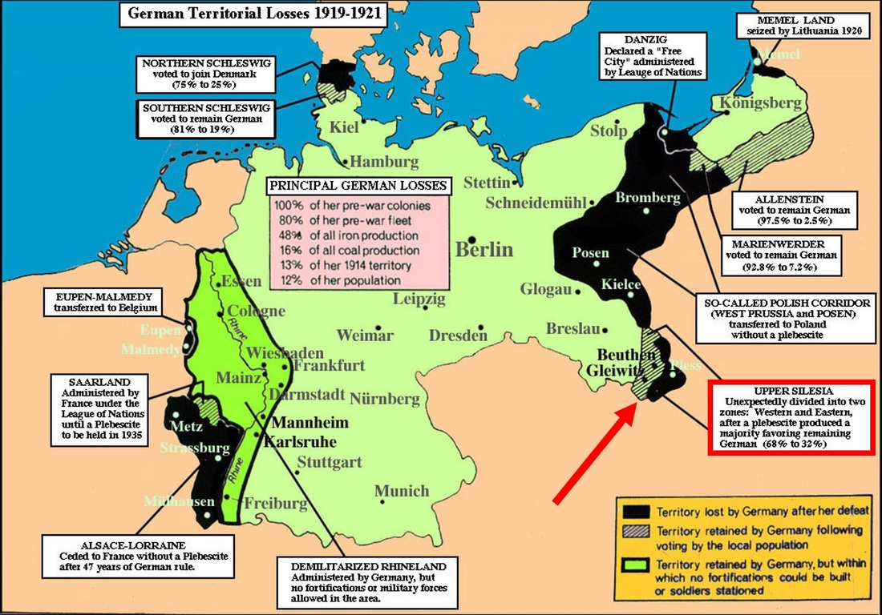

What did France gain from these articles?

What was the purpose of establishing a demilitarized buffer zone in the Rhineland?

How might the terms regarding the Saar Basin affect the German economy?

In what ways was Germany’s military affected by these articles?

What sovereign powers did Germany lose?

How might Germany react to these articles?

The purpose of these specific articles was to limit the German economy and military, but what was the overall goal of the entire Treaty of Versailles? Was it successful in reaching that goal? Why or why not?

