Would you spend just 20 minutes viewing a property that is most likely going to be the biggest purchase you ever make and your home for many years? Some buyers do – and live to regret it. The following are questions you should be able to answer after viewing a home.
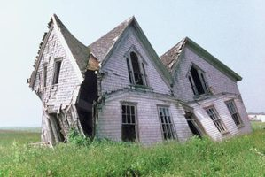
Is the building structurally sound?
If the house looks and feels solid and structurally sound you may not need a surveyor at all. Big cracks are what you are looking for – you should expect some hairline cracks. Look especially around where extensions join, end-of-terrace walls, and bay windows, all of which can start to fall or bow away from the rest of the house. If you see major cracks or have any doubts it might be worth getting a surveyor if only for peace of mind. If any walls look like they are seriously bowing consider engaging a structural engineer.

Do the window frames have cracking paint? Is the double-glazing intact?
The state of the external window frames is a great indicator of the state of the house – if people look after those, they are likely to have taken great care of the rest. If you can easily push your finger into wooden window frame, they are usually rotten. If there is condensation between double-glazed windowpanes it means that they are faulty.
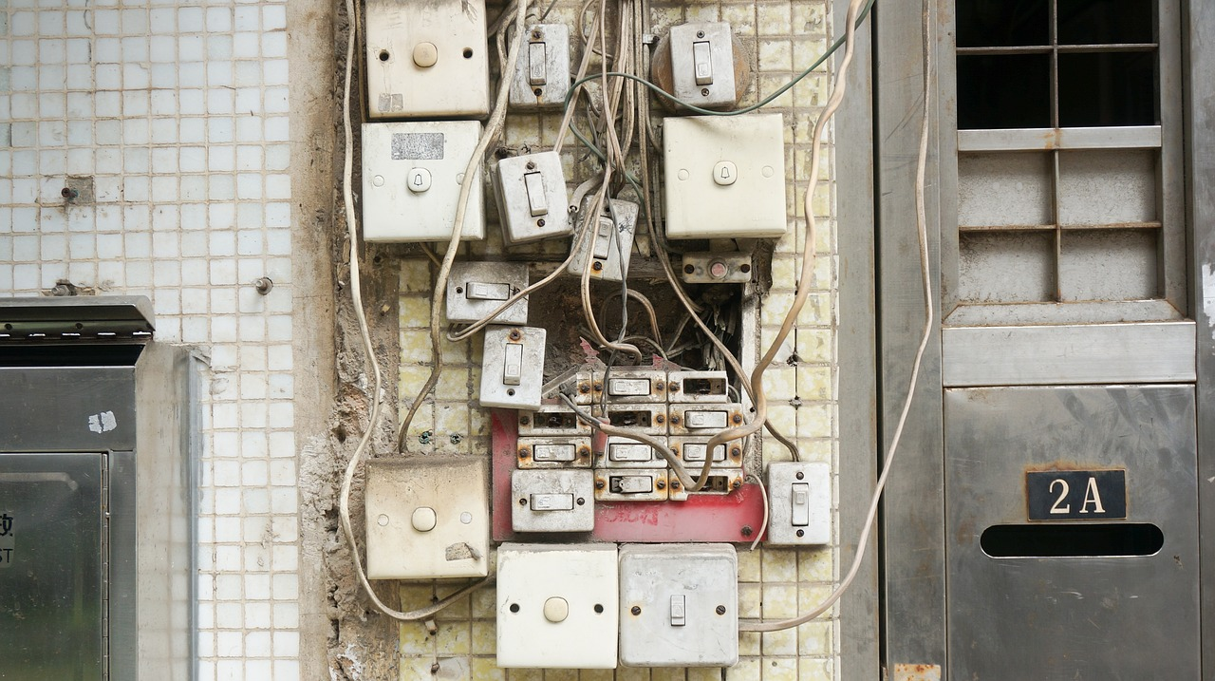
Are there enough power outlets and what condition are they in?
Dodgy wiring can be dangerous, and rewiring your new home can be an expensive business. Also check out the fuse board – often an indication of the state of the wiring. Does it look old and outdated?

Is the plumbing up to scratch?
Run the taps to check the water pressure. Ask if the pipes are insulated, and ensure they are not lead which would have to be replaced. Do the radiators actually work? How old is the boiler? If the hot water tank is situated in the roof it is probably an old one, and may have to be replaced soon

How old is the roof?
Replacing roofs is an expensive business, and newer roofs have a life expectancy of only 15-20 years, depending on the materials. Also, if the property has a flat or nearly flat roof, check out the material with which it sealed. Nowadays a membrane is used and is better than asphalt and gravel, which can leave seams and edges unsealed

How much storage space is there?
Storage space is a valuable but often overlooked asset. Where will you keep your vacuum cleaner, towels, spare linen, and boxes of junk? Is there room for cupboards or shelves to be built in? Especially in newly built houses, storage space can be scarce

What’s the attic like?
People often ignore the attic, but it is an important part of the house. How easy is it to access? Is there much storage space? Could it be converted into extra rooms? Is there insulation?

Which way does the house face?
In winter, during a cloudy day or at night, it is difficult to tell the difference between a north and south facing house or garden – but in summer it can make the difference between a home that is full of light and warmth, and one that is frustratingly dark. Your favorite plants might notice too, and protest by dying. Don’t be shy about taking a compass with you to the viewing – you might have one on your iPhone

Have you been influenced by staging?
Make sure you don’t get fooled. Be sure to bring a measuring tape and measure the rooms. Some sellers actually put smaller furniture in rooms to make them seem bigger than they are. Cleverly placed mirrors, strategic lighting, delicious smells, cozy fires, and fresh paint are all tricks sellers use to make their home more appealing.

What’s the area like?
Are you near a bar or restaurant that becomes rowdy in the evening?
Can you walk to shops to get bread or milk, or do you have to drive?
Is it easy to get to public transport?
Are there noisy roads or train tracks nearby?
Are you underneath a flight path?

Is there sufficient drainage in the area?
Check the whereabouts and levels of external drains. Are the drains accessible and are they fully functional? Keen gardeners may use lots of extra water which can cause severe structural problems for potential home improvements such as conservatories or patios. If you are concerned about insufficient drainage for a property you wish to buy, then get a structural survey.
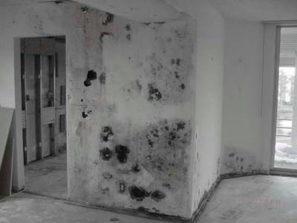

Is it damp?
The main giveaway signs are a moldy smell, flaky plaster, and watermarked walls or ceilings. It sounds obvious, but make sure you look closely near the ceiling and around the skirting boards. Another clue might be if the room has just been repainted – possibly covering any damp areas.

Does it feel like you could make it your home?
If you like a property, arrange another viewing for a different time of day, and scout out the local area a bit more. If you can, take someone with you – they might notice things you did not.

