**Directions: Read and annotate the packet.**

*As part of their vision for Europe, the Nazis proposed a new racial order. They proclaimed that the Germanic peoples, or Aryans, were a “master race.” (This was a misuse of the term Aryan, which actually refers to the Indo-European peoples who began to migrate into the Indian subcontinent around 1500 B.C.) The Nazis claimed that all non-Aryan peoples, particularly Jewish people, were inferior. This racist message would eventually lead to the Holocaust, the systematic mass slaughter of Jews and other groups judged inferior by the Nazis.*

**The Holocaust Begins**

To gain support for his racist ideas, Hitler knowingly tapped into a hatred for Jews that had deep roots in European history. For generations, many Germans, along with other Europeans, had targeted Jews as the cause of their failures. Some Germans even blamed Jews for their country’s defeat in World War I and for its economic problems after that war.

In time, the Nazis made the targeting of Jews a government policy. The Nuremberg Laws, passed in 1935, deprived Jews of their rights to German citizenship and forbade marriages between Jews and non-Jews. Laws passed later also limited the kinds of work that Jews could do.

**“Night of Broken Glass”**

Worse was yet to come. Early in November 1938, 17-year-old Herschel Grynszpan, a Jewish youth from Germany, was visiting an uncle in Paris. While Grynszpan was there, he received a postcard. It said that after living in Germany for 27 years, his father had been deported to Poland. On November 7, wishing to avenge his father’s deportation, Grynszpan shot a German diplomat living in Paris.

When Nazi leaders heard the news, they launched a violent attack on the Jewish community. On November 9, Nazi storm troopers attacked Jewish homes, businesses, and synagogues across Germany and murdered close to 100 Jews. An American in Leipzig wrote, “Jewish shop windows by the hundreds were systematically . . . smashed. . . . The main streets of the city were a positive litter of shattered plate glass.” It is for this reason that the night of November 9 became known as *Kristallnacht*, or “Night of Broken Glass.” A 14-year-old boy described his memory of that awful night:

*All the things for which my parents had worked for eighteen long years were destroyed in less than ten minutes. Piles of valuable glasses, expensive furniture, linens—in short, everything was destroyed. . . . The Nazis left us, yelling, “Don’t try to leave this house! We’ll soon be back again and take you to a concentration camp to be shot.”*

M. I. LIBAU, quoted in *Never to Forget: The Jews of the Holocaust*

*Kristallnacht* marked a major step-up in the Nazi policy of Jewish persecution. The future for Jews in Germany looked truly grim.

**A Flood of Refugees**

After *Kristallnacht*, some Jews realized that violence against them was bound to increase. By the end of 1939, a number of German Jews had fled to other countries. Many however, remained in Germany. Later, Hitler conquered territories in which millions more Jews lived.

At first, Hitler favored emigration as a solution to what he called “the Jewish problem.” Getting other countries to continue admitting Germany’s Jews became an issue, however. After admitting tens of thousands of Jewish refugees, such countries as France, Britain, and the United States abruptly closed their doors to further immigration. Germany’s foreign minister observed, “We all want to get rid of our Jews. The difficulty is that no country wishes to receive them.”

**Isolating the Jews**

When Hitler found that he could not get rid of Jews through emigration, he put another plan into effect. He ordered Jews in all countries under his control to be moved to designated cities. In those cities, the Nazis herded the Jews into dismal, overcrowded ghettos, or segregated Jewish areas. The Nazis then sealed off the ghettos with barbed wire and stone walls. They hoped that the Jews inside would starve to death or die from disease.

*(left: German soldiers round up Jews in the Warsaw Ghetto.)*

Even under these horrible conditions, the Jews hung on. Some formed resistance organizations within the ghettos. They also struggled to keep their traditions. Ghetto theaters produced plays and concerts. Teachers taught lessons in secret schools. Scholars kept records so that one day people would find out the truth.

**Jewish Resistance**

Even in the extermination camps, Jews rose up and fought against the Nazis. At Treblinka in August 1943, and at Sobibor in October 1943, small groups of Jews revolted. They killed guards, stormed the camp armories and stole guns and grenades, and then broke out. In both uprisings, about 300 prisoners escaped. Most were killed soon after. Of those who survived, many joined up with partisan groups and continued to fight until the end of the war.

Late in 1944, prisoners at Auschwitz revolted, too. Like the escapees at Treblinka and Sobibor, most were caught and killed. Young women like Ella Gartner and Roza Robota made the Auschwitz uprising possible. Gartner smuggled gunpowder into the camp from the munitions factory where she worked. Robota helped organize resistance in the camp. Gartner and Robota were executed on January 6, 1945. Less than a month later, Auschwitz was liberated.

**The “Final Solution”**

Hitler soon grew impatient waiting for Jews to die from starvation or disease. He decided to take more direct action. His plan was called the “Final Solution.” It was actually a program of genocide, the systematic killing of an entire people.

Hitler believed that his plan of conquest depended on the purity of the Aryan race. To protect racial purity, the Nazis had to eliminate other races, nationalities, or groups they viewed as inferior - as “subhumans.” They included Roma (gypsies), Poles, Russians, homosexuals, the insane, the disabled, and the incurably ill. But the Nazis focused especially on the Jews.

**The Killings Begin**

As Nazi troops swept across Eastern Europe and the Soviet Union, the killings began. Units from the SS (Hitler’s elite security force) moved from town to town to hunt down Jews. The SS and their collaborators rounded up men, women, children, and even babies and took them to isolated spots. They then shot their prisoners in pits that became the prisoners’ graves.

Jews in communities not reached by the killing squads were rounded up and taken to concentration camps, or slave-labor prisons. These camps were located mainly in Germany and Poland. Hitler hoped that the horrible conditions in the camps would speed the total elimination of the Jews.

The prisoners worked seven days a week as slaves for the SS or for German businesses. Guards severely beat or killed their prisoners for not working fast enough. With meals of thin soup, a scrap of bread, and potato peelings, most prisoners lost 50 pounds in the first few months. Hunger was so intense, recalled one survivor, “that if a bit of soup spilled over, prisoners would . . . dig their spoons into the mud and stuff the mess in their mouths.”

**The Final Stage**

The “Final Solution” reached its last stage in 1942. At that time, the Nazis built extermination camps equipped with huge gas chambers that could kill as many as 6,000 human beings in a day. When prisoners arrived at Auschwitz, the largest of the extermination camps, they paraded before a committee of SS doctors. With a wave of the hand, these doctors separated the strong - mostly men - from the weak - mostly women, young children, the elderly, and the sick. Those labeled as weak would die that day. They were told to undress for a shower and then led into a chamber with fake showerheads. After the doors were closed, cyanide gas poured from the showerheads. All inside were killed in a matter of minutes. Later, the Nazis installed crematoriums, or ovens, to burn the bodies.

**The Survivors**

Some six million European Jews died in these death camps and in Nazi massacres. Fewer than four million survived. Some escaped the horrors of the death camps with help from non-Jewish people. These rescuers, at great risk to their own lives, hid Jews in their homes or helped them escape to neutral countries.

Those who survived the camps were changed forever by what they had experienced. As Elie Wiesel, nearly 15 years old when he entered Auschwitz, noted:

*Never shall I forget the little faces of the children, whose bodies I saw turned into wreaths of smoke beneath a silent blue sky. Never shall I forget those flames which consumed my faith forever. . . . Never shall I forget those moments which murdered my God and my soul and turned my dreams to dust. . . . Never.* ELIE WIESEL, quoted in *Night*

**Nuremberg Laws on Citizenship and Race**

*The “Nuremberg Laws” established the legal basis for racial discrimination. There was almost no opposition to the introduction of these laws. Only a person of ‘German blood’ could be a German citizen.*

**The Nuremberg Laws on Citizenship and Race: September and November 1935**

The Reich Citizenship Law of September 15, 1935

THE REICHSTAG HAS ADOPTED by unanimous vote the following law which is herewith promulgated.

ARTICLE 1

(1) A subject of the state is one who belongs to the protective union of the German Reich, and who, therefore, has specific obligations to the Reich.

(2) The status of subject is to be acquired in accordance with the provisions of the Reich and the state Citizenship Law.

ARTICLE 2

(1) A citizen of the Reich may be only one who is of German or kindred blood, and who, through his behavior, shows that he is both desirous and personally fit to serve loyally the German people and the Reich.

(2) The right to citizenship is obtained by the grant of Reich citizenship papers.

(3) Only the citizen of the Reich may enjoy full political rights in consonance with the provisions of the laws.

ARTICLE 3

The Reich Minister of the Interior, in conjunction with the Deputy to the Fuehrer, will issue the required legal and administrative decrees for the implementation and amplification of this law.

Promulgated: September 16, 1935.   
In force: September 30, 1935.

**First Supplementary Decree of November 14, 1935**

On the basis of Article III of the Reich Citizenship Law of September 1935, the following is hereby decreed:

ARTICLE 1

(1) Until further provisions concerning citizenship papers, all subjects of German or kindred blood who possessed the right to vote in the Reichstag elections when the Citizenship Law came into effect, shall, for the present, possess the rights of Reich citizens. The same shall be true of those upon whom the Reich Minister of the Interior, in conjunction with the Deputy to the Fuehrer shall confer citizenship.

(2) The Reich Minister of the Interior, in conjunction with the Deputy to the Fuehrer, may revoke citizenship.

ARTICLE 2

(1) The provisions of Article I shall apply also to subjects who are of mixed Jewish blood.

(2) An individual of mixed Jewish blood is one who is descended from one or two grandparents who, racially, were full Jews, insofar that he is not a Jew according to Section 2 of Article 5. Full-blooded Jewish grandparents are those who belonged to the Jewish religious community.

ARTICLE 3

Only citizens of the Reich, as bearers of full political rights, can exercise the right of voting in political matters, and have the right to hold public office. The Reich Minister of the Interior, or any agency he empowers, can make exceptions during the transition period on the matter of holding public office. The measures do not apply to matters concerning religious organizations.

ARTICLE 4

(1) A Jew cannot be a citizen of the Reich. He cannot exercise the right to vote; he cannot hold public office.

(2) Jewish officials will be retired as of December 31, 1935. In the event that such officials served at the front in the World War either for Germany or her allies, they shall receive as pension, until they reach the age limit, the full salary last received, on the basis of which their pension would have been computed. They shall not, however, be promoted according to their seniority in rank. When they reach the age limit, their pension will be computed again, according to the salary last received on which their pension was to be calculated.

(3) These provisions do not concern the affairs of religious organizations.

(4) The conditions regarding service of teachers in public Jewish schools remains unchanged until the promulgation of new laws on the Jewish school system.

ARTICLE 5

(1) A Jew is an individual who is descended from at least three grandparents who were, racially, full Jews...

(2) A Jew is also an individual who is descended from two full-Jewish grandparents if: (a) he was a member of the Jewish religious community when this law was issued, or joined the community later; (b) when the law was issued, he was married to a person who was a Jew, or was subsequently married to a Jew; (c) he is the issue from a marriage with a Jew, in the sense of Section I, which was contracted after the coming into effect of the Law for the Protection of German Blood and Honor of September 15, 1935; (d) he is the issue of an extramarital relationship with a Jew, in the sense of Section I, and was born out of wedlock after July 31, 1936.

ARTICLE 6

Insofar as there are, in the laws of the Reich or in the decrees of the National Socialist German Workers' Party and its affiliates, certain requirements for the purity of German blood which extend beyond Article 5, the same remain untouched....

ARTICLE 7

The Fuehrer and Chancellor of the Reich is empowered to release anyone from the provisions of these administrative decrees.

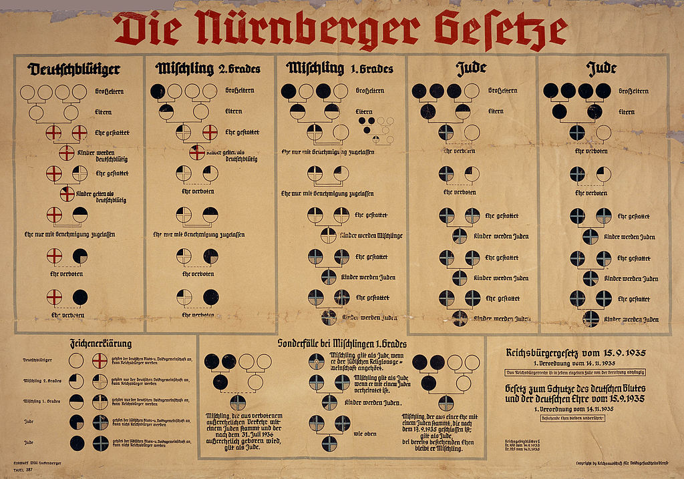

1935 racial classifications chart under the Nuremberg Laws: German, *Mischlinge* [mixed blood], and Jew

Only people with four German grandparents (four white circles in top row left) were of “German blood.” A Jew is someone who descends from three or four Jewish grandparents (black circles in top row right). In the middle stood people of “mixed blood” of the “first or second degree.” A Jewish grandparent was defined as a person who is or was a member of a Jewish religious community. Also includes a list of allowed marriages (“Ehe gestattet”) and forbidden marriages (“Ehe verboten”).