**Communism**

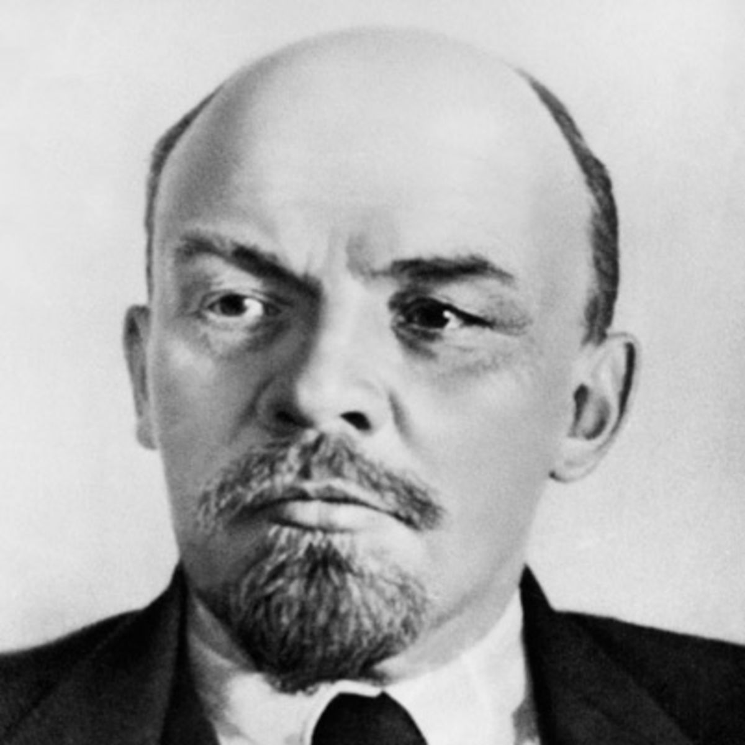Communism is a political and economic system of organization. In theory, property is owned by the community and all citizens share in the common wealth according to their need. In practice, this was difficult to achieve.

German philosopher Karl Marx saw communism as the end result of an essential historical process. Russian revolutionary Vladimir Lenin built on Marx’s theories and sought ways of applying those theories. Ultimately, however, Lenin’s communist state - the Union of Soviet Socialist Republics (USSR) - became a one-party, totalitarian system.

**The Bolshevik Revolution**

By the fall of 1917, people in the cities were rallying to the call, “All power to the soviets.” Lenin’s slogan - “Peace, Land, and Bread” - gained widespread appeal. Lenin decided to take action.

**The Provisional Government Topples**

In November 1917, without warning, armed factory workers stormed the Winter Palace in Petrograd. Calling themselves the Bolshevik Red Guards, they took over government offices and arrested the leaders of the provisional government. Kerensky and his colleagues disappeared almost as quickly as the czarist regime they had replaced.



**Bolsheviks in Power**

Within days after the Bolshevik takeover, Lenin ordered that all farmland be distributed among the peasants. Lenin and the Bolsheviks gave control of factories to the workers. The Bolshevik government also signed a truce with Germany to stop all fighting and began peace talks.

In March 1918, Russia and Germany signed the Treaty of Brest-Litovsk. Russia surrendered a large part of its territory to Germany and its allies. The humiliating terms of this treaty triggered widespread anger among many Russians. They objected to the Bolsheviks and their policies and to the murder of the royal family.

**Civil War Rages in Russia**

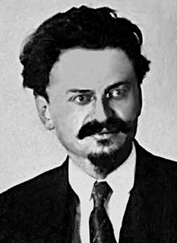The Bolsheviks now faced a new challenge - stamping out their enemies at home. Their opponents formed the White Army. The White Army was made up of very different groups. There were those groups who supported the return to rule by the czar, others who wanted democratic government, and even socialists who opposed Lenin’s style of socialism. Only the desire to defeat the Bolsheviks united the White Army. The groups barely cooperated with each other. At one point there were three White Armies fighting against the Bolsheviks’ Red Army.

The revolutionary leader, Leon Trotsky, expertly commanded the Bolshevik Red Army. From 1918 to 1920, civil war raged in Russia. Several Western nations, including the United States, sent military aid and forces to Russia to help the White Army. However, they were of little help.

Russia’s civil war proved far more deadly than the earlier revolutions. Around 14 million Russians died in the three-year struggle and in the famine that followed. The destruction and loss of life from fighting, hunger, and a worldwide flu epidemic left Russia in chaos. In the end, the Red Army crushed all opposition. The victory showed that the Bolsheviks were able both to seize power and to maintain it.

**Comparing World Revolutions**

In its immediate and long-term effects, the Russian Revolution was more like the French Revolution than the American Revolution. The American Revolution expanded English political ideas into a constitutional government that built on many existing structures. In contrast, both the French and Russian revolutions attempted to destroy existing social and political structures. Revolutionaries in France and Russia used violence and terror to control people. France became a constitutional monarchy for a time, but the Russian Revolution established a state-controlled society that lasted for decades.

**Lenin Restores Order**

War and revolution destroyed the Russian economy. Trade was at a standstill. Industrial production dropped, and many skilled workers fled to other countries. Lenin turned to reviving the economy and restructuring the government.

**New Economic Policy**

In March 1921, Lenin temporarily put aside his plan for a state-controlled economy. Instead, he resorted to a small-scale version of capitalism called the New Economic Policy (NEP). The reforms under the NEP allowed peasants to sell their surplus crops instead of turning them over to the government. The government kept control of major industries, banks, and means of communication, but it let some small factories, businesses, and farms operate under private ownership. The government also encouraged foreign investment.

Thanks partly to the new policies and to the peace that followed the civil war, the country slowly recovered. By 1928, Russia’s farms and factories were producing as much as they had before WWI.

**Political Reforms**

Bolshevik leaders saw nationalism as a threat to unity and party loyalty. To keep nationalism in check, Lenin organized Russia into several self-governing republics under the central government. In 1922, the country was named the Union of Soviet Socialist Republics (USSR), in honor of the councils that helped launch the Bolshevik Revolution.

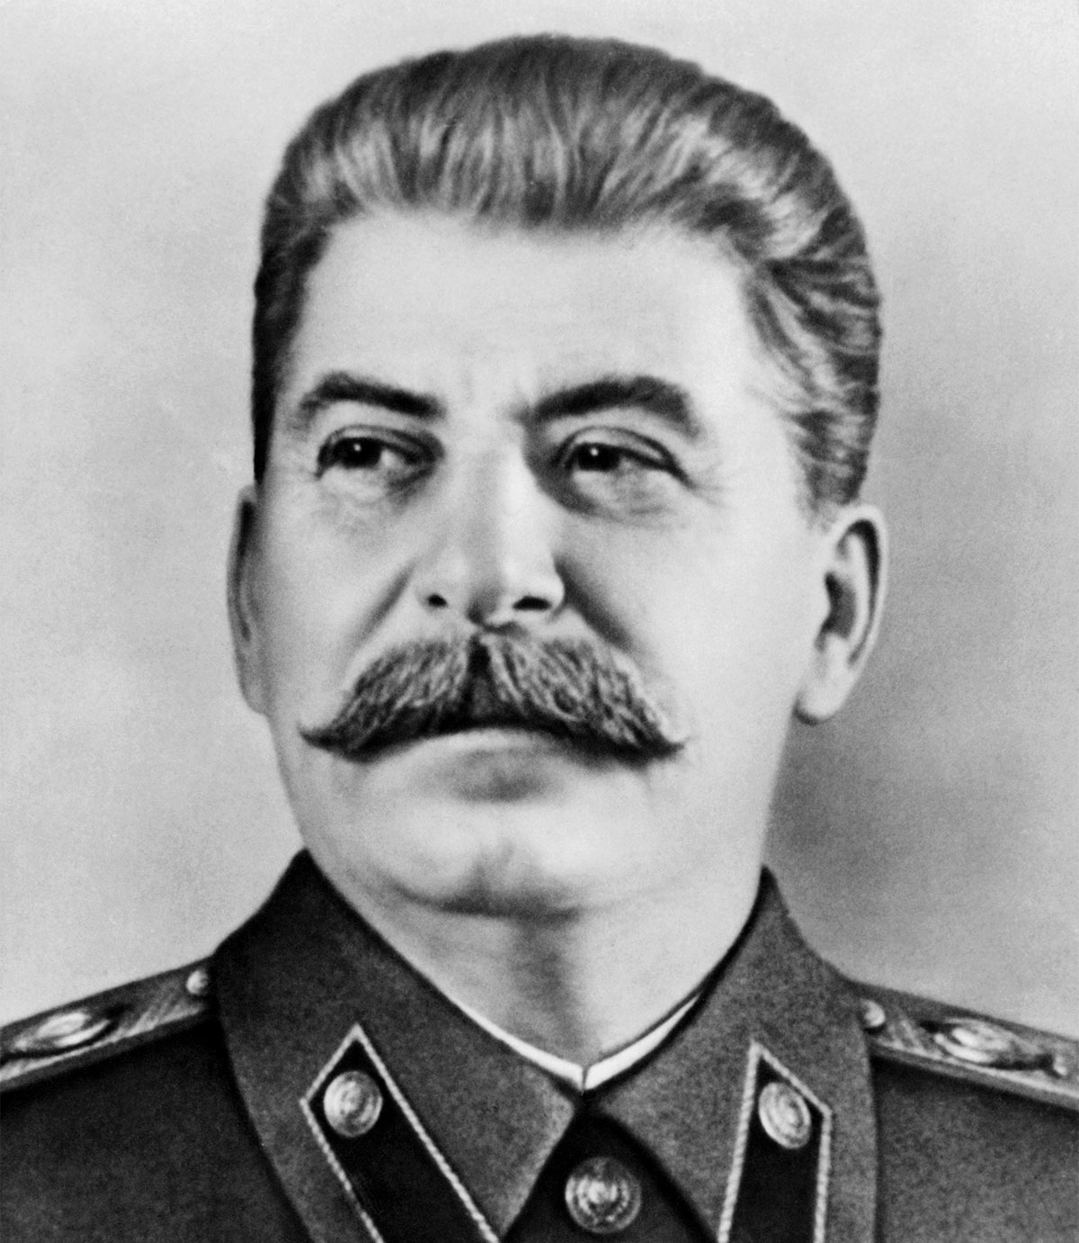The Bolsheviks renamed their party the Communist Party. The name came from the writings of Karl Marx. He used the word communism to describe the classless society that would exist after workers had seized power. In 1924, the Communists created a constitution based on socialist and democratic principles. In reality, the Communist Party held all the power. Lenin had established a dictatorship of the Communist Party, not “a dictatorship of the proletariat,” as Marx had promoted.

**Stalin Becomes Dictator**

Lenin suffered a stroke in 1922. He survived, but the incident set in motion competition for heading up the Communist Party. Two of the most notable men were Leon Trotsky and Joseph Stalin. Stalin was cold, hard, and impersonal. During his early days as a Bolshevik, he changed his name to Stalin, which means “man of steel” in Russian. The name fit well.

Stalin began his ruthless climb to the head of the government between 1922 and 1927. In 1922, as general secretary of the Communist Party, he worked behind the scenes to move his supporters into positions of power. Lenin believed that Stalin was a dangerous man. Shortly before he died in 1924, Lenin wrote, “Comrade Stalin […] has concentrated enormous power in his hands, and I am not sure that he always knows how to use that power with sufficient caution.” By 1928, Stalin was in total command of the Communist Party. Trotsky, forced into exile in 1929, was no longer a threat. Stalin now stood poised to wield absolute power as a dictator.