Directions: Read and annotate the packet.

The German Path to War
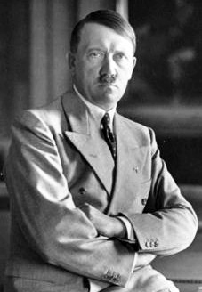
World War II in Europe had its beginnings in the ideas of Adolf Hitler. He believed that Germans belonged to a so-called Aryan race that was superior to all other races and nationalities. Consequently, Hitler believed that Germany was capable of building a great civilization. To be a great power, however, he thought that Germany needed more land to support a larger population.

Already in the 1920s, Hitler had indicated that a Nazi regime would find this land to the east—in the Soviet Union. Germany therefore must prepare for war with the Soviet Union. After the Soviet Union had been conquered, according to Hitler, its land would be resettled by German peasants. The Slavic peoples could be used as slave labor to build an Aryan racial state that Hitler thought would dominate Europe for a thousand years.

Hitler Violates Treaty
After World War I, the Treaty of Versailles had limited Germany’s military power. As chancellor, Hitler, posing as a man of peace, stressed that Germany wished to revise the unfair provisions of the treaty by peaceful means. Germany, he said, only wanted its rightful place among the European states.

On March 9, 1935, however, Hitler announced the creation of a new air force. One week later, he began a military draft that would expand Germany’s army from 100,000 to 550,000 troops. These steps were in direct violation of the Treaty of Versailles. France, Great Britain, and Italy condemned Germany’s actions and warned against future aggressive steps. In the midst of the Great Depression, however, these nations were distracted by their own internal problems and did nothing further.

Hitler was convinced that the Western states had no intention of using force to maintain the Treaty of Versailles. Hence, on March 7, 1936, he sent German troops into the Rhineland. The Rhineland was part of Germany, but, according to the Treaty of Versailles, it was a demilitarized area. That is, Germany was not allowed to have weapons or fortifications there. France had the right to use force against any violation of this provision but would not act without British support.

Great Britain did not support the use of force against Germany. The British government viewed the occupation of German territory by German troops as a reasonable action by a dissatisfied power. The London Times noted that the Germans were “only going into their own back garden.” Great Britain thus began to practice a policy of appeasement. This policy was based on the belief that if European states satisfied the reasonable demands of dissatisfied powers, the dissatisfied powers would be content, and stability and peace would be achieved in Europe.

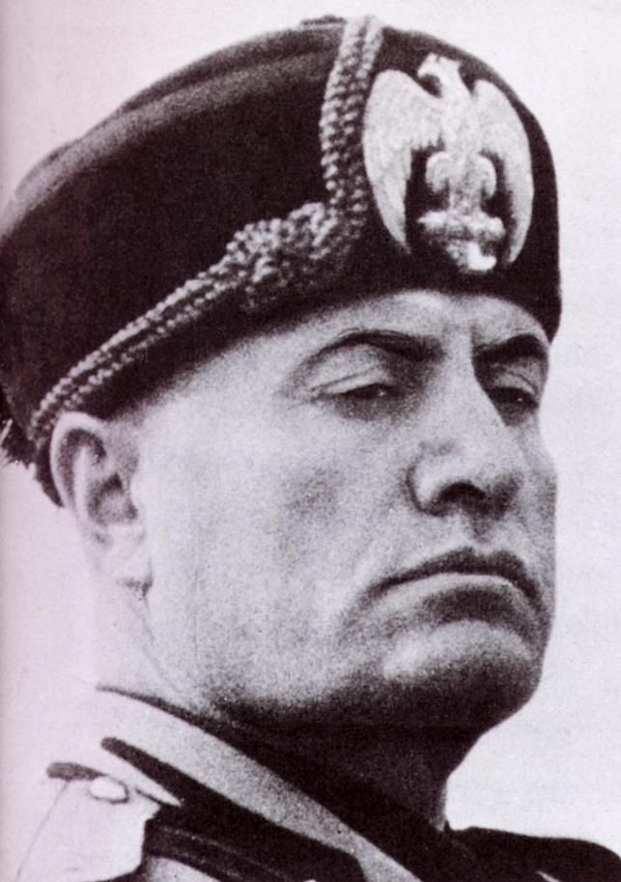
New Alliances
Meanwhile, Hitler gained new allies. Benito Mussolini of Italy (pictured left) had long dreamed of creating a new Roman Empire. In October 1935, Mussolini’s forces invaded Ethiopia. Angered by French and British opposition to his invasion, Mussolini welcomed Hitler’s support. He began to draw closer to the German dictator.

In 1936 both Germany and Italy sent troops to Spain to help General Francisco Franco in the Spanish Civil War. In October 1936, Mussolini and Hitler made an agreement recognizing their common interests. One month later, Mussolini spoke of the new alliance between Italy and Germany, called the Rome-Berlin Axis. Also in November, Germany and Japan signed the Anti-Comintern Pact, promising a common front against communism.

Union With Austria
By 1937, Germany was once more a “world power,” as Hitler proclaimed. He was convinced that neither France nor Great Britain would provide much opposition to his plans. In 1938 he decided to pursue one of his goals: Anschluss, or union, with Austria, his native land.

By threatening Austria with invasion, Hitler forced the Austrian chancellor to put Austrian Nazis in charge of the government. The new government promptly invited German troops to enter Austria and “help” in maintaining law and order. One day later, on March 13, 1938, after his triumphal return to his native land, Hitler annexed Austria to Germany.

Demands and Appeasement
Hitler’s next objective was the destruction of Czechoslovakia. On September 15, 1938, he demanded that Germany be given the Sudetenland, an area in northwestern Czechoslovakia that was inhabited largely by Germans. He was willing to risk “world war” to achieve his objective.

At a hastily arranged conference in Munich, British, French, German, and Italian representatives did not object to Hitler’s plans but instead reached an agreement that met virtually all Hitler’s demands. German troops were allowed to occupy the Sudetenland. The Czechs, abandoned by their Western allies, stood by helplessly.

The Munich Conference was the high point of Western appeasement of Hitler. When Neville Chamberlain, the British prime minister, returned to England from Munich, he boasted that the agreement meant “peace for our time.” One British statesman, Winston Churchill, warned instead that the settlement at Munich was “a disaster of the first magnitude.” Hitler, however, had promised Chamberlain that he would make no more demands. Like many others, Chamberlain believed Hitler’s promises.
In fact, Hitler was more convinced than ever that the Western democracies would not fight. Increasingly, he was sure that he could not make a mistake, and he had by no means been satisfied at Munich.

In March 1939, Hitler invaded and took control of Bohemia and Moravia in western Czechoslovakia. In the eastern part of the country, Slovakia became a puppet state controlled by Nazi Germany. On the evening of March 15, 1939, Hitler triumphantly declared in Prague that he would be known as the greatest German of them all.

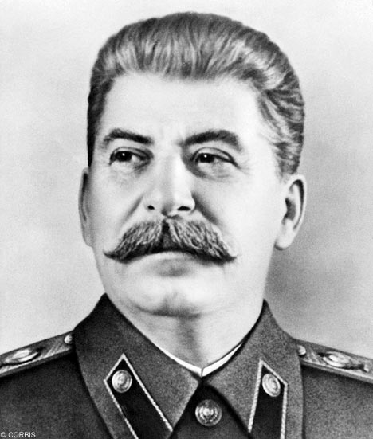
At last, the Western states reacted to the Nazi threat. Hitler’s aggression had made clear that his promises were worthless. When Hitler began to demand the Polish port of Danzig, Great Britain saw the danger and offered to protect Poland in the event of war. At the same time, both France and Britain realized that only the Soviet Union was powerful enough to help contain Nazi aggression. They began political and military negotiations with Joseph Stalin, the Soviet dictator (right).

Hitler and the Soviets
Meanwhile, Hitler continued to believe that the West would not fight over Poland. He now feared, however, that the West and the Soviet Union might make an alliance. Such an alliance could mean a two-front war for Germany. To prevent this, Hitler made his own agreement with Stalin.

On August 23, 1939, Germany and the Soviet Union signed the Nazi-Soviet Nonaggression Pact. In it, the two nations promised not to attack each other. To get the nonaggression pact, Hitler offered Stalin control of eastern Poland and the Baltic states. Because he expected to fight the Soviet Union anyway, it did not matter to Hitler what he promised—he was accustomed to breaking promises.

Hitler shocked the world when he announced the treaty. Hitler was now free to attack Poland. He told his generals, “Now Poland is in the position in which I wanted her . . . . I am only afraid that at the last moment some swine will yet submit to me a plan for mediation.”

Hitler need not have worried. On September 1, German forces invaded western Poland. Two days later, Britain and France declared war on Germany.

The Japanese Path to War
On the night of September 18, 1931, Japanese soldiers, disguised as Chinese soldiers, blew up a small section of the Manchurian Railway near the city of Mukden. Japan owned this area, and the Japanese soldiers wanted to blame the “Mukden incident” on the Chinese. The Japanese army used this incident to justify its taking all of Manchuria in a series of rapid military advances.

Manchuria offered many resources the Japanese needed. After this conquest, the Japanese army became committed to an expansionist policy— a policy of enlarging the Japanese Empire.
By September 1932, the Japanese army had formed Manchuria into a separate state and renamed it Manchukuo. They placed a puppet ruler, Henry Pu Yi, on the throne. As an infant, Henry Pu Yi had been China’s “last emperor.” He had abdicated that throne, however, following the revolution of 1911 in China.

Worldwide protests against the Japanese seizure of Manchuria led the League of Nations to send in investigators. When the investigators issued a report condemning the seizure, Japan withdrew from the League. The United States refused to recognize the Japanese takeover of Manchuria but was unwilling to threaten force.

Over the next several years, Japan continued its expansion and established control over the eastern part of Inner Mongolia and areas in north China around Beijing. Neither Emperor Hirohito nor government leaders could control the army. In fact, it was the army that established Japanese foreign policy. The military held the upper hand. By the mid-1930s, militants connected to the government and the armed forces had gained control of Japanese politics.

War With China
Chiang Kai-shek tried to avoid a conflict with Japan so that he could deal with what he considered the greater threat, the Chinese Communists. When clashes between Chinese and Japanese troops broke out, he sought to appease Japan by allowing it to govern areas in north China.

As Japan moved steadily southward, protests against Japanese aggression grew stronger in Chinese cities. In December 1936, Chiang ended his military efforts against the Communists and formed a new united front against the Japanese. In July 1937, Chinese and Japanese forces clashed south of Beijing and hostilities spread.

Although Japan had not planned to declare war on China, the 1937 incident turned into a major conflict. Japan seized the Chinese capital of Nanjing in December. The Japanese Army destroyed the city and massacred more than 100,000 civilians and prisoners of war. The event was so brutal it became known as the “Rape of Nanjing.” Chiang Kai-shek refused to surrender and moved his government upriver, first to Hankou, then to Chongqing. Temporarily defeated, the Chinese continued to resist.

The New Asian Order
Japanese military leaders had hoped to force Chiang to agree to join a New Order in East Asia, comprising Japan, Manchuria, and China. Japan would attempt to establish a new system of control in Asia with Japan guiding its Asian neighbors to prosperity.

Part of Japan’s plan was to seize Soviet Siberia, with its rich resources. During the late 1930s, Japan began to cooperate with Nazi Germany. Japan assumed that the two countries would ultimately launch a joint attack on the Soviet Union and divide Soviet resources between them.

When Germany signed the nonaggression pact with the Soviets in August 1939, Japanese leaders had to rethink their goals. Because Japan lacked the resources to defeat the Soviet Union, it looked to South Asia for raw materials for its military machine.

Japan Launches Attack
A move southward would risk war with the European powers and the United States. Japan’s attack on China had already aroused strong criticism, especially in the United States. Still, in the summer of 1940, Japan demanded the right to exploit economic resources in French Indochina.

The United States objected. It warned Japan that it would apply economic sanctions unless Japan withdrew from the area and returned to its borders of 1931. Japan badly needed the oil and scrap iron it was getting from the United States. Should these resources be cut off, Japan would have to find them elsewhere. This would threaten Japan’s long-term objectives.

Japan was now caught in a dilemma. To guarantee access to raw materials in Southeast Asia, Japan had to risk losing them from the United States. After much debate, Japan decided to launch a surprise attack on U.S. and European colonies in Southeast Asia.

