Name: ___________________ Economic Skills Date: ____________

Final Assessment

**Part I: Career Choice**

Identify the career you would like to pursue after high school graduation and explain the reasons why you have chosen this career. Be sure to describe specific, personal reasons why this career interests you. Include where you might live to work at this career and what the annual starting salary for this job would be. You may write this in the space below, print an electronic copy and hand it in, or share an electronic copy with me online.

______________________________________________________________________________

______________________________________________________________________________

______________________________________________________________________________

______________________________________________________________________________

______________________________________________________________________________

______________________________________________________________________________

______________________________________________________________________________

______________________________________________________________________________

______________________________________________________________________________

______________________________________________________________________________

______________________________________________________________________________

______________________________________________________________________________

______________________________________________________________________________

______________________________________________________________________________

______________________________________________________________________________

______________________________________________________________________________

______________________________________________________________________________

______________________________________________________________________________

______________________________________________________________________________

______________________________________________________________________________

______________________________________________________________________________

______________________________________________________________________________

______________________________________________________________________________

______________________________________________________________________________

______________________________________________________________________________

**Part II: Post-Secondary Education Plan**

Identify the cost of attending the post-secondary education institution you have chosen.

Post-Secondary Education (name):

______________________________

Location (city/state):

______________________________

***From the “Paying” section for this college on collegeboard.com:***

Tuition and Fees: ____________________

Room and Board: ____________________

Books and Supplies: ____________________

Estimated Expenses: ____________________

Transportation Expenses: ____________________

Estimated Total: ____________________ x 4 years = ____________________

Access the loan payment calculator at <http://www.finaid.org/calculators/loanpayments.phtml>.

Loan Balance: ____________________

*total amount you will need to borrow for all four years; the “x 4 years” total above*

Loan Interest Rate: ____________________

Loan Term: ____________________

Monthly Loan Payment: ____________________

Number of Payments: ____________________

Cumulative Payments: ____________________

Total Interest Paid: ____________________

**Part III: Job Application Materials**

Provide a printed copy of your resume and a separate list of three references (or share them with me if they are in electronic form).

**Part IV: Spending**

Use the information in the W2 below for to answer the following questions.



Ima B. Student’s yearly net income is __________________

*not counting insurance and other deductions not listed on a W2*

We learned that you should spend no more than 50% of your NET INCOME on needs, no more than 30% on your “wants,” and put away at least 20% in savings.

The MAXIMUM Ima B. Student should spend on “needs” each year is __________________

The MAXIMUM Ima B. Student should spend on “wants” each year is __________________

The MINIMUM Ima B. Student should save each year is __________________

**Part V: Taxes**

Complete the 1040EZ on the following page using the information from the W2 on the previous page for a non-married individual with no dependents. You can access the instructions and tax tables on our website.



**Part VI: Purchasing A Vehicle**

Use the used car ad below to answer the questions that follow.

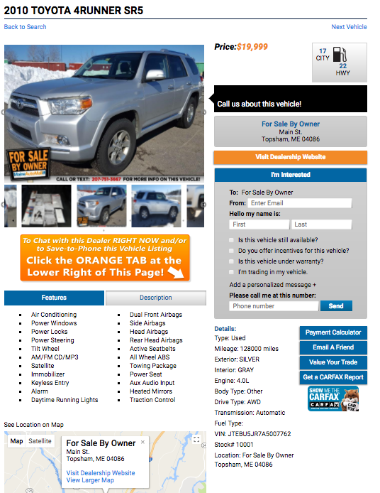What is the Kelley Blue Book value of this vehicle?

$ __________________

What are the positive aspects of this vehicle?

____________________

____________________

____________________

____________________

____________________

____________________

____________________

What are the negative aspects of this vehicle?

____________________

____________________

____________________

____________________

____________________

____________________

____________________

Should Ima B. Student purchase this vehicle? Why or why not?

______________________________________________________________________________

______________________________________________________________________________

______________________________________________________________________________

______________________________________________________________________________

______________________________________________________________________________

______________________________________________________________________________

______________________________________________________________________________

______________________________________________________________________________

**Part VII: Renting An Apartment**

Use the apartment ad below to answer the questions that follow.



What are the positive aspects of this apartment?

____________________

____________________

____________________

____________________

____________________

____________________

____________________

____________________

What are the negative aspects of this apartment?

____________________

____________________

____________________

____________________

____________________

____________________

____________________

____________________

Should Ima B. Student rent this apartment? Why or why not?

______________________________________________________________________________

______________________________________________________________________________

______________________________________________________________________________

______________________________________________________________________________

______________________________________________________________________________

______________________________________________________________________________

______________________________________________________________________________

______________________________________________________________________________