Modern European History
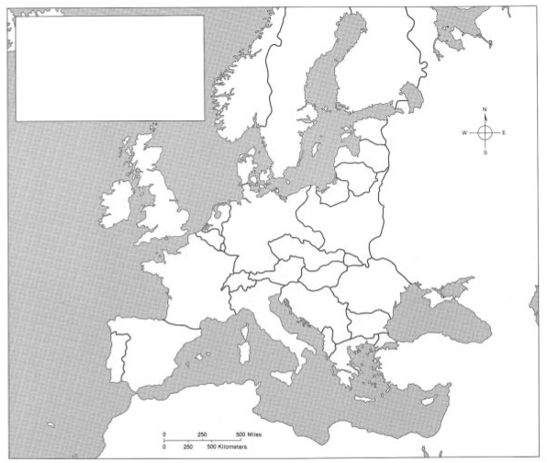
Unit 6 – Nation-Building and War
Europe After Versailles (1918) Map Activity
Europe After Versailles
(1918)

Label the Alsace-Lorraine region in BLACK and mark it with forward slashes [/////]

Label the Rhineland region in BLACK and mark it with backward slashes [\\\\\]

Label the following countries in BLACK and color each country a different color than those along their borders:

Austria
Czechoslovakia
East Prussia
Estonia
Finland
Hungary
Latvia
Lithuania
Luxembourg (Lux)
Poland
U.S.S.R.
Yugoslavia

