Twitter is a social media website and a “tweet” is an update made on the Twitter site. A tweet is a short message of 140 characters or less that describes whatever the author is doing at the moment, but can also contain personal messages, random thoughts, links to other tweets or websites, or anything of interest to the person who wrote it.

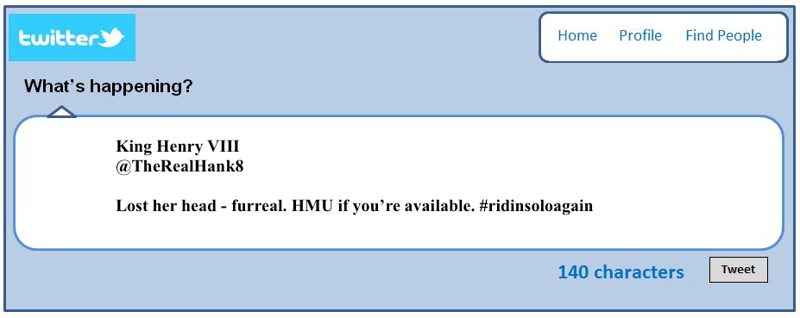
Here’s an example:

Choose a character from your Scientific Revolution reading, create an appropriate twitter name for them, and then write a tweet that could have been written by that character. You will be sharing these tweets with the rest of the class and we’ll be voting on the best name and tweet.

Feel free to make as many as you’d like – there are extra Tweet boxes on the back.

