Read and thoroughly annotate this handout.

The Scientific Revolution is associated with the various scientific and technological changes made during the sixteenth and seventeenth centuries, but it was also about changes in the way Europeans looked at themselves and their world.

Causes of the Scientific Revolution
In the Middle Ages, many educated Europeans took great interest in the world around them. However, these “natural philosophers,” as medieval scientists were known, did not make observations of the natural world. Instead they relied on a few ancient authorities - especially Aristotle - for their scientific knowledge. During the fifteenth and sixteenth centuries, a number of changes occurred that caused the natural philosophers to abandon their old views.

Renaissance humanists had mastered Greek as well as Latin. These language skills gave them access to newly discovered works by Archimedes and Plato. These writings made it obvious that some ancient thinkers had disagreed with Aristotle and other accepted authorities of the Middle Ages.

Other developments also encouraged new ways of thinking. Technical problems that required careful observation and accurate measurements, such as calculating the amount of weight that ships could hold, served to stimulate scientific activity. Then, too, the invention of new instruments, such as the telescope and microscope, made fresh scientific discoveries possible. Above all, the printing press helped spread new ideas quickly and easily.

Mathematics played a key role in the scientific achievements of the time. It was promoted in the Renaissance by the rediscovery of the works of ancient mathematicians. Moreover, mathematics was seen as the key to navigation, military science, and geography.

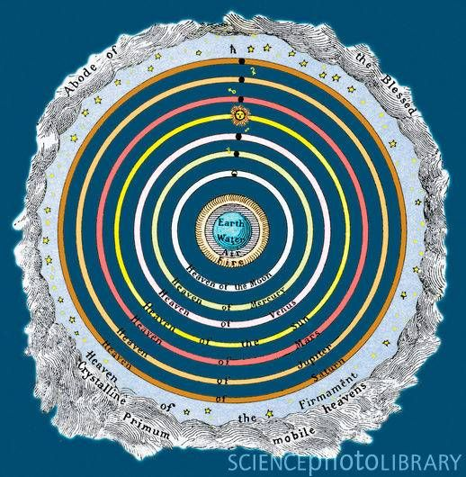
Renaissance thinkers also believed that mathematics was the key to understanding the nature of things in the universe. Nicolaus Copernicus, Johannes Kepler, Galileo Galilei, and Isaac Newton were all great mathematicians who believed that the secrets of nature were written in the language of mathematics. After studying and sometimes discarding the ideas of the ancient mathematicians, these intellectuals developed new theories that became the foundation of the Scientific Revolution.

Scientific Breakthroughs
During the Scientific Revolution, discoveries in astronomy led to a new conception of the universe. Breakthroughs advanced medical knowledge and launched the field of chemistry as well.

The Ptolemaic System
Ptolemy, who lived in the a.d. 100s, was the greatest astronomer of antiquity. Using Ptolemy’s ideas, as well as those of Aristotle and of Christianity, philosophers of the Middle Ages constructed a model of the universe known later as the Ptolemaic (TAH • luh • MAY • ihk) system. This system is geocentric because it places Earth at the center of the universe.

In the Ptolemaic system, the universe is seen as a series of concentric spheres - one inside the other. Earth is fixed, or motionless, at the center. The heavenly bodies - pure orbs of light - are embedded in the crystal-like, transparent spheres that rotate about Earth. The moon is embedded in the first sphere, Mercury in the second, Venus in the third, and the sun in the fourth. The rotation of the spheres makes these heavenly bodies rotate about Earth and move in relation to one another.

The tenth sphere in the Ptolemaic system is the “prime mover.” This sphere moves itself and gives motion to the other spheres. Beyond the tenth sphere is Heaven, where God resides. God was at one end of the universe, then, and humans were at the center.

Copernicus and Kepler
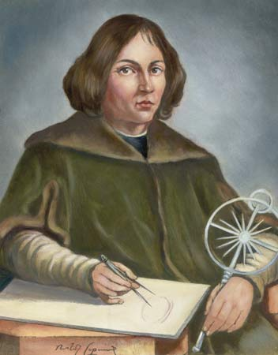
In May 1543, Nicolaus Copernicus, a native of Poland, published his famous book, On the Revolutions of the Heavenly Spheres. Copernicus, a mathematician, thought that his heliocentric, or sun-centered, conception of the universe offered a more accurate explanation than did the Ptolemaic system. In his system, the sun, not Earth, was at the center of the universe. The planets revolved around the sun. The moon, however, revolved around Earth. Moreover, according to Copernicus, the apparent movement of the sun around Earth was caused by the rotation of Earth on its axis and its journey around the sun.

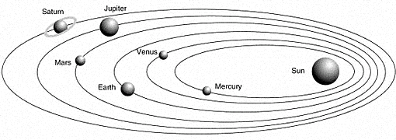
Johannes Kepler, a German mathematician, took the next step in destroying the Ptolemaic system. Kepler used detailed astronomical data to arrive at his laws of planetary motion. His observations confirmed that the sun was at the center of the universe and also added new information. In his first law, Kepler showed that the planets’ orbits around the sun were not circular, as Copernicus had thought. Rather, the orbits were elliptical (eggshaped), with the sun toward the end of the ellipse instead of at the center. This finding, known as Kepler’s First Law, contradicted the circular orbits and crystal-like spheres that were central to the Ptolemaic system.

Galileo’s Discoveries
Scientists could now think in terms of planets revolving around the sun in elliptical orbits. Important questions remained unanswered, however. Of what are the planets made? How does one explain motion in the universe? As the first European to make regular observations of the heavens using a telescope, Italian scientist and mathematician Galileo Galilei made a series of remarkable discoveries: mountains on Earth’s moon, four moons revolving around Jupiter, and sunspots. Galileo’s observations seemed to destroy another aspect of the Ptolemaic conception. Heavenly bodies had been seen as pure orbs of light. They now appeared to be composed of material substance, just as Earth was.

Galileo’s discoveries, published in The Starry Messenger in 1610, did more to make Europeans aware of the new view of the universe than did the works of Copernicus and Kepler. But in the midst of his newfound fame, Galileo found himself under suspicion by the Catholic Church. The Church ordered him to abandon the Copernican idea, which threatened the Church’s entire conception of the universe. In the Copernican view, humans were no longer at the center of the universe; God was no longer in a specific place.

In spite of the Church’s position, by the 1630s and 1640s, most astronomers had accepted the heliocentric idea of the universe. However, motion in the universe had not been explained. The ideas of Copernicus, Kepler, and Galileo had yet to be tied together.

Newton’s View of the Universe
Born in England in 1642, Isaac Newton attended Cambridge University where he later became a professor of mathematics. His major work was Mathematical Principles of Natural Philosophy, known simply as the Principia, from a shortened form of its Latin title.

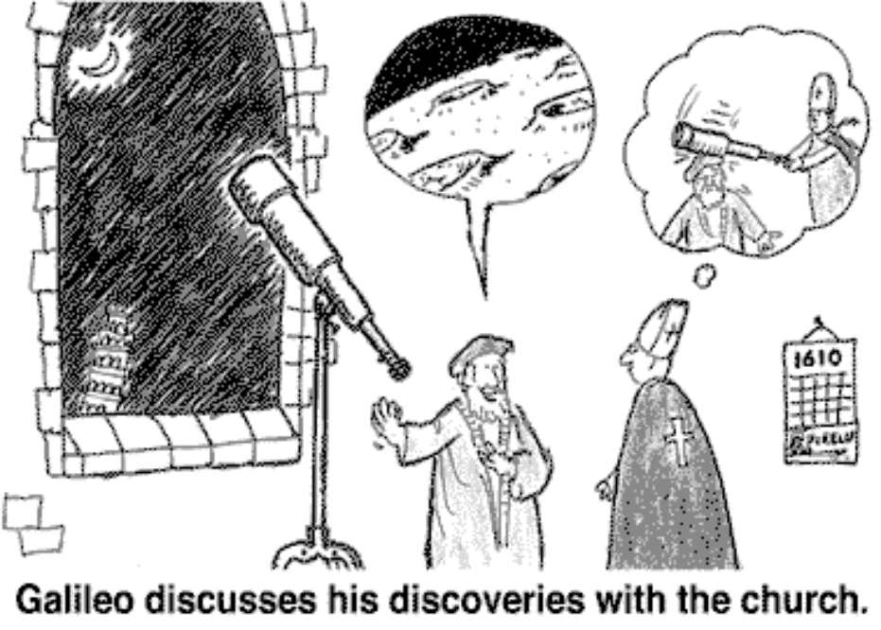
In the Principia, Newton defined the three laws of motion that govern the planetary bodies, as well as objects on Earth. Crucial to his whole argument was the universal law of gravitation. This law explains why the planetary bodies continue their elliptical orbits about the sun. The law states, in mathematical terms, that every object in the universe is attracted to every other object by a force called gravity. This one universal law, mathematically proved, could explain all motion in the universe.

Newton’s ideas created a new picture of the universe. It was now seen as one huge, regulated, uniform machine that worked according to natural laws. Newton’s concept dominated the modern worldview until Albert Einstein’s concept of relativity gave a new picture of the universe.

Breakthroughs in Medicine and Chemistry
The teachings of Galen, a Greek physician in the A.D. 100s, dominated medicine in the Late Middle Ages. Relying on animal rather than human dissection to picture human anatomy, Galen was wrong in many instances.
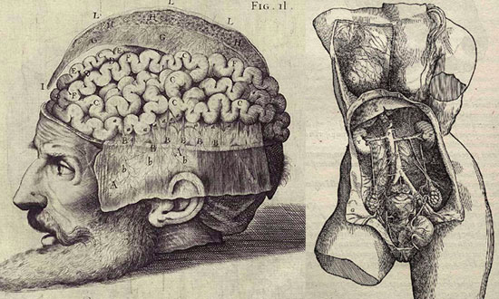
A revolution in medicine began in the sixteenth century. During this time Andreas Vesalius and William Harvey added to the understanding of human anatomy by dissecting human bodies at the University of Padua. Vesalius accurately described the individual organs and general structure of the human body. William Harvey showed that the heart - not the liver, as Galen had thought - was the beginning point for the circulation of blood. He also proved that the same blood flows through the veins and arteries and makes a complete circuit through the body.

The French scientist Blaise Pascal experimented with how liquids behaved under pressure. This led him to the principle known as Pascal’s Law. He applied this principle to the development of tools such as the syringe and the hydraulic press.

Robert Boyle was one of the first scientists to conduct controlled experiments in chemistry. His work on the properties of gases led to Boyle’s Law, which states that the volume of a gas varies with the pressure exerted on it. In the eighteenth century, Antoine Lavoisier invented a system for naming chemical elements still used today. Many people consider him the founder of modern chemistry.

Women’s Contributions
Although scholarship was once considered the exclusive domain of men, women also contributed to the Scientific Revolution. Margaret Cavendish came from an English aristocratic family and was tutored on subjects considered “suitable for girls of proper upbringing” - music, dancing, reading, and needlework. Although not formally educated in the sciences, Cavendish wrote a number of works on scientific matters, including Observations Upon Experimental Philosophy. In this work, Cavendish was especially critical of the growing belief that humans, through science, were the masters of nature. Cavendish published under her own name at a time many female writers had to publish anonymously. Her contribution to philosophy is widely recognized today; however, many intellectuals of the time did not take her work seriously.

In Germany, many women had the opportunity to become astronomers from working in family observatories where their fathers or husbands trained them. Between 1650 and 1710, women made up 14 percent of all German astronomers. The most famous female astronomer in Germany was Maria Winkelmann. She received training in astronomy from a self-taught astronomer. When she married Gottfried Kirch, Prussia’s foremost astronomer, she became his assistant and began to practice astronomy. Winkelmann made some original contributions to astronomy, including the discovery of a comet.

Descartes and Rationalism
New conceptions of the universe brought about by the Scientific Revolution strongly influenced the Western view of humankind. Nowhere is this more evident than in the work of the seventeenth-century French philosopher René Descartes (day • KAHRT), who brought a philosophical perspective to the natural sciences. He began by considering the doubt and uncertainty that seemed to be everywhere in the confusion of the seventeenth century. In his most famous work, Discourse on Method, written in 1637, Descartes decided to set aside all that he had learned and to begin again. One fact seemed to him to be beyond doubt - his own existence. Descartes emphasized the importance of his own mind, accepting only those things that his reason said were true. From his first principle – “I think, therefore I am” - Descartes used his reason to arrive at a second principle. He argued that because “the mind cannot be doubted but the body and material world can, the two must be radically different.”

From this idea came the principle of the separation of mind and matter (and of mind and body). Descartes’s idea that mind and matter were completely separate allowed scientists to view matter as dead or inert. That is, matter was something that was totally detached from the mind and that could be investigated independently by reason. Descartes has rightly been called the father of modern rationalism. This system of thought is based on the belief that reason is the chief source of knowledge, a philosophy that largely dominated Western thought until the twentieth century.

Bacon and the Scientific Method
During the Scientific Revolution, people became concerned about how they could best understand the physical world. The result was the creation of the scientific method - a systematic procedure for collecting and analyzing evidence. The scientific method was crucial to the evolution of science in the modern world.

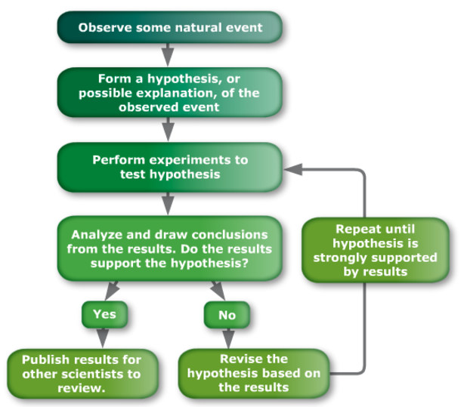
The person who developed the scientific method was not a scientist, but an English philosopher with few scientific credentials. Francis Bacon believed that scientists should not rely on the ideas of ancient authorities. Instead, they should learn about nature by using inductive reasoning - knowledge of the natural world should be achieved through observation and experimentation.

Before beginning this reasoning, scientists try to free their minds of opinions that might distort the truth. Then they start with detailed facts and proceed toward general principles. From observing natural events, scientists propose hypotheses, or possible explanations, for the events. Then systematic observations and carefully organized experiments to test the hypotheses would lead to correct general principles.

Bacon was clear about what he believed his scientific method could accomplish. He stated that “the true and lawful goal of the sciences is none other than this: that human life be endowed with new discoveries and powers.” He was much more concerned with practical matters than pure science. Bacon wanted science to benefit industry, agriculture, and trade. He said, “I am laboring to lay the foundation, not of any sect or doctrine, but of human utility and power.” Bacon believed this “human power” could be used to “conquer nature in action.” The control and domination of nature became an important concern of science and the technology that accompanied it.

