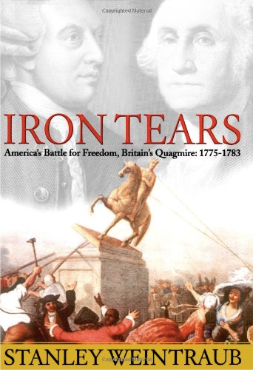
LIANE HANSEN, host:
This weekend, to mark the Fourth of July, Independence Day, festivities are scheduled in small towns and large to celebrate the American Colonies severing ties with the British crown. Seen through American eyes, the new nation's Founding Fathers were all noble, guided by lofty ideals. But through British eyes, events and people were, not surprisingly, seen quite differently. Historian Stanley Weintraub provides that perspective in his new book, "Iron Tears: America's Battle for Freedom, Britain's Quagmire, 1775-1783." When he spoke to us last week, he explained that the British felt the Colonies were indebted to them and should be more appreciative.

Professor STANLEY WEINTRAUB (Author, "Iron Tears"): They felt that the American colonists owed them a great deal for protection, for purveying their culture, for providing them with manufacturers. But what they didn't say is that they prevented manufacturers from being made in American Colonies themselves; they wanted to keep the economy dependent on England. So when the American Revolution actually began, there was no way to make gunpowder in America. There were no armories to make rifles or cannon; they had to import them or take them from the British. We were totally unprepared for war because the British made sure we weren't by making them dependent. And so the resentment in America was dependency.

HANSEN: Well, what about British Parliament? I mean, was everyone in agreement about how to deal with the American Colonies?

Prof. WEINTRAUB: No. The British Parliament was quite unrepresentative. The British Parliament largely was based on men who were elected from the small towns and farmlands and not from the burgeoning big cities that were growing up with the Industrial Revolution. So Manchester or Birmingham didn't have any seats in Parliament, and the British said, `Why are you complaining, you in America? The same thing's true over here. We're not representative, but we're happy.'

HANSEN: Hmm. How important, though, were the Colonies to Britain?

Prof. WEINTRAUB: They were very important as a source of raw materials, particularly agricultural materials and tobacco. But the Colonies were also important as a source of pride. We think in terms of `the jewel in the crown' applied to India, but that term was really first applied to the American Colonies. They were the jewel in the king's crown.

HANSEN: So you have this deep resentment growing on both sides, on the British side and on the American side, and the protests against the taxes were beginning to grow. Did the view begin to change? Did the resentment begin to build?

Prof. WEINTRAUB: The resentment built on the part of the patriots, patriots who were really extremists, largely in the Northeast, like Massachusetts. And when the Tea Party occurred and the bales of tea were thrown overboard, Benjamin Franklin actually said, `This was an act of piracy and the Americans should repay the British for the tea.' So it took a long time before people we consider the super patriots of the country to get around to the extreme view of separation.

HANSEN: Let's go to April 19th, 1775; British troops firing on American militia at Lexington and Concord. The idea of going to war--Did all the Britons think that going to war with America was a good idea?

Prof. WEINTRAUB: They were very surprised when we went to war. They were surprised especially when they lost.

(Soundbite of laughter)

HANSEN: But were--well, they were surprised when it actually started.

Prof. WEINTRAUB: When it started. They weren't prepared for it, and they hadn't realized that the American militias that were building up at the time, particularly in places like Virginia and in Massachusetts, were armed. They were armed largely because they had hunting rifles. They had very little sources of ammunition. And the British at Bunker Hill lost a lot of men, and it took so long before the news got to England--the patriots were very shrewd. They rushed the news and newspapers to England faster than the British could send their official communiques. And so the American spin, the patriots' spin on the war, affected England before the government could put its own spin on the war.

HANSEN: So how did the British public first react to the idea of war with...

Prof. WEINTRAUB: They reacted with shock, especially with the casualties that came across. And they reacted with shock when they realized that their taxes would have to go up. They couldn't get taxation out of America. And not only did their taxes go up, their taxes were on every little thing one could imagine. Not merely tea or stamps or newspapers, but even rabbit hair for women's hats was taxed. Ink, paper, all kinds of things were taxed. And these were nuisance taxes because the British didn't want to raise the property tax, but eventually they had to do that, too. And so the war was largely unpopular because it was an economic dent in the British.
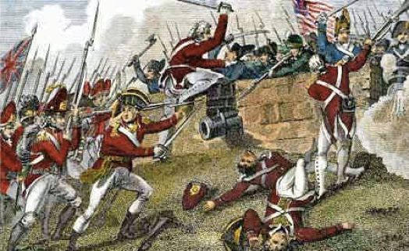
HANSEN: So in talking about the execution of the war, was Britain's heart really in it?

Prof. WEINTRAUB: Not the heart of the merchants. The merchants were very hostile to the war. This was the radical center of the war because the businessmen were taking a big hit. They wanted the trade to continue, and there was no trade.

HANSEN: Hmm. So ultimately, why do you think Britain lost the war?

Prof. WEINTRAUB: Britain lost the war because General Washington had two other generals on his side. One was `General Demography,' population. The population was burgeoning. And the other general that Washington had on his side was `General Atlantic,' that is Atlantic Ocean. It took two and a half months to cross the Atlantic by sail against the wind. By the time the Donald Rumsfeld of that war, the secretary for America, Lord George Germaine, sent his orders across to America 3,000 miles away, it was too late; the orders were moot. Things had changed. It took two and a half months. So General Atlantic, meaning `General Distance,' and `General Demography,' meaning population, were really generals who aided Washington tremendously.

HANSEN: Why was it important for you to present the Revolutionary War from the British point of view?

Prof. WEINTRAUB: The losers seldom ever write the history. We've always had flag-waving histories. And it's nice to have flag-waving histories, but I think we needed some balance to see what the war was like from the lens of the British. How did they see it? How did they take to it?

Copyright © 2005 NPR. All rights reserved. No quotes from the materials contained herein may be used in any media without attribution to NPR. This transcript is provided for personal, noncommercial use only, pursuant to our Terms of Use.

