Show Your School Spirit – DRESS UP TO WIN!

During Winter Carnival week your period 1-2 teacher will count the number of students from each grade dressed up according to that day’s theme – the class with the greatest participation wins points toward their total for Winter Carnival!

Winter Carnival Dress-Up Days
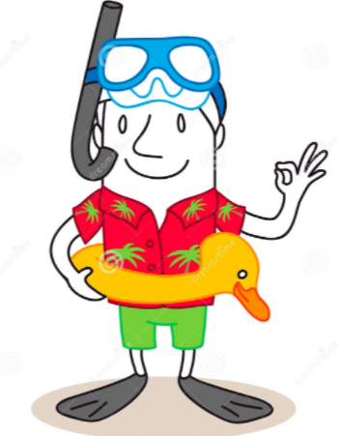
Monday: Hawaiian Day (beachwear, grass skirts, etc.)
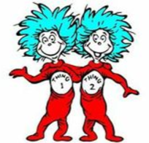
February 13th

Tuesday: Twin Day Tuesday
February 14th

Wednesday: Class Color Day
February 15th (9: yellow; 10: green; 11: red; 12: blue; faculty: white)
Thursday: Jersday (sports jersey)
February 16th

Friday: Black and Orange Day
February 17th

