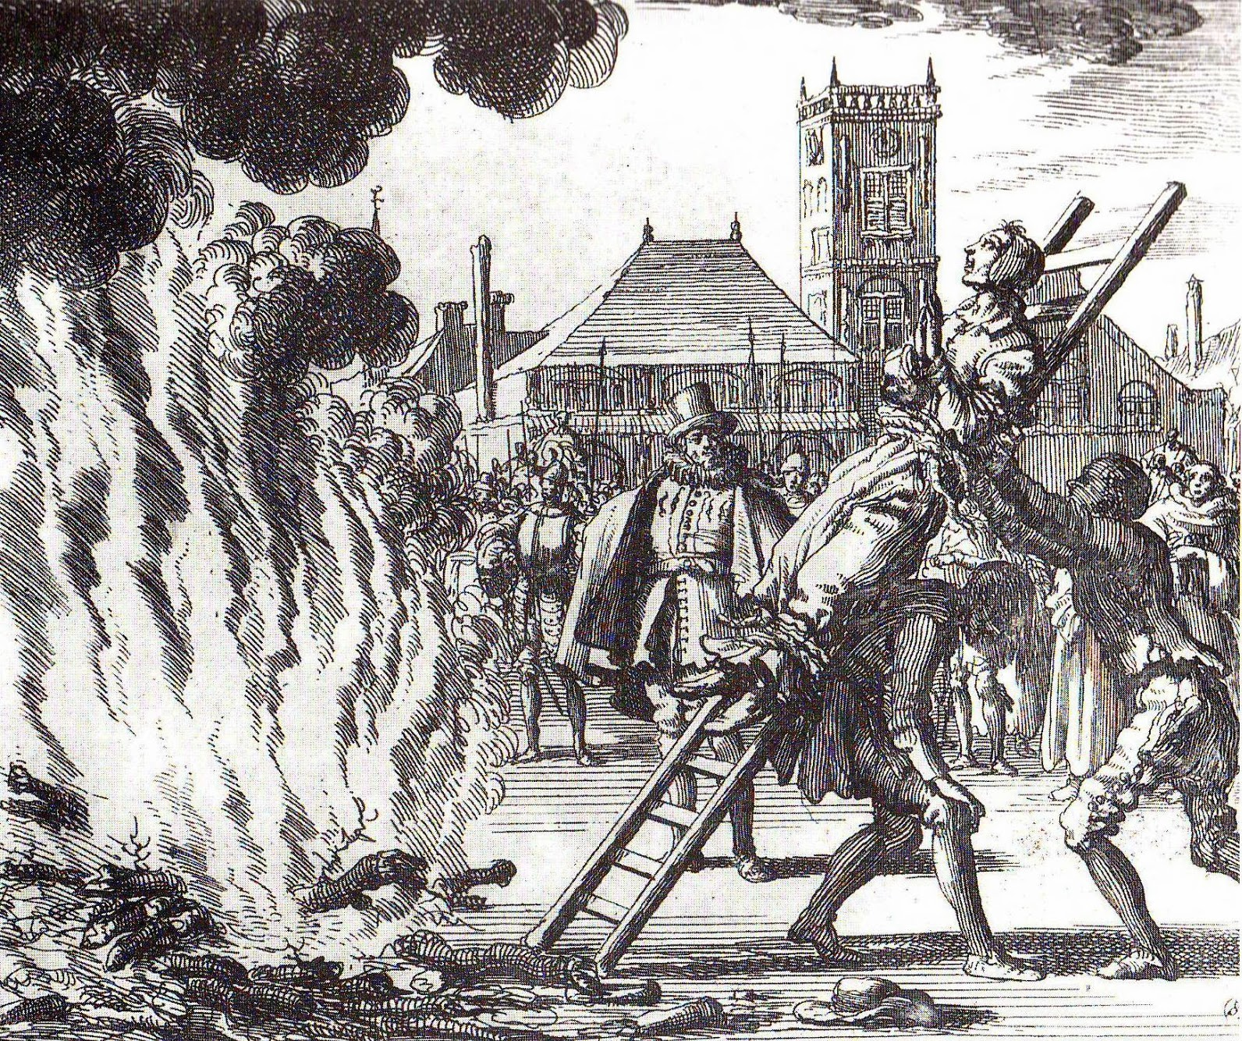

The Roman Inquisition was a system of tribunals developed by the Roman Catholic Church during the second half of the 16th century, responsible for prosecuting individuals accused of a wide array of crimes relating to religious doctrine or alternate religious doctrine or alternate religious beliefs.

