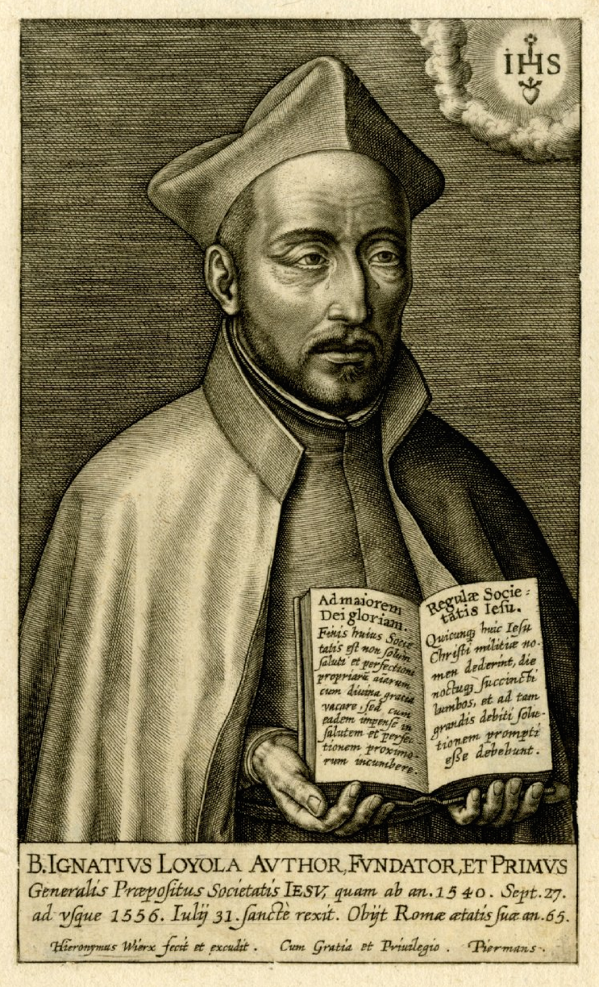

Portrait of Saint Ignatius of Loyola, head and shoulders, wearing the Jesuit habit and holding an open book with the rules of the Society; tears running down his face; the emblem of Jesus seen top right. Engraving.

