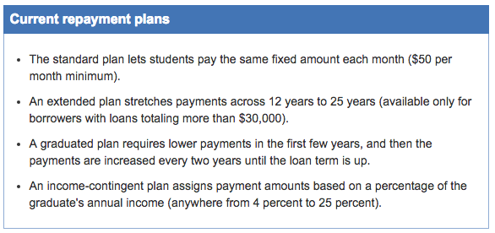

Ten years is the standard repayment period for a student loan, but that doesn’t mean you have to make equal payments every month for all 10 years. The federal government currently offers four basic types of repayment plans:

But how much can you afford to pay each month? That depends on how much money you make:

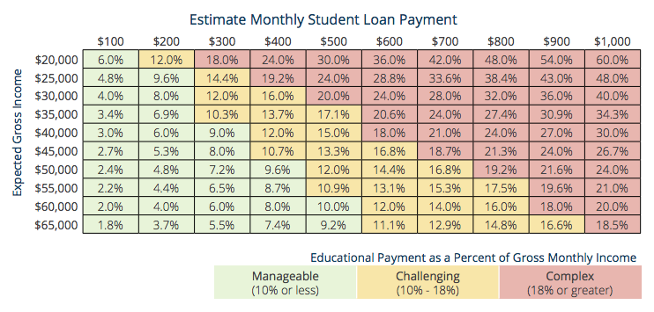
So how long will it take to pay off your student loan? Again, it depends on your income, the loan interest rate, and the minimum payment required by your lender.

Go to http://www.finaid.org/calculators/loanpayments.phtml to access a loan payment calculator

At the bottom of the page Use this information to determine your interest rate:
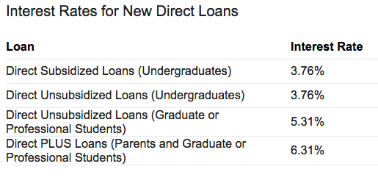
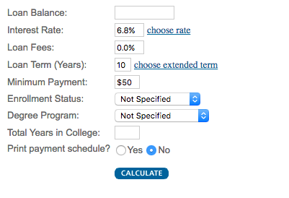
you will see this:

Input the loan amount for the two institutions you identified on your Comparing Colleges exercise from last class and copy the necessary information into the spaces below:

Name of Institution #1
from “Comparing Colleges” exercise
Loan Balance (total $ you would borrow): | $
Loan Interest Rate: | $
Loan Term (how long you have to pay it): | $
Monthly loan payment: | $
Number of payments: | $
Cumulative payments: | $
Total interest paid: | $

Name of Institution #2
from “Comparing Colleges” exercise
Loan Balance (total $ you would borrow): | $
Loan Interest Rate: | $
Loan Term (how long you have to pay it): | $
Monthly loan payment: | $
Number of payments: | $
Cumulative payments: | $
Total interest paid: | $

