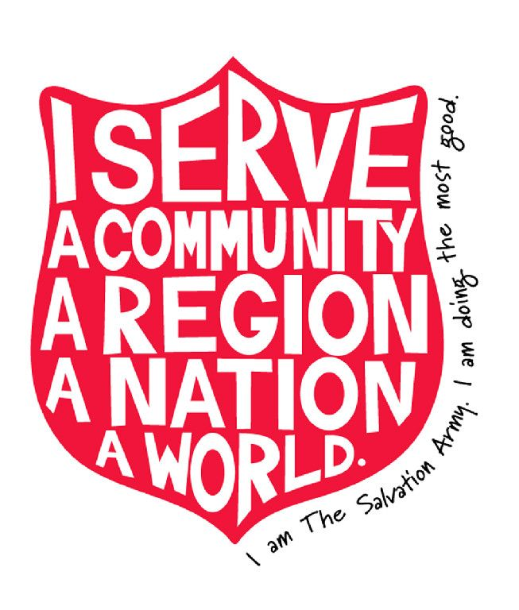

Salvation Army Field Trip
(Brunswick)
Friday, February 10th, 2017

On Friday, February 10th, BHS Economic Skills students will have the opportunity to participate in a field trip to the Salvation Army Retail Store on Pleasant Street in Brunswick. The assignment students will be required to complete while there is choosing one interview-appropriate outfit - to show them that they can find suitable interview clothing without breaking the bank. Students are not required to actually purchase the clothing but may do so with their own funds - and the Salvation Army has generously offered to donate clothing to any student in need of financial assistance.

Students will only be gone during our regular class period. We will leave at 7:45AM and travel via school bus from BHS to the store on Pleasant Street, returning to the school in time for Period 3-4.

Itinerary

7:45 AM Depart Brunswick High School

7:55AM Arrive Pleasant Street Salvation Army

9:00AM Leave Salvation Army

9:10AM Arrive back at BHS

__________________________________ has my permission to participate in
Student’s Name the BHS field trip to the Salvation
Army in Brunswick.

________________________________ ______________________________
Parent/Guardian Name Parent/Guardian Signature

