Fill out the worksheet form below with the information you will need to complete your resume.

Take Note: you are creating this resume as though you have completed your post-secondary education and training and are applying for your first job in your career area.

Heading
Name:__________________________________________________________________

Current Address:__________________________________________________________

City:_____________________________ State:______________ ZIP:________

Home (or Cell) Phone:_________________________ Email Address:__________________________

Career Objective
There are several different objective formats that you could choose (or combine).

Focus on the kind of position you want.

Example: Seeking a full-time position as an Administrative Assistant.

Seeking a position as a ________________________________.

Focus on the field or industry in which you are interested in working.

Example: Seeking an entry-level position in the Healthcare field.

Seeking a position in the ________________________________ field.

Focus on your skills/abilities.

Example: Seeking a position that will utilize my communication, data-entry skills, and my strong work ethic.

Seeking a position that will utilize my ________________________________,

________________________________, and ________________________________, skills.

Education
You usually omit your high school information once you finish your post-secondary education because it is assumed you completed high school or obtained your GED.

Name of post-secondary institution: ________________________________________________

City and State of school: _________________________________________________________

Program of Study/Major/Minor: ___________________________________

Expected Graduation Date: ___________________________________
Work Experience
Name and city/state of company:______________________________________________

Job Title:________________________________________________________________

Date From: (Mo/YR)________________ Date To: (Mo/YR):____________________

Description of responsibilities and accomplishments (Write your experiences in bullet statements):

Example: Responsible for sorting 1,000 small packages each hour of operation.

• ________________________________________________________________________

• ________________________________________________________________________

• ________________________________________________________________________

Repeat this step as necessary to include all relevant work experience.

Activities
List full name of organization, include dates, and include offices/positions you held (if applicable).

Example: Norton’s Suburban Hospital, Volunteer, Summer 2003

______________________________________________________________________________

Now you will create a Google Doc Resume using this information.

Sign into your school Google Docs account.
If you’re in Google Drive, click on the icon in the upper right corner that looks like this:
Pull down to “Docs.”

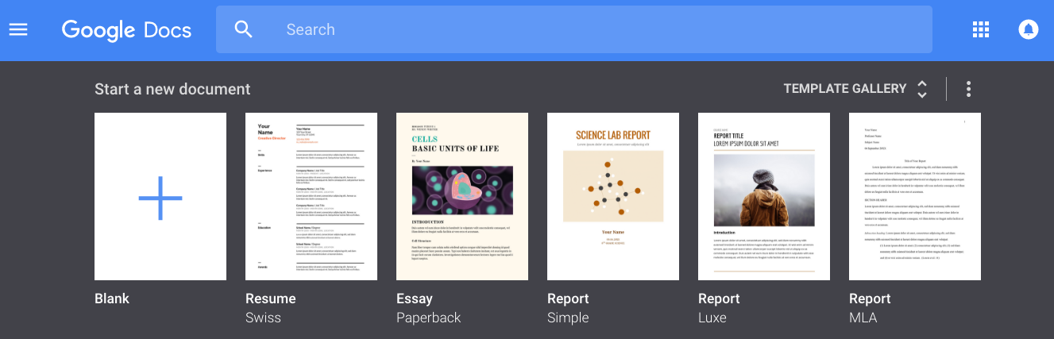
Once you’re in Google Docs you should see this menu:

Click on “Resume” and choose the format you would like to use.

Type the info from this worksheet into your resume.

