Saving for Post-Secondary Education
The cost of obtaining education after high school can be quite high. When considering the total cost of attendance and the continued rising price of tuition and fees, covering the entire cost in advance can seem impossible. There are, however, many ways that students and their families can finance future education. Preparing now to cover these future expenses is a smart move, and there are programs available that can help you leverage your education savings.

One option to consider is an education IRA or a 529 account. These types of savings plans can be started when a child is born, with the funds available for withdrawal when the child is ready for post-secondary education. These accounts build wealth over time, much like retirement savings accounts, and rely on compounded interest to grow the principle investment. There are also significant tax benefits associated with these plans. While contributions are not deductible, distributions used to pay for post-secondary education can be withdrawn without any federal taxes on the earnings. There may be tax benefits at the state level as well, depending on where you live.

Another avenue to consider is tuition pre-payment programs. By purchasing tuition credits, parents can pay for post-secondary education tuition while a child is still young. The advantage to this type of purchase is that one can avoid the annual increase in tuition costs between now and when one’s child goes on to post-secondary education.

Scholarships
Students should also consider applying for scholarships. There are a wide range of scholarships awarded each year from all types of public and private groups. Some are based on academic performance in school along with scores on tests such as the ACT or SAT. Other scholarships are awarded based on involvement in certain activities, majoring in specific types of studies, financial need, and a range of other criteria. Many require that recipients maintain a certain level of academic performance while in post-secondary education.

There are a number of websites dedicated to helping students locate and secure scholarships as well as assisting with completing scholarship applications. Since scholarships are awards that generally do not have to be repaid, applying for this “free money” is usually time well spent.

Students who may be interested in the military and also in obtaining a post-secondary education education may consider exploring the Reserve Officers’ Training Corps (ROTC) program. This program provides a career path into the military while paying a student’s post-secondary education tuition. The training provided by this program does obligate students to serve as reservists for up to 8 years and can include deployment to active duty.

Another route to consider is enlistment in the armed forces. Completing successful military service offers the opportunity to obtain job training in many different areas while serving one’s country. In addition, individuals who have served in the armed forces and completed their enlistment can access additional educational programs and opportunities through the Department of Veterans Affairs. These programs assist veterans with paying for many types of post-secondary education in return for their active military service.

Financial Aid Basics
Even with savings and scholarships, most students will still need additional resources to complete their post-secondary education. This is typically referred to as financial aid. Understanding how to navigate the world of post-secondary education financial aid can give students additional resources for financing their education. Once you are on the road to saving and are exploring scholarship opportunities, the next step will be to complete the FAFSA, or Free Application for Federal Student Aid. This aid is awarded based on financial need, and financial information related to both the student and parents is considered when determining the level of need. This level of need is reported in a letter called a Student Aid Report. The report provides your EFC, or Estimated Family Contribution, and this data is used by schools to determine what aid the student qualifies to receive. Submitting the FAFSA application is critical to receiving financial aid, and all required data and due dates must be followed in order to receive aid.

Grants and Work-Study
After completing all of the required financial aid applications, you will receive an award letter. In it, you will learn what kinds of financial support can be offered to you by each school. If you are considering more than one institution, it is important to compare the offers before deciding which school to attend. Aid is awarded in three main categories: grants, loans, and work-study.

Some students will receive a grant as part of the aid package. Since this money does not have to be repaid, it is an excellent way to pay for post-secondary education expenses. A Pell Grant can be awarded for up to $5,815 (2016-2017 limit), but awards vary depending on need, the cost of the school attended, and whether or not a student attends full or part-time. A student can receive a Pell Grant for up to 12 semesters (6 years) worth of undergraduate study. This money is typically applied first to the cost of tuition and fees and then to room and board for students who live on campus.

Completing the FAFSA and submitting it early can be especially beneficial for students with a high need for financial assistance. Each year, schools receive a set amount of funds to distribute as Supplemental Educational Opportunity Grants. These grants of $100 to $4,000 per year are awarded on a first-come, first-serve basis to the students with demonstrated need.

Work-study is another part of many students’ financial aid packages. Part-time jobs are provided for students at the school, at a public agency, or at a not-for- profit organization. Students are paid the federal minimum wage for the hours worked, and this money is paid directly to the student. These funds can be used to pay for post-secondary education tuition or living expenses.

Loans
Even with grants and work study, there is often additional funding needed to cover post-secondary education expenses. This is where student loans become part of the equation. Within an award letter, there are a number of different loan options that can be provided. Most student loans offer low interest rates, a grace period, and deferred payment options for repaying the amount borrowed. This allows students to borrow money for education without worrying about paying it back while they are still in school. The most popular loans for students are the Perkins Loan and the Stafford Loan. Perkins Loans are awarded based on need with a limit of $5,500 (2016-2017) annually. The interest rate on these loans is 5%, and borrowers have 10 years to pay back the amount borrowed. Stafford Loans have a higher interest rate of 6.8% and require you to begin repayment 6 months after graduating or dropping below a half-time student. Borrowers generally have 10 years to repay this loan.

If financial need still remains after grants, work-study and loans have been awarded, a Parent Loan for Undergraduate Students (PLUS) can be considered. At a rate of 7.9% interest, this is a more expensive post-secondary education loan and it is taken by the student’s parents, making them liable for repayment of the funds. The maximum amount of this loan is equal to the total estimated cost of attendance minus all other nancial aid that has been o ered. Repayment of the loan is expected to begin when the funds are disbursed, but loan recipients can make deferred payments if requested and approved.

How Post-Secondary Education Loans Work
For many students, taking out a loan is a way to cover the cost of post-secondary education, but when you take out a post-secondary education loan, you borrow money and have to repay it. You also have to pay interest, or a charge for borrowing the money that is usually a percentage of the loan that is added to the amount you borrow. Different types of loans have different interest rates; the lower the interest rate, the less money you pay. Some federal loans let you defer - or delay - paying the loan back until after you graduate. Repaying the loan will cost you more money, but in exchange, you’ll get a post-secondary education education.

Types of Loans
Federal and state governments, post-secondary education institutions, and private organizations all provide post-secondary education loans to students and parents.

Need-Based Loans
Aid that is need-based is awarded to students who are determined to have financial need; that is, the amount they are able to pay for post-secondary education is less than the cost of attending the post-secondary education institution. The federal government offers need-based loans to students.*

Perkins Loans are federal need-based loans given out by post-secondary education institutions to students with the highest need.

Direct Subsidized Loans are federal need-based loans that are interest-free while you're in the process of obtaining your post-secondary education and have a borrowing limit that increases for each year of school you complete.

The federal government's Perkins Loan and the Direct Subsidized Loan are need-based loans that may be offered to eligible students. Federal need-based loans are often the best choices for the following reasons:
The government subsidizes the loan (paying the interest fees while you’re in school).
These loans often provide low interest rates.
They allow you to defer repayment until you’re out of school and, hopefully, earning an income.
They don’t require a credit check.
They may provide better benefits than private loans.

Non-Need-Based Loans
Federal Direct Unsubsidized Loans charge interest, but allow you to wait until after graduation to add the interest fees to the amount you borrow. However, doing this means you’ll actually end up owing more.

Federal Direct PLUS Loans allow parents (or graduate students) to borrow the total cost of post-secondary education, minus any financial aid received.

State Loans
Post-secondary education loans may be available from your state; check the U.S. Department of Education's list of state higher-education agencies (available online).

Private Loans
In general, private loans are not subsidized or need-based. They also often require a cosigner, or someone who promises to repay the money if the student fails to do so. The interest rates of private loans vary:
banks and other financial institutions usually have the highest interest rates.
some private organizations and foundations offer lower interest rates.
some post-secondary education institutions offer loans with relatively low interest rates.

Some private loans might offer relatively low interest rates, but their other terms might not be as favorable as those of a federal loan. For example, federal loans generally offer flexible terms - if you don't have a job or become disabled, you might be able to adjust your payments - while private loans may not be as flexible.

* Eligibility for these loans is determined by the Free Application for Federal Student Aid (FAFSA).
Loan Breakdown

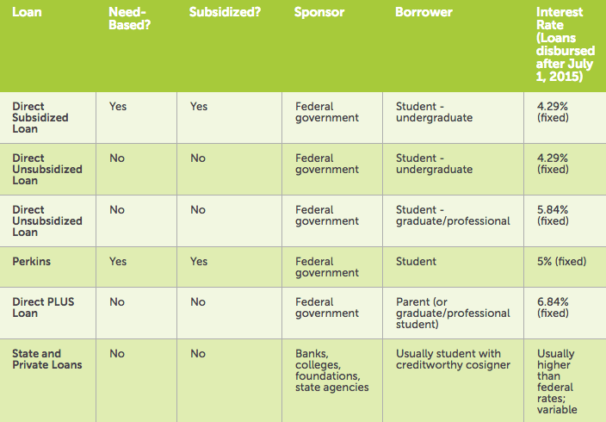

The chart below shows the annual and aggregate limits for subsidized and unsubsidized loans:

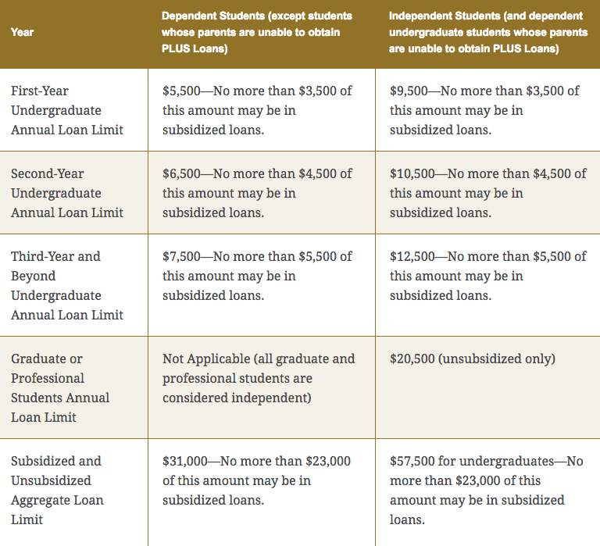

Adapted and revised from “Types of College Loans,” CollegeBoard.com. Accessed on 9/2/16. https://bigfuture.collegeboard.org/pay-for-post-secondary education institution/loans/types-of-post-secondary education institution-loans.

