Modern European History
Museum of Fine Arts Field Trip Activity
Friday, October 21st, 2016

The exercises that follow direct you to examine specific pieces of Medieval and Renaissance art as well as additional artwork of your choice. In order too get a real feel for the art of each era and to help you complete all parts of this assignment, please view additional items in the galleries specified in the assignment.

The following pieces of art are listed by artist and title. Go to the artwork, take a good long look, and then answer the questions.

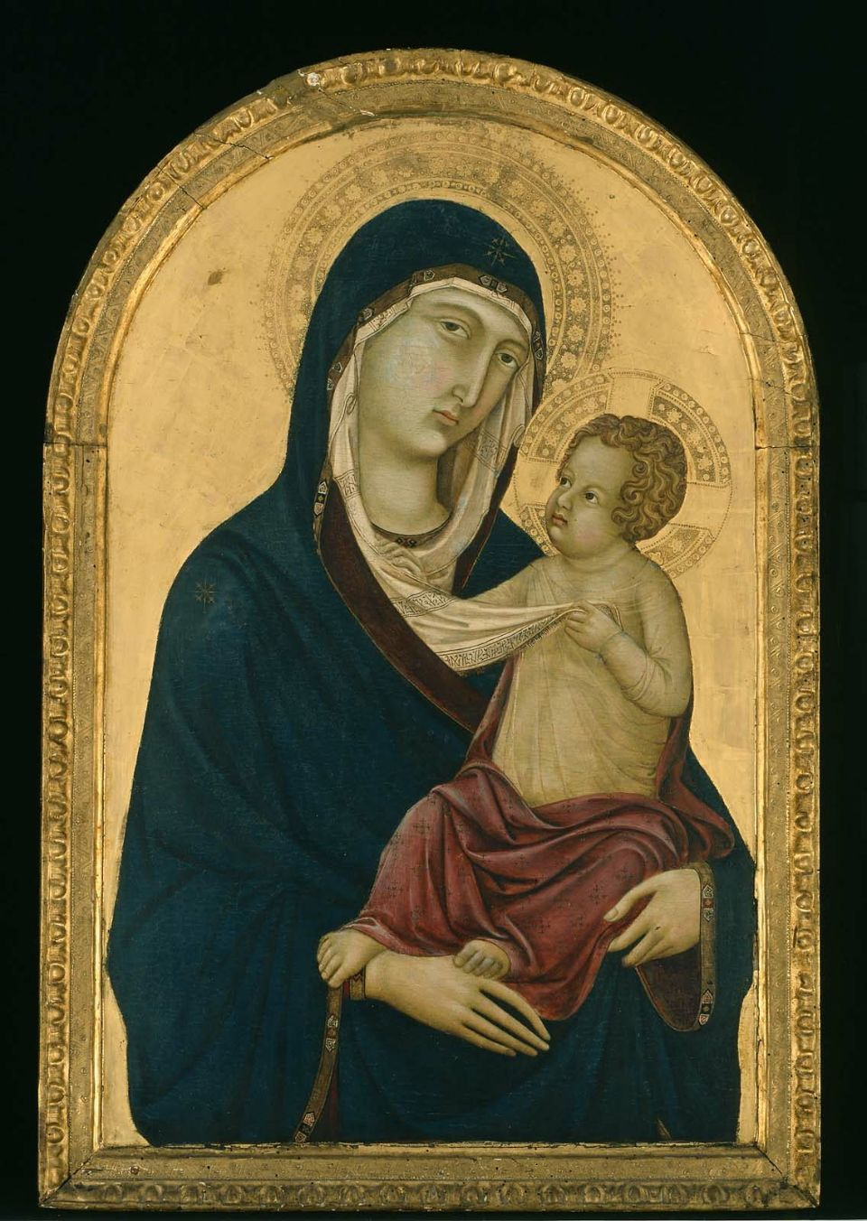
Ugolino di Nerio, Italian (Sienese), active in 1317–1339
Virgin and Child
about 1325–30
Tempera on panel
81.4 x 52.1 cm (32 1/16 x 20 1/2 in.)
16.65

What do you see in this painting that identifies it as being from the Medieval period?

Choose another piece of art from this gallery and describe or sketch it in the space below. Identify the reason behind your choice.

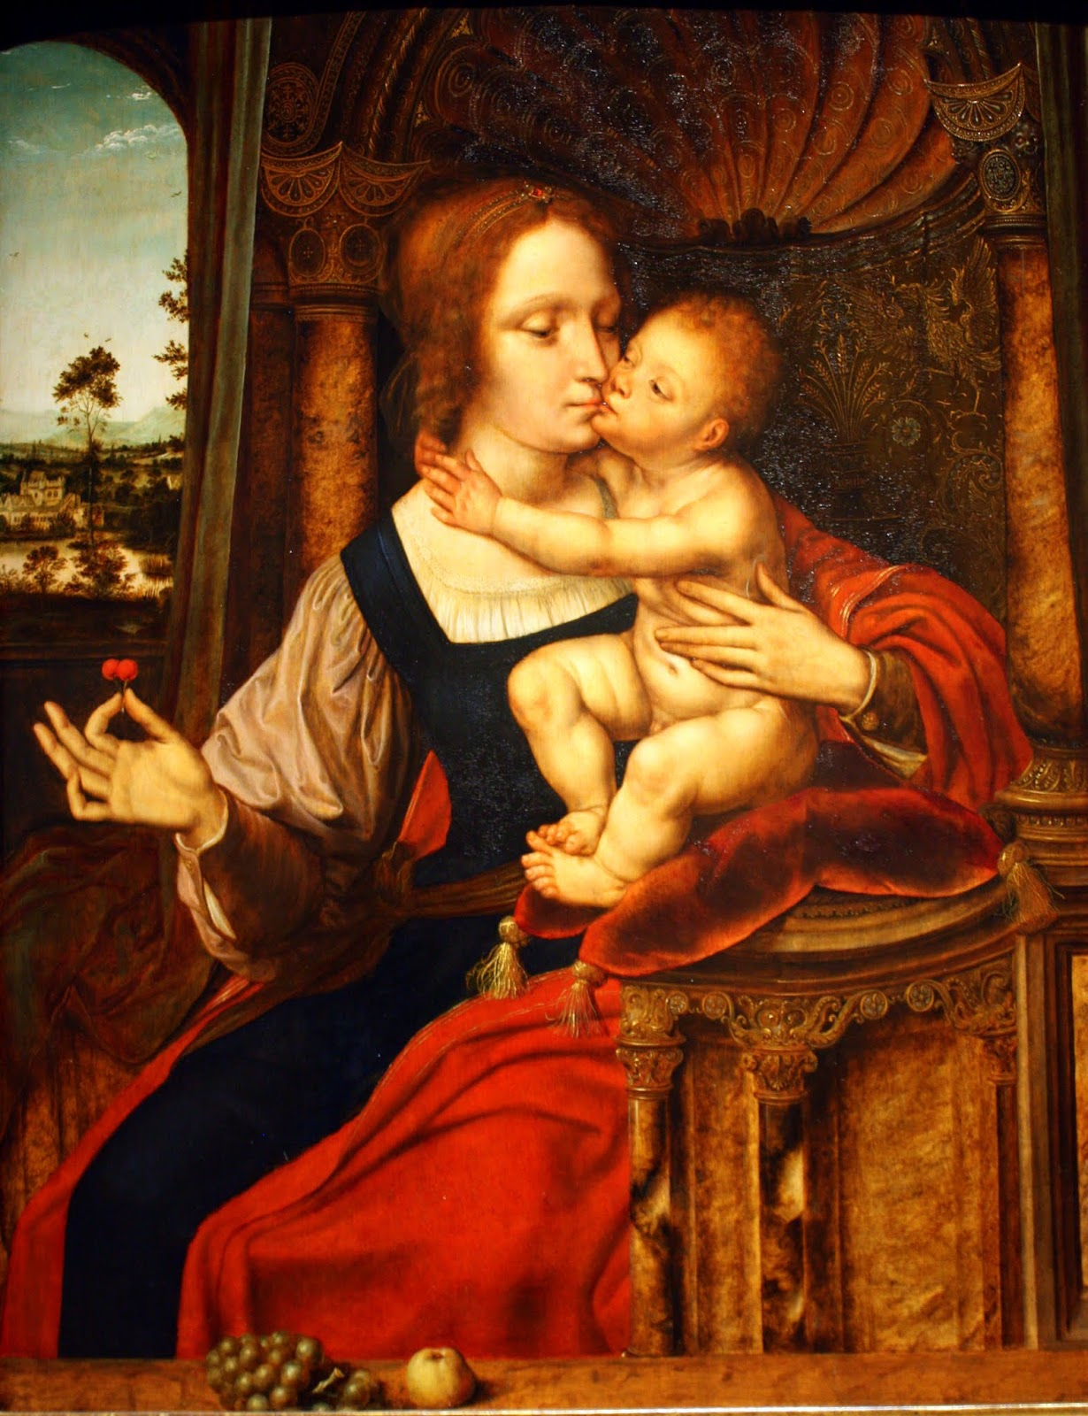
Quentin Massys (Netherlandish, 1466–1530)
Virgin and Child (Madonna of the Cherries)
Oil on panel
Overall (panel only): 75.9 x 62.9 cm
69.2009

What artistic devices does the artist use draw your attention to specific parts of this painting, and what are the sections you are drawn to?

Choose another piece of art from this gallery and describe or sketch it in the space below. Identify the reason behind your choice.

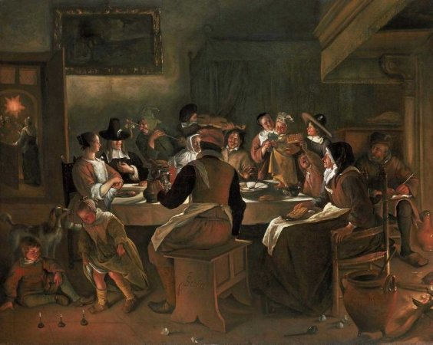
Jan Havicksz. Steen (Dutch, 1626–1679)
Twelfth-Night Feast
1662
Oil on canvas
Overall: 131.1 x 164.5cm (51 5/8 x 64 3/4in.)
54.102

What artistic styles used in this painting make it an accurate representation of Northern Renaissance Art?

Choose another piece of art from this gallery and describe or sketch it in the space below. Identify the reason behind your choice.

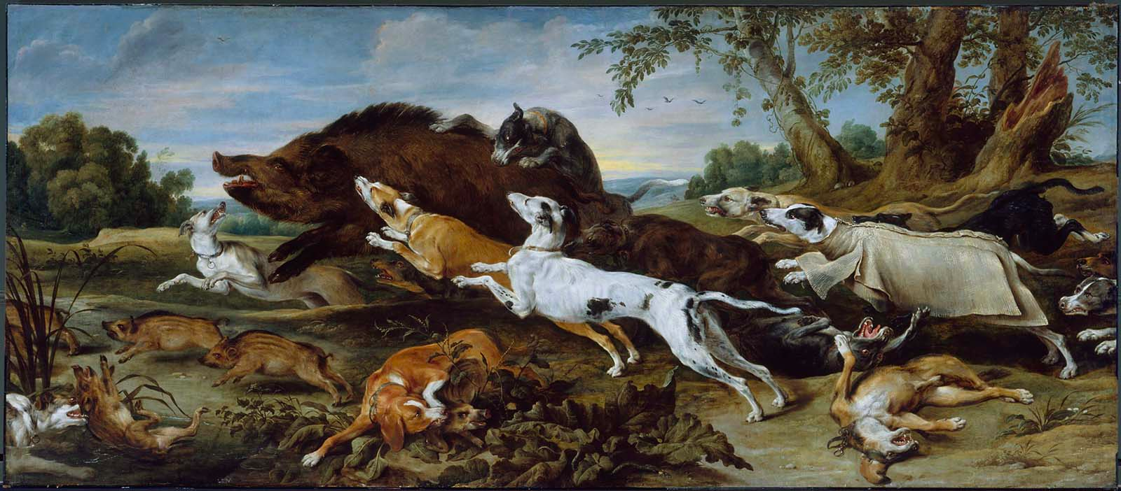

Frans Snyders (Flemish, 1579–1657)
Boar Hunt
about 1625–30
Oil on canvas
220.6 x 505.1 cm (86 7/8 x 198 7/8 in.)
17.322

This late-Renaissance era work is evidence of the shift in focus and form in painting. What are these changes, as evident in this piece?

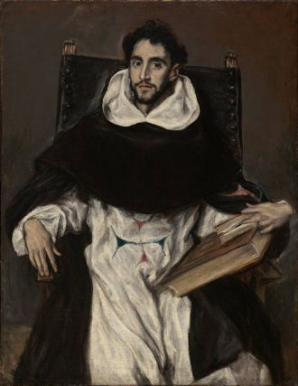
El Greco (Domenikos Theotokopoulos) (Greek (active in Spain), 1541–1614)
Fray Hortensio Félix Paravicino
1609
Oil on canvas
Overall: 112.1 x 86.1cm (44 1/8 x 33 7/8in.)
04.234

How does this portrait differ from those of other Renaissance-era artists? Use the artistic methods we discussed in class in your answer.

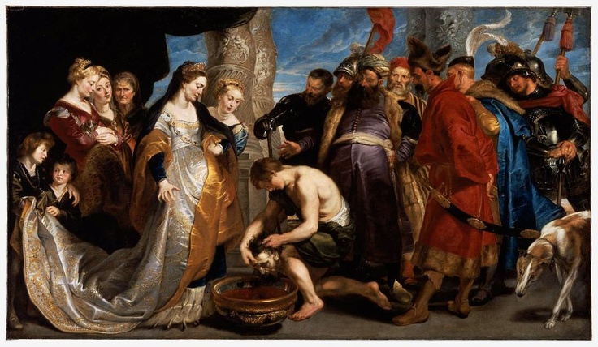
Peter Paul Rubens (Flemish, 1577–1640)
Head of Cyrus Brought to Queen Tomyris
about 1622–23
Oil on canvas
205.1 x 361 cm (80 3/4 x 142 1/8 in.)
41.40

What is the story behind this painting? Read the placard and describe the scene both in terms of the tale it tells and the artistic methods used in its presentation.

Choose another piece of art from this gallery and describe or sketch it in the space below. Identify the reason behind your choice.

Sandro Botticelli (Italian (Florentine), 1444 or 1445–1510)
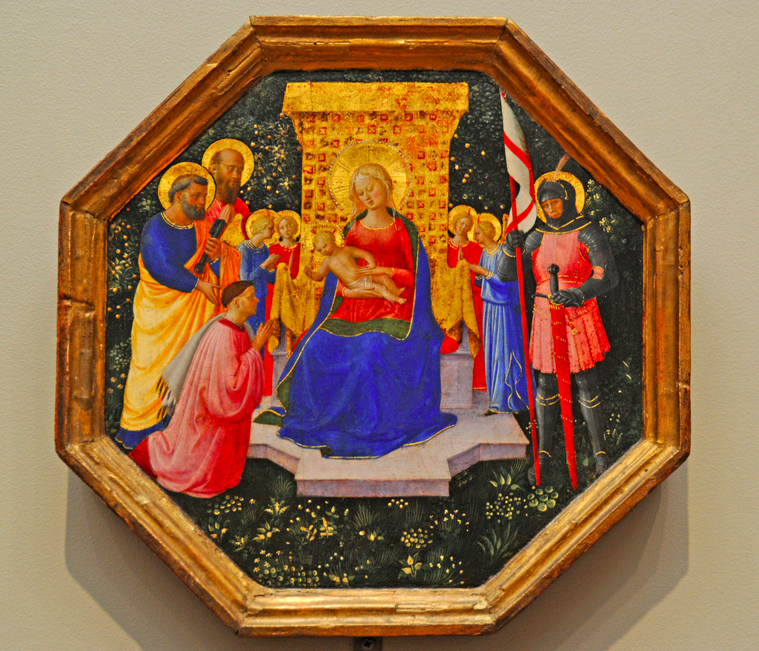
Virgin and Child with Saint John the Baptist
about 1500
Tempera on panel
123.8 x 84.4 cm (48 3/4 x 33 1/4 in.)
95.1372
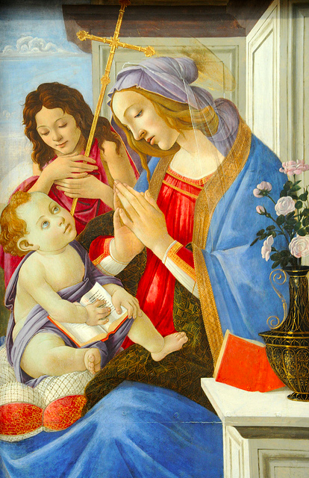

Fra Angelico (Italian (Florentine), about 1395/1400–1455)
Virgin and Child Enthroned with Saints Peter, Paul and George (?), Four Angels, and a Donor about 1446–49
Tempera on panel
24.9 x 24.8 cm (9 13/16 x 9 3/4 in.)
103. 14.416
These two paintings are famous for their trademark early-Renaissance style. Identify their similarities and differences, noting why you think each exists.

Choose another piece of art from this gallery and describe or sketch it in the space below. Identify the reason behind your choice.

You and your group can now explore the rest of the museum for the rest of our visit. There are many important and/or famous artists from all over the world and throughout history on display throughout the museum, such as Rembrandt, Paul Gauguin, Monet, Manet, Renoir, Degas, Monet, Van Gogh, Cézanne, John Singleton Copley, Winslow Homer, John Singer Sargent, Gilbert Stuart, John James Audubon, Mary Cassatt, etc. Choose your favorite art piece from somewhere else in the museum and describe and/or sketch it in the space below.

