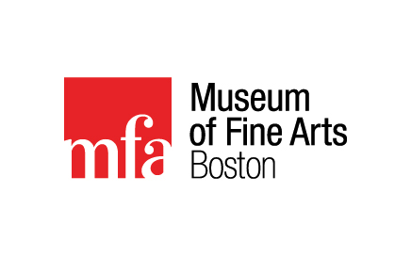
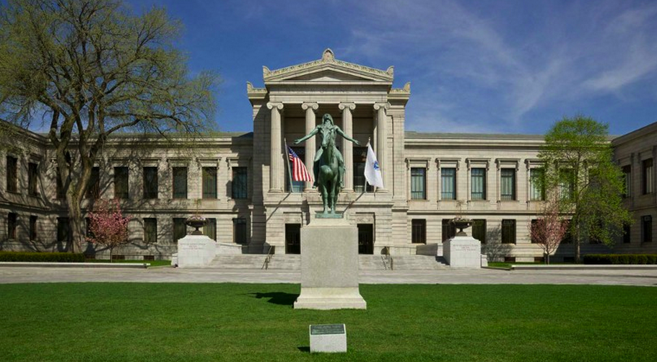

Museum of Fine Arts Field Trip
(Boston)
Friday, October 21st, 2016

On Friday, October 21st, BHS European History students will have the opportunity to participate in a field trip to the Museum of Fine Arts in Boston.

Students will travel via motorcoach from BHS to Boston, where we will spend two and half hours at the Museum of Fine Arts viewing some of the finest examples of Medieval and Renaissance Art in the United States. Students will complete a scavenger hunt based on this artwork but will also have free time to view (with their group) any other art on display.

Students will then travel via the bus to Quincy Market and Faneuil Hall where they will have the opportunity to see this historic marketplace, first built in 1742 but still the bustling centerpiece of Boston’s eateries and tourist industry. Students will have approximately two hours to explore the market area and eat lunch (either brought from home or purchased at the market).

To secure a seat students must return this signed permission slip along with $45.00 check or cash to Mrs. Wagner by Friday, October 7th (please make checks payable to BHS).

Parents: Please be sure to let us know if your student could use some financial assistance to make this trip happen for them. Please also feel free to contribute more than the required $45 in order to help fund the trip for another student. And lastly, please let us know if you are interested in being a chaperone!

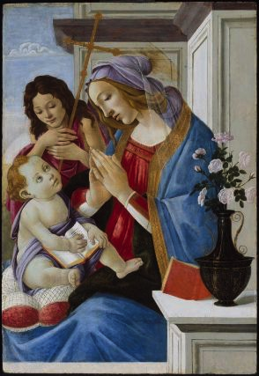
Itinerary
times are approximate

7:00 AM Depart Brunswick High
(bring a morning snack to eat en route)

10:00-12:30 Tour MFA Boston

1:00-3:00 Lunch at Quincy Market/Faneuil Hall

3:00PM Depart Boston

6:00PM Arrive in Brunswick

Virgin and Child with Saint John the Baptist
Tempera on panel, about 1500, Sandro Botticelli, Italian (Florentine),1444 or 1445–1510
part of the MFA Renaissance Italy collection

__________________________________ has my permission to participate in the BHS field
Student’s Name trip to the Museum of Fine Arts, Boston.

__________________________________
Parent/Guardian Signature

