GEORGE W. BUSH

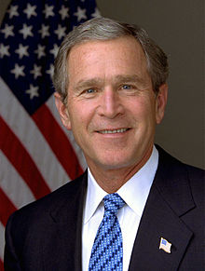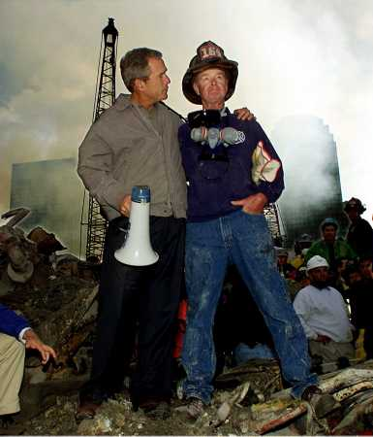

George W. Bush (1946-), America’s 43rd president, served in office from 2001 to 2009. Before entering the White House, Bush, the oldest son of George H.W. Bush, the 41st U.S. president, was a two-term Republican governor of Texas. A graduate of Yale University and Harvard Business School, Bush worked in the Texas oil industry and was an owner of the Texas Rangers baseball team before becoming governor. In 2000, he won the presidency after narrowly defeating Democratic challenger Al Gore. Bush’s time in office was shaped by the September 11, 2001, terrorist attacks against America. In response to the attacks, he declared a global “war on terrorism,” established the Department of Homeland Security, and authorized U.S.-led wars in Afghanistan and Iraq.

GEORGE W. BUSH: EDUCATION, FAMILY AND EARLY POLITICAL CAREER
Bush, the oldest of six children of George H.W. Bush (1924-) and Dorothy Pierce Bush (1925-), was born on July 6, 1946, in New Haven, Connecticut, when his father, a former World War II naval aviator, was a student at Yale University. He was raised in Texas, where the senior Bush was an executive in the oil industry, and attended high school at Phillips Academy in Andover, Massachusetts. Bush went on to Yale, the alma mater of his father and grandfather, Prescott Bush (1985-1972), a banker and U.S. senator, and earned a degree in history in 1968.

That same year, with America fighting the Vietnam War (1954-75), Bush was accepted into the Texas Air National Guard. He trained to become a pilot and completed his active-duty service in 1970. In 1973, he entered Harvard Business School, and received an MBA in 1975. Bush then returned to Texas to work in the oil and gas industry and eventually started his own exploration company.

On November 5, 1977, he married Laura Welch (1946-), a librarian and school teacher. The couple had twin daughters, Jenna and Barbara, in 1981.

In 1978, Bush ran for the U.S. House of Representatives from Texas but lost to his Democratic opponent in the general election. Afterward, he returned to his oil business, which he sold in 1986. Bush moved to Washington, D.C., to work on his father’s successful 1988 presidential campaign, and the following year became an investor in the Texas Rangers baseball team (he sold his ownership stake in 1998 for $15 million).

In 1994, Bush defeated Democratic incumbent Ann Richards to become governor of Texas. He was re-elected four years later. In the summer of 1999, Bush announced his candidacy for president, and campaigned as a “compassionate conservative.”

GEORGE W. BUSH: 2000 PRESIDENTIAL ELECTION
In the 2000 election, Bush and running mate Dick Cheney (1941-), a former congressman and U.S. defense secretary under George H.W. Bush, defeated Vice President Al Gore (1948-) and his running mate, U.S. Senator Joe Lieberman (1942-) of Connecticut, by a margin of 271-266 electoral votes, though Gore won the popular vote by 48.4 percent to Bush’s 47.9 percent. The 2000 election was the fourth election in U.S. history in which the winner of the electoral votes did not carry the popular vote.

GEORGE W. BUSH: FIRST PRESIDENTIAL TERM: 2001-2005
Bush’s first term in the White House was dominated by the September 11, 2001, terrorist attacks against America, in which nearly 3,000 people were killed, and their aftermath. The following month, in response to the attacks, the United States invaded Afghanistan in an attempt to overthrow the Taliban government, which was suspected of harboring Osama Bin Laden (1957-2011), leader of Al-Qaeda, the organization responsible for the 9/11 attacks. The Taliban regime was quickly toppled; Bin Laden, however, was not captured for another decade.

With the goal of protecting the United States from future terrorist attacks, Bush also signed the Patriot Act into law and created the Cabinet-level Department of Homeland Security, which was officially established in November of 2002. Then, in the spring of 2003, the United States invaded Iraq in order to overthrow leader Sadaam Hussein (1937-2006), whose regime was accused of supporting international terrorist groups and possessing large caches of WMDs, or weapons of mass destruction. In December 2003, U.S. forces captured Hussein (who was later executed by Iraqi officials); however, no WMDs were ever discovered.

Also in his first term, Bush won Congressional approval of widespread tax-cut bills and a Medicare prescription drug coverage program for seniors; signed the No Child Left Behind Act into law; allocated billions of dollars to fight HIV/AIDS around the world; created the White House Office of Faith-Based and Community Initiatives, and withdrew America’s support of the 1997 Kyoto Protocol, which was signed by President Bill Clinton and was intended to combat worldwide global warming (Bush said he was concerned that the international agreement’s requirements would hurt the U.S. economy).

Bush ran for re-election in 2004 and defeated Democratic challenger Massachusetts senator John Kerry (1943-) by a margin of 286-251 electoral votes and with 50.7% of the popular vote (Kerry = 48.3%).

GEORGE W. BUSH: SECOND PRESIDENTIAL TERM: 2005-2009
Bush enjoyed strong public approval ratings throughout much of his first term; however, during his second term his popularity plummeted. Critics said Bush had used misleading claims about Iraq’s WMDs as a justification for the invasion of that Middle Eastern nation. Additionally, after Hurricane Katrina devastated America’s Gulf Coast region in August 2005, resulting in some 1,800 deaths and billions of dollars in damages, the Bush administration was widely criticized for its slow response to the disaster.

A troubled economy also contributed to Americans’ dissatisfaction with Bush. He began his presidency with a federal budget surplus; however, factors such as the enormous cost of fighting two wars and the broad tax cuts led to annual budget deficits starting in 2002. Then, in 2008, with America experiencing its worst financial crisis since the Great Depression, Congress passed a series of controversial Bush administration-sponsored plans to bail out the financial industry with hundreds of billions in federal funds. Bush also lobbied unsuccessfully for a plan to replace Social Security with private retirement savings accounts.

Throughout his terms, Bush rarely wavered from his stance as a social conservative. He made two nominations to the U.S. Supreme Court, both in 2005: Chief Justice John Roberts (1955-) and Samuel Alito (1950-), both regarded as judicial conservatives.

