Directions: Read and annotate this handout.

Holding the Line Against Japan
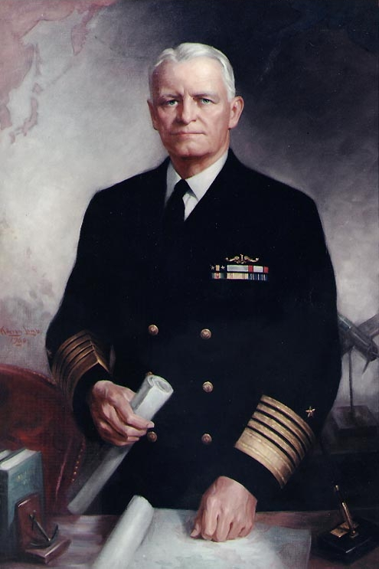
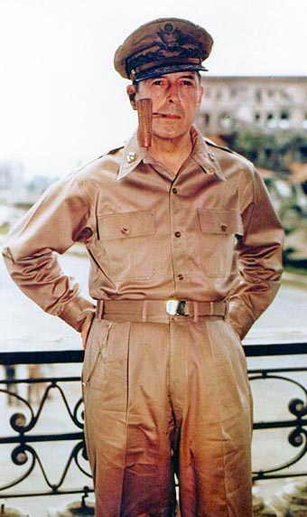
Admiral Chester Nimitz (left), the commander of the United States Navy in the Pacific, began planning operations against the Japanese navy. Although the Japanese had badly damaged the American fleet at Pearl Harbor, they had missed the American aircraft carriers, which were at sea on a mission. The United States had several carriers in the Pacific, and Nimitz was determined to use them. In the days just after Pearl Harbor, however, Nimitz could do little to stop Japan’s advance into Southeast Asia.

The Fall of the Philippines
A few hours after bombing Pearl Harbor, the Japanese attacked American airfields in the Philippines. Two days later, they landed troops. The American and Filipino forces defending the Philippines were badly outnumbered. Their commander, General Douglas MacArthur (right), retreated to the Bataan Peninsula. Using the peninsula’s rugged terrain, the troops held out for more than three months.

By March, in desperation, the troops ate cavalry horses and mules. The lack of food and supplies, along with diseases such as malaria, scurvy, and dysentery, took their toll. The women of the Army Nurse Corps worked on Bataan in primitive conditions. Patients slept in the open air. One nurse, Rose Meier, reported, “If we needed more room, we got our axes and chopped some bamboo trees down.”

Realizing MacArthur’s capture would demoralize the American people, President Roosevelt ordered the general to evacuate to Australia. MacArthur promised, “I came through, and I shall return.”
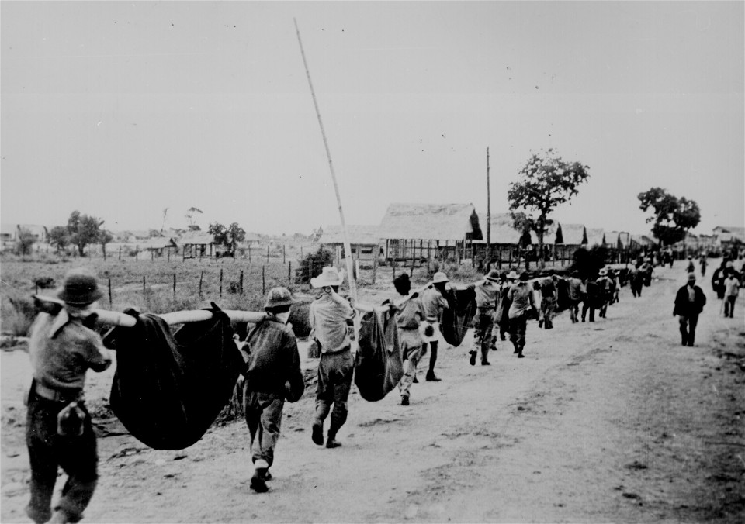
On April 9, 1942, the weary defenders of the Bataan Peninsula finally surrendered. Nearly 78,000 prisoners of war were forced to march—sick, exhausted, and starving—65 miles (105 km) to a Japanese prison camp. Almost 10,000 troops died on this march, which was later to be called the Bataan Death March. Private Leon Beck was taken prisoner when Bataan surrendered and took part in the Bataan Death March for 13 days before escaping. He later recalled:
"They’d halt us in front of these big artesian wells . . . so we could see the water and they wouldn’t let us have any. Anyone who would make a break for water would be shot or bayoneted. Then they were left there. Finally, it got so bad further along the road that you never got away from the stench of death. There were bodies laying all along the road in various degrees of decomposition—swollen, burst open, maggots crawling by the thousands. . . ."
~ from Death March: The Survivors of Bataan, 1981

Sixty-six women nurses were also captured and sent to the University of Santo Tomas in Manila. They remained there—with 11 navy nurses and some 3,000 Allied civilians—until early in 1945. Although the troops in the Bataan Peninsula surrendered, a small force held out on the island of Corregidor in Manila Bay. Finally, in May 1942, Corregidor surrendered. The Philippines had fallen to the Japanese.

The Doolittle Raid on Tokyo
Even before the Philippines fell, President Roosevelt was searching for a way to raise the morale of the American people. He wanted to bomb Tokyo, but American planes could reach Tokyo only if an aircraft carrier brought them close enough. However, Japanese ships in the North Pacific prevented carriers from getting near Japan.

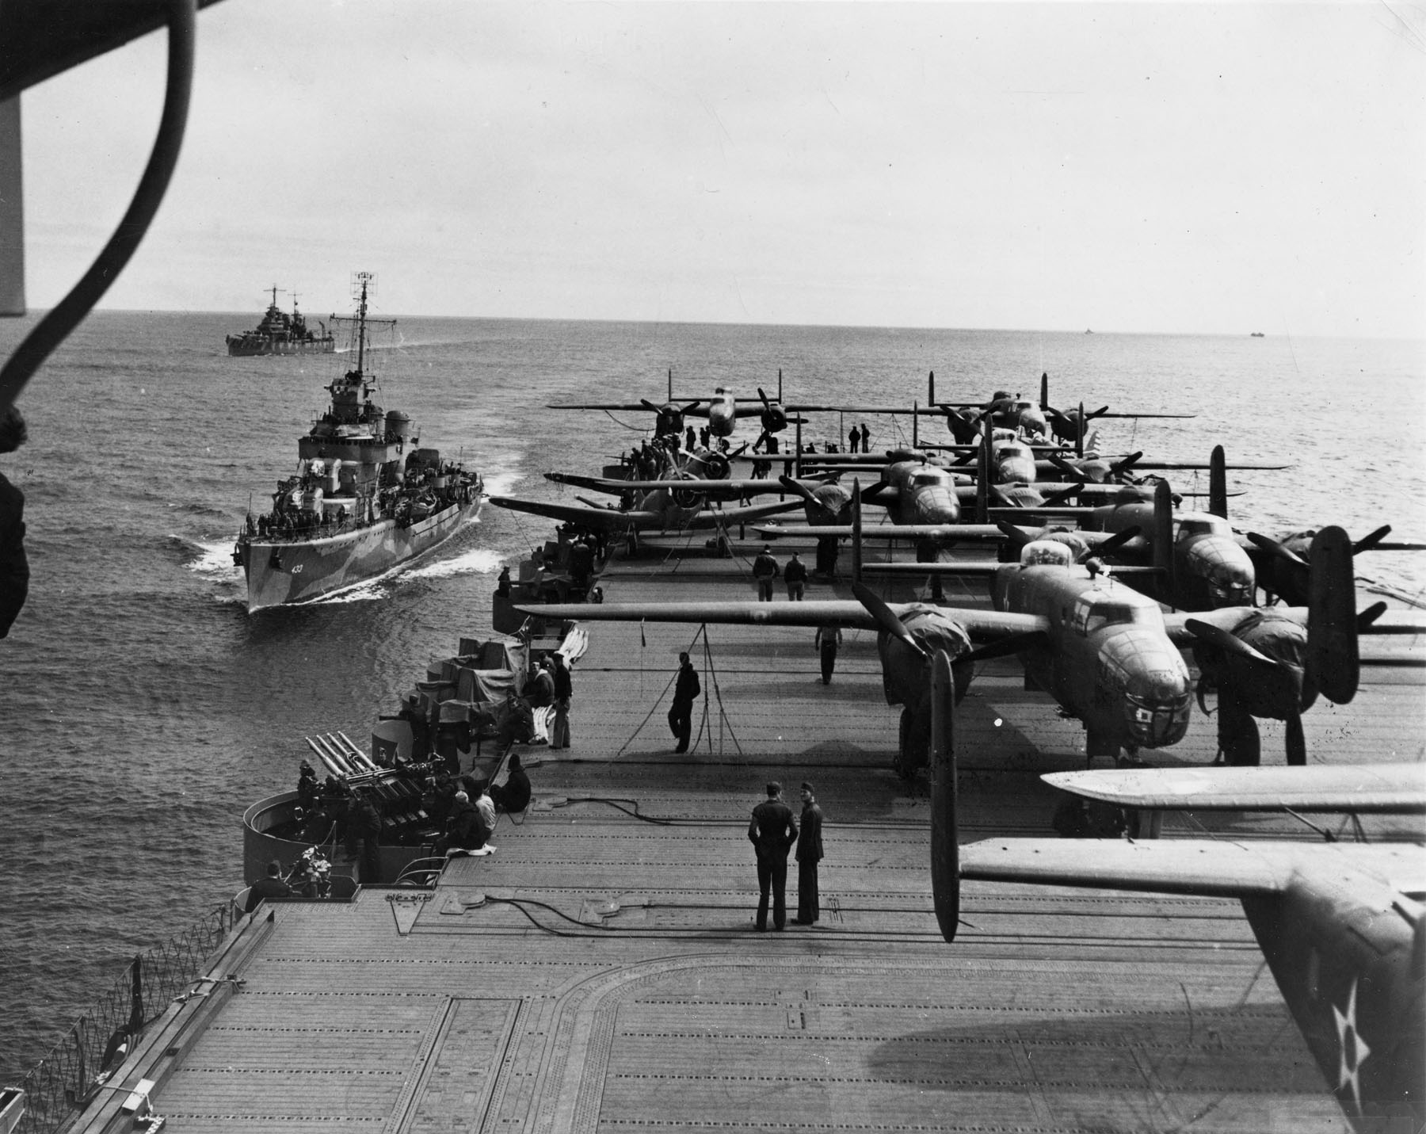
In early 1942, a military planner suggested replacing the carrier’s usual short-range bombers with long-range B-25 bombers that could attack from farther away. The only problem was that, although B-25s could take off from a carrier, the bombers could not land on its short deck. After attacking Japan, they would have to land in China.

President Roosevelt put Lieutenant Colonel James Doolittle in command of the mission to bomb Tokyo. At the end of March, a crane loaded sixteen B-25s onto the aircraft carrier Hornet. The next day, the Hornet headed west across the Pacific. On April 18, American bombs fell on Japan for the first time.

Japan Changes Strategy
While Americans rejoiced in the air force’s success, Japanese leaders were aghast at the raid. Those bombs could have killed Emperor Hirohito, who was revered as a god. The Doolittle Raid convinced Japanese leaders to change their strategy.

Before the raid, the Japanese navy had disagreed about the next step. The officers in charge of the navy’s planning wanted to cut American supply lines to Australia by capturing the south coast of New Guinea. The commander of the fleet, Admiral Yamamoto, wanted to attack Midway Island - the last American base in the North Pacific west of Hawaii. Yamamoto believed that attacking Midway would lure the American fleet into battle and enable his fleet to destroy it.

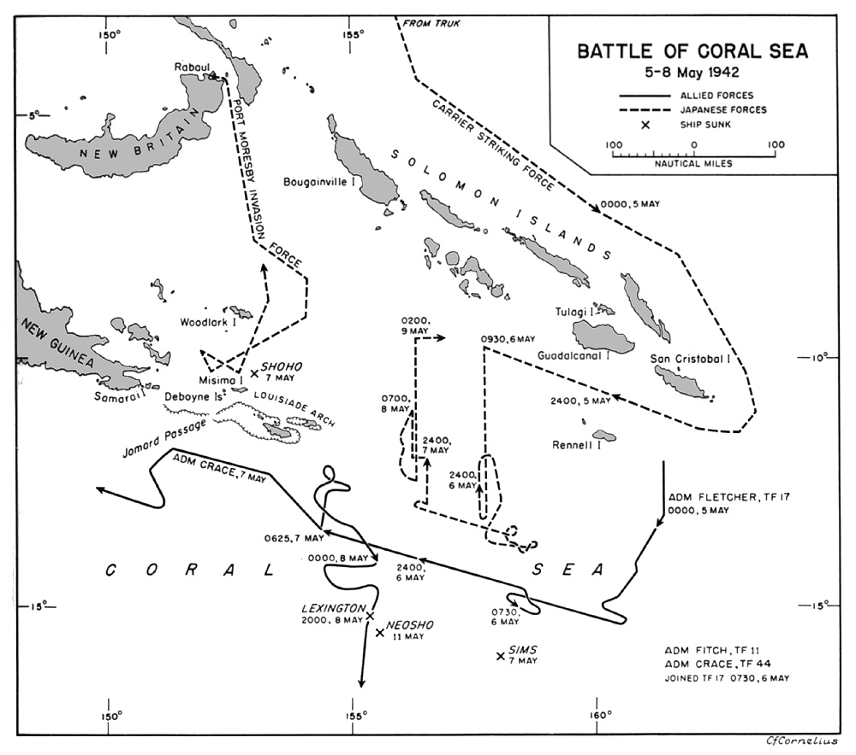
After Doolittle’s raid, the Japanese war planners dropped their opposition to Yamamoto’s idea. The American fleet had to be destroyed to protect Tokyo from bombing. The attack on New Guinea would still go ahead, but only three aircraft carriers were assigned to the mission. All of the other carriers were ordered to assault Midway.

The Battle of the Coral Sea
The Japanese believed that they could safely proceed with two attacks at once because they thought their operations were secret. What the Japanese did not know was that an American team of code breakers based in Hawaii had already broken the Japanese navy’s secret code for conducting operations.

In March 1942, decoded Japanese messages alerted the United States to the Japanese attack on New Guinea. In response, Admiral Nimitz sent two carriers, the Yorktown and the Lexington, to intercept the Japanese in the Coral Sea. There, in early May, carriers from both sides launched all-out airstrikes against each other. Although the Japanese sank the Lexington and badly damaged the Yorktown, the American attacks prevented the Japanese from landing on New Guinea’s south coast and kept the supply lines to Australia open.

The Navajo Code Talkers
When American marines stormed an enemy beach, they used radios to communicate. Using radios, however, meant that the Japanese could intercept and translate the messages. In the midst of the battle, there was no time to use a code-machine. Acting upon the suggestion of Philip Johnston, an engineer who had lived on a Navajo reservation as a child, the marines recruited Navajo to serve as “code talkers.”

The Navajo language had no written alphabet and was known only to the Navajo and a few missionaries and anthropologists. The Navajo recruits developed code words, using their own language, that stood for military terms. For example, the Navajo word jay-sho, or “buzzard,” was code for bomber; lo-tso, or “whale,” meant battleship; and ni-ma-si, or “potatoes,” stood for grenades.

Code talkers proved invaluable in combat. They could relay a message in minutes that would have taken a code-machine operator hours to encipher and transmit. During the Battle of Iwo Jima, code talkers transmitted more than 800 messages during the first 48 hours as the marines struggled to get ashore under intense bombardment. Sworn to secrecy, their mission was not revealed until 1971. In 2001 Congress awarded the code talkers the Congressional Gold Medal for their unique contribution during the war.

Battle of Midway
Back at Pearl Harbor, the code-breaking team now learned of the plan to attack Midway. With so many ships at sea, Admiral Yamamoto transmitted the plans for the Midway attack by radio, using the same code the Americans had already cracked.

Admiral Nimitz had been waiting for the opportunity to ambush the Japanese fleet. He immediately ordered carriers to take up positions near Midway. Unaware that they were heading into an ambush, the Japanese launched their aircraft against Midway on June 4, 1942. The Americans were ready. The Japanese ran into a blizzard of antiaircraft fire, and 38 planes were shot down. As the Japanese prepared a second wave to attack Midway, aircraft from the American carriers Hornet, Yorktown, and Enterprise then launched a counterattack. The American planes caught the Japanese carriers with fuel, bombs, and aircraft exposed on their flight decks. Within minutes, three Japanese carriers were reduced to burning wrecks. A fourth was sunk a few hours later, and Admiral Yamamoto ordered his remaining ships to retreat.
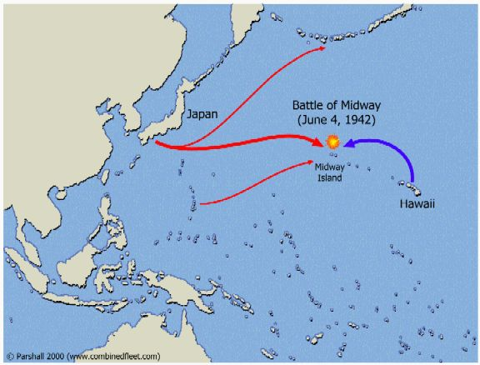
The Battle of Midway was a turning point in the war. The Japanese navy lost four large carriers—the heart of its fleet. Just six months after Pearl Harbor, the United States had stopped the Japanese advance. The victory was not without cost, however. The battle killed 362 Americans and 3,057 Japanese.

Driving Back Japan
The American plan to defeat Japan called for a two-pronged attack. The Pacific Fleet, commanded by Admiral Nimitz, would advance through the central Pacific by “hopping” from one island to the next, closer and closer to Japan. Meanwhile, General MacArthur’s troops would advance through the Solomon Islands, capture the north coast of New Guinea, and then launch an invasion to retake the Philippines.

Island-Hopping in the Pacific
By the fall of 1943, the navy was ready to launch its island-hopping campaign, but the geography of the central Pacific posed a problem. Many of the islands were coral reef atolls. The water over the coral reef was not always deep enough to allow landing craft to get to the shore. If the landing craft ran aground on the reef, the troops would have to wade to the beach. As some 5,000 United States Marines learned at Tarawa Atoll, wading ashore could cause very high casualties. Tarawa, part of the Gilbert Islands, was the navy’s first objective. The Japanese base there had to be captured in order to put air bases in the nearby Marshall Islands.

When the landing craft hit the reef, at least 20 ships ran aground. The marines had to plunge into shoulder-high water and wade several hundred yards to the beach. Raked by Japanese fire, only one marine in three made it ashore. Once the marines reached the beach, the battle was still far from over.
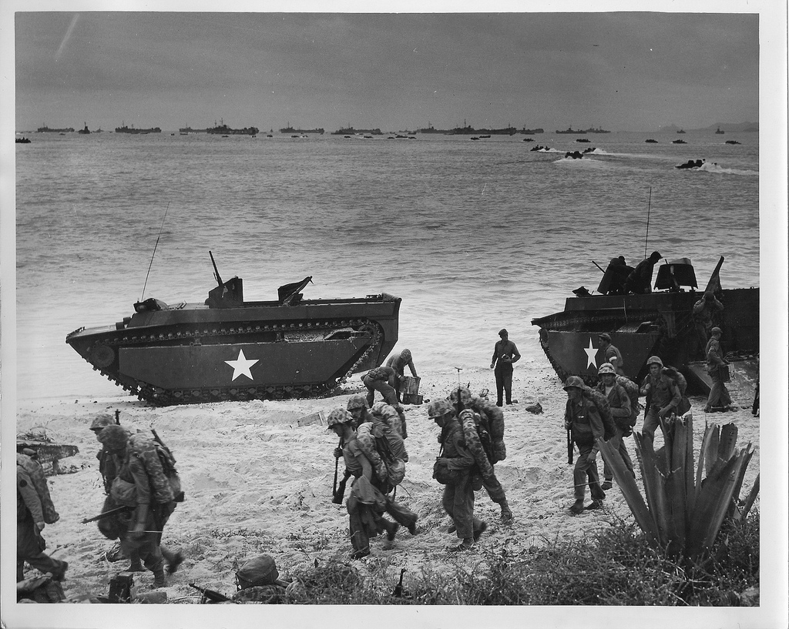
Although many troops died wading ashore, one vehicle had been able to cross the reef and deliver its troops onto the beaches. The vehicle was a boat with tank tracks, nicknamed the “Alligator.” This amphibious tractor, or amphtrac, had been invented in the late 1930s to rescue people in Florida swamps. It had never been used in combat, and the navy decided to buy only 200 of them in 1941. If more had been available at Tarawa, American casualties probably would have been much lower. More than 1,000 marines died on Tarawa. Photos of bodies lying crumpled next to burning landing craft shocked Americans back home. Many people began to wonder how many lives would be lost in defeating Japan.

The next assault - Kwajalein Atoll in the Marshall Islands - went much more smoothly. This time all of the troops went ashore in amphtracs. Although the Japanese resisted fiercely, the marines captured Kwajalein and nearby Eniwetok with far fewer casualties.

After the Marshall Islands, the navy targeted the Mariana Islands. American military planners wanted to use the Marianas as a base for a new heavy bomber, the B-29 Superfortress. The B-29 could fly farther than any other plane in the world. From airfields in the Marianas, B-29s could bomb Japan. Admiral Nimitz decided to invade three of the Mariana Islands: Saipan, Tinian, and Guam. Despite strong Japanese resistance, American troops captured all three by August 1944. A few months later, B-29s began bombing Japan.

MacArthur Returns
As the forces under Admiral Nimitz hopped across the central Pacific, General Douglas MacArthur’s troops began their own campaign in the southwest Pacific. The campaign began by invading Guadalcanal in the Solomon Islands, east of New Guinea, in August 1942. It continued until early 1944, when MacArthur’s troops finally captured enough islands to surround the main Japanese base in the region. In response, the Japanese withdrew their ships and aircraft from the base, although they left 100,000 troops behind to hold the island.

Worried that the navy’s advance across the central Pacific was leaving him behind, MacArthur ordered his forces to leap nearly 600 miles (966 km) to capture the Japanese base at Hollandia on the north coast of New Guinea. Shortly after securing New Guinea, MacArthur’s troops seized the island of Morotai—the last stop before the Philippines.

To take back the Philippines, the United States assembled an enormous invasion force. In October 1944, over 700 ships carrying more than 160,000 troops sailed for Leyte Gulf in the Philippines. On October 20, the troops began to land on Leyte, an island on the eastern side of the Philippines. A few hours after the invasion began, MacArthur headed to the beach. Upon reaching the shore, he strode to a radio and said: “People of the Philippines, I have returned. By the grace of Almighty God, our forces stand again on Philippine soil.”
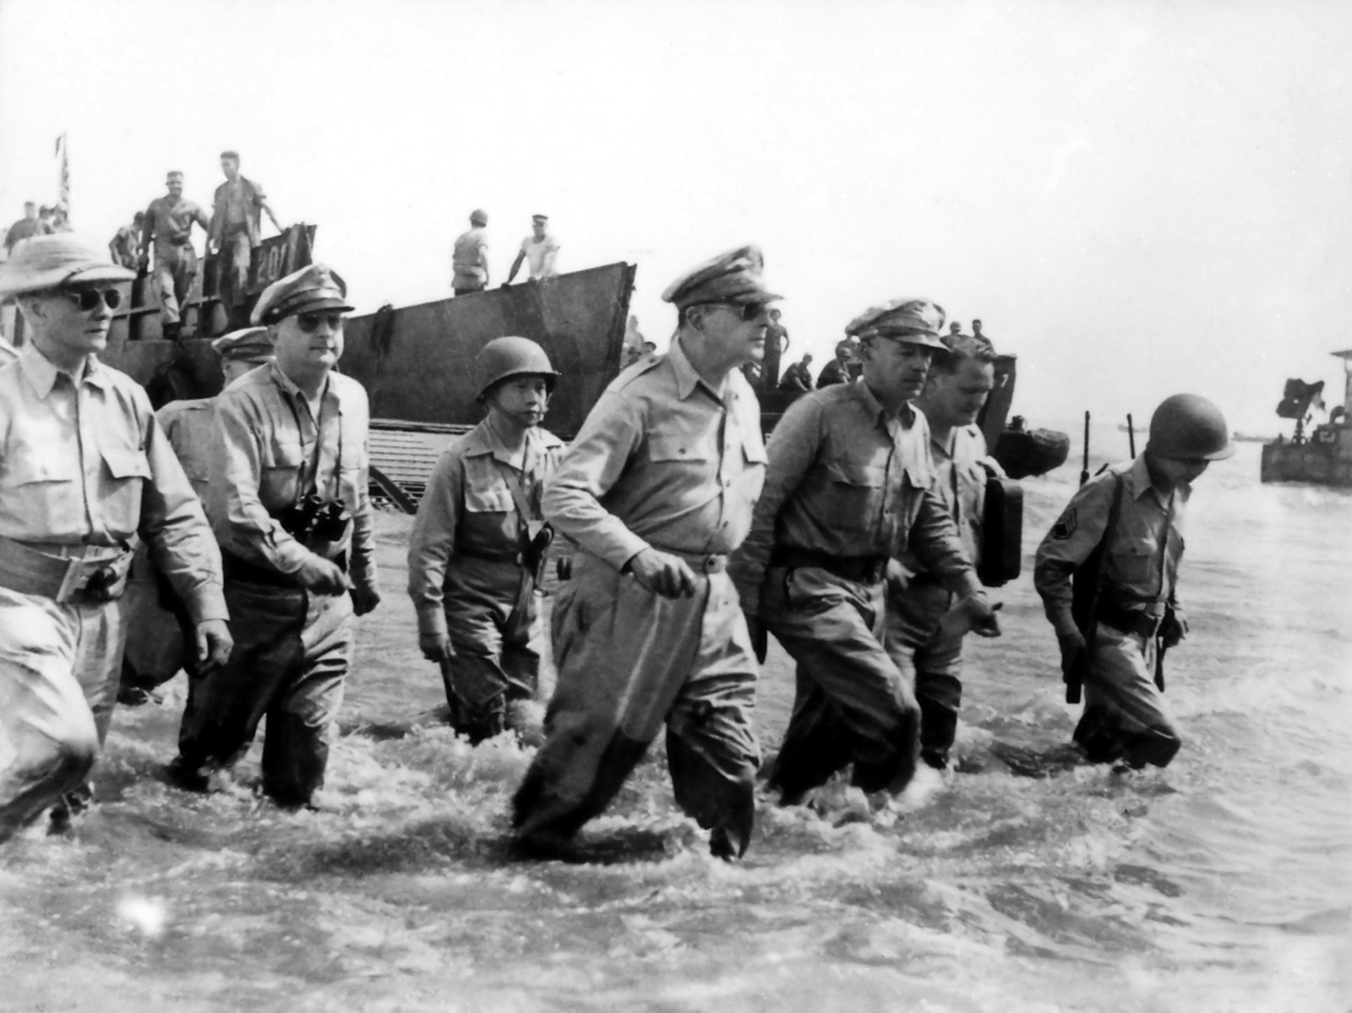
To stop the American invasion, the Japanese sent four aircraft carriers toward the Philippines from the north and secretly dispatched another fleet from the west. Believing the Japanese carriers were leading the main attack, most of the American carriers protecting the invasion left Leyte Gulf and headed north to stop them. Seizing their chance, the Japanese warships to the west raced through the Philippine Islands into Leyte Gulf and ambushed the remaining American ships.

The Battle of Leyte Gulf was the largest naval battle in history. It was also the first time that the Japanese used kamikaze attacks. Kamikaze means “divine wind” in Japanese. It refers to the great storm that destroyed the Mongol fleet during its invasion of Japan in the thirteenth century. Kamikaze pilots would deliberately crash their planes into American ships, killing themselves but also inflicting severe damage. Luckily for the Americans, just as their situation was becoming desperate, the Japanese commander, believing more American ships were on the way, ordered a retreat.

Although the Japanese fleet had retreated, the campaign to recapture the Philippines from the Japanese was long and grueling. More than 80,000 Japanese were killed; fewer than 1,000 surrendered. MacArthur’s troops did not capture Manila until March 1945. The battle left the city in ruins and more than 100,000 Filipino civilians dead. The remaining Japanese retreated into the rugged terrain north of Manila; they were still fighting in August 1945 when word came that Japan had surrendered.

