Directions: Read and annotate this handout.

After the conference in Tehran, Roosevelt headed to Cairo, Egypt, where he and Churchill continued planning an invasion of France to force Germany to again fight the war on two fronts. One major decision still had to be made. The president had to choose the commander for Operation Overlord—the code name for the invasion. Roosevelt selected General Eisenhower.

Planning Operation Overlord
Hitler had fortified the French coast along the English Channel, but he did not know when or where the Allies would land. The Germans believed the landing would be in Pas-de-Calais—the area of France closest to Britain. The Allies encouraged this belief by placing dummy equipment along the coast across from Calais. The real target was farther south, a 60-mile stretch of five beaches along the Normandy coast.

The selection of a site for the largest amphibious landing in history was one of the biggest decisions of World War II. Allied planners considered coastlines from Denmark to Portugal in search of a sheltered location with firm flat beaches within range of friendly fighter planes in England. There also had to be enough roads and paths to move jeeps and trucks off the beaches and to accommodate the hundreds of thousands of American, Canadian, and British troops set to stream ashore following the invasion. An airfield and a seaport that the Allies could use were also needed. Most important was a reasonable expectation of achieving the element of surprise.

Planners also discussed who should lead France after the invasion. General Eisenhower had informed Charles de Gaulle that the French Resistance forces would assist in the liberation of Paris, but President Roosevelt was not sure he trusted de Gaulle and refused to recognize him as the official French leader.

By the spring of 1944, more than 1.5 million American soldiers, 12,000 airplanes, and 5 million tons (4.6 million t) of equipment had been sent to England. Only setting the invasion date and giving the command to go remained. The invasion had to begin at night to hide the ships crossing the English Channel. The ships had to arrive at low tide so that they could see the beach obstacles. The low tide had to come at dawn so that gunners bombarding the coast could see their targets. Paratroopers, who would be dropped behind enemy lines, needed a moonlit night to see where to land. Perhaps most important of all was good weather. A storm would ground the airplanes, and high waves would swamp landing craft.

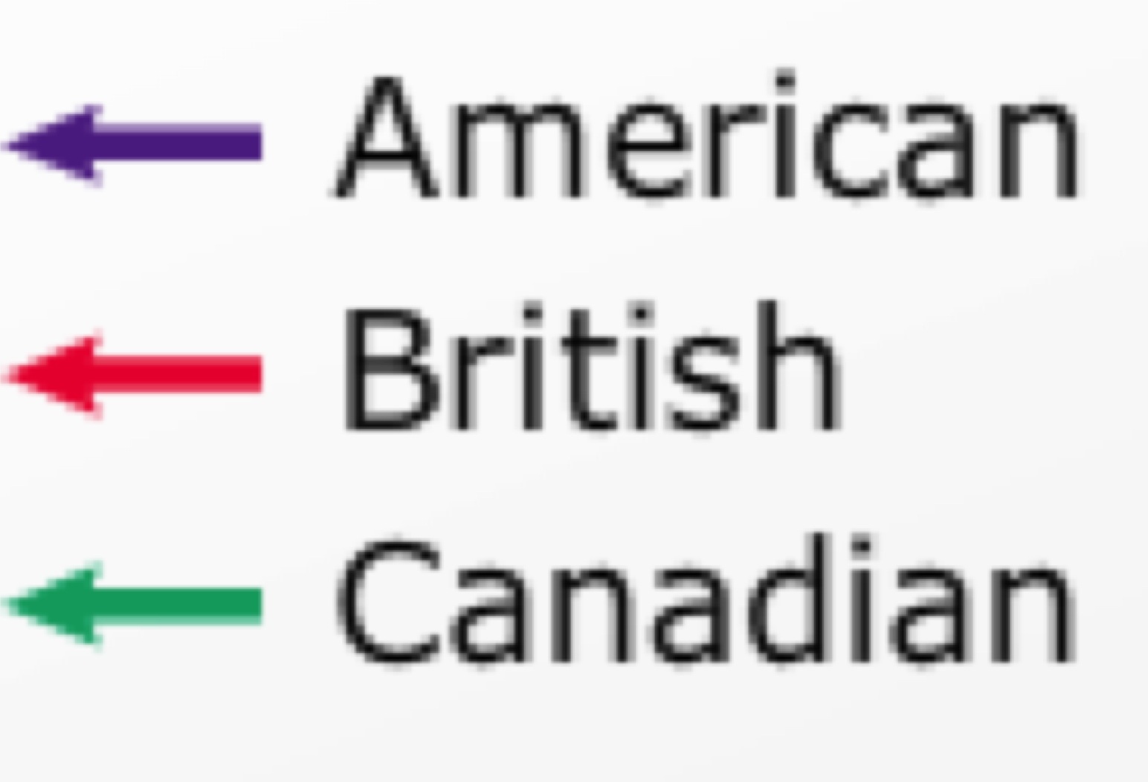
Given all these requirements, there were only a few days each month to begin the invasion. The first opportunity was from June 5 to 7, 1944. Eisenhower’s planning staff referred to the day any operation began by the letter D. The invasion date, therefore, came to be known as D-Day. Heavy cloud cover, strong winds, and high waves made June 5 impossible. The weather was forecast to improve briefly a day later. The Channel would still be rough, but the landing ships and aircraft could operate. After looking at forecasts one last time, shortly after midnight on June 6, 1944, Eisenhower gave the final order: “OK, we’ll go.”
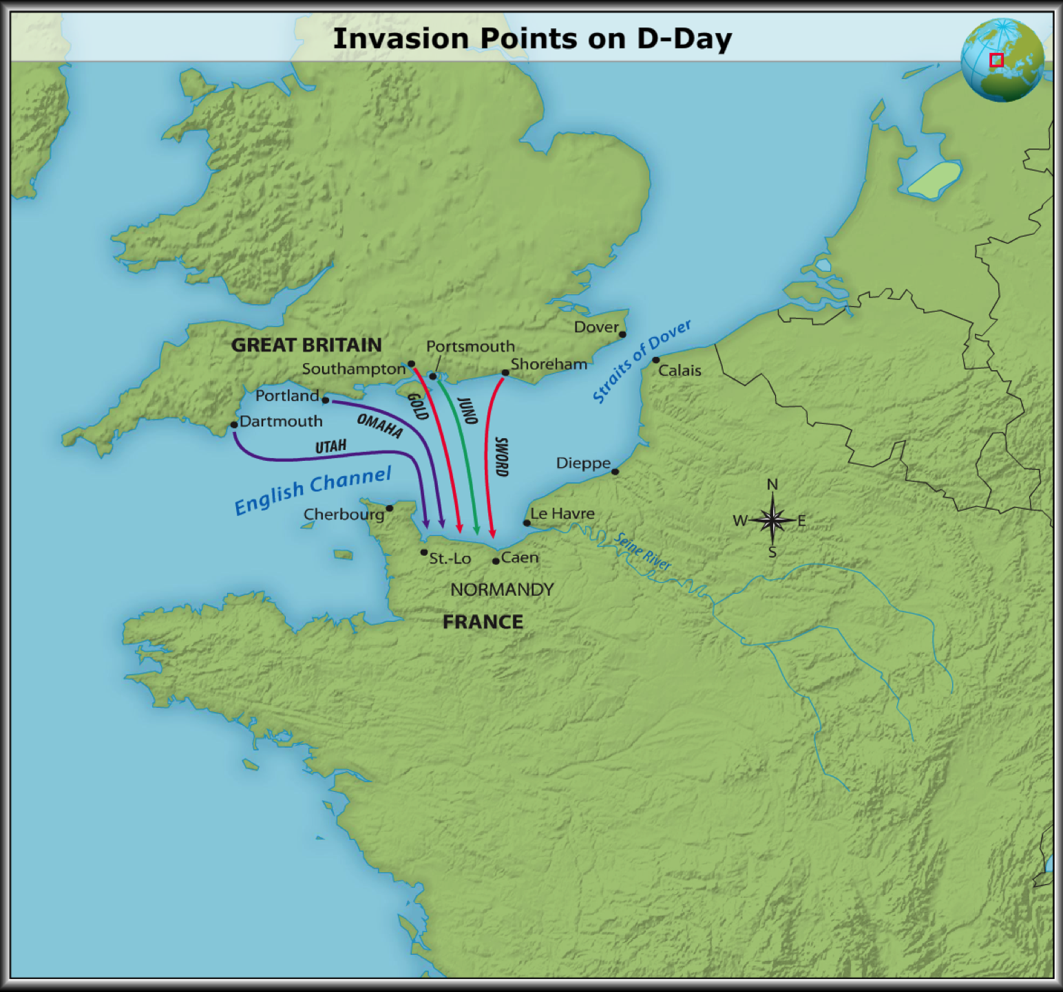
The Longest Day
Nearly 7,000 ships carrying more than 100,000 soldiers headed for Normandy’s coast. At the same time, 23,000 paratroopers were dropped inland, east and west of the beaches. Allied fighter-bombers raced up and down the coast, hitting bridges, bunkers, and radar sites. At dawn, Allied warships began a tremendous barrage. Thousands of shells rained down on the beaches, code-named “Utah,” “Omaha,” “Gold,” “Sword,” and “Juno.”

The American landing at Utah Beach went well. The German defenses were weak, and in less than three hours, the troops had captured the beach and moved inland, suffering fewer than 200 casualties. On the eastern flank, the British and Canadian landings also went well. By the end of the day, British and Canadian forces were several miles inland.

Omaha Beach, however, was a different story. Surrounded at both ends by cliffs that rose wall-like from the sea, Omaha Beach was only four miles long. The entire beach overlooked a 150-foot high bluff, and there were only five ravines leading from the beach to the top of the bluff. The Germans had made full use of the geographic advantage the high bluff gave them. They dug trenches and built concrete bunkers for machine guns at the top of the cliffs and positioned them to guard the ravines leading to the beach. Under intense German fire, the American assault almost disintegrated.

General Omar Bradley, commander of the American forces landing at Omaha and Utah, began making plans to evacuate. Slowly, however, the American troops began to knock out the German defenses. More landing craft arrived, ramming their way through the obstacles to get to the beach. Nearly 2,500 Americans were either killed or wounded on Omaha, but by early afternoon, Bradley received this message: “Troops formerly pinned down on beaches . . . [are] advancing up heights behind beaches.” By the end of the day, nearly 35,000 American troops had landed at Omaha, and another 23,000 had landed at Utah. More than 75,000 British and Canadian troops were on shore as well. The invasion had succeeded.

Use correct spelling and grammar in complete sentences to answer each of the questions below. Be sure to use specific information from the reading in each answer.

1. What was the code name of the D-Day invasion?

_____________________________________________________________________________________

2. Why were so few dates available to the Allies for the D-Day invasion?

_____________________________________________________________________________________

_____________________________________________________________________________________

3. Who was the commander of the U.S. forces landing on Omaha Beach and Utah Beach?

_____________________________________________________________________________________

4. Why was it so important that all of the conditions be met before Eisenhower could order D-Day to begin?

_____________________________________________________________________________________

_____________________________________________________________________________________

_____________________________________________________________________________________

_____________________________________________________________________________________

5. What would have happened if the invasion had failed?

_____________________________________________________________________________________

_____________________________________________________________________________________

_____________________________________________________________________________________

_____________________________________________________________________________________

_____________________________________________________________________________________

_____________________________________________________________________________________

