DIRECTIONS: Read the following handout, identifying any important vocabulary, terms, names, and/or events that you think might be historically important. Write content notes in the margins next to the important text that will help you remember the information. You may wish to highlight or underline the important text.

A Doomed Plan for Peace
As conflicts escalated with Native Americans, Congress took action. In 1867 Congress formed an Indian Peace Commission, which proposed creating two large reservations on the Plains, one for the Sioux and another for Native Americans of the southern Plains. Federal agents would run the reservations, and the army would deal with any groups that refused to report or remain there.

The Indian Peace Commission’s plan was doomed to failure. Although negotiators pressured Native American leaders into signing treaties, they could not ensure that those leaders or their followers would abide by them. Nor could anyone prevent settlers from violating their terms. The Native Americans who did move to reservations faced many of the same conditions that drove the Dakota Sioux to violence—poverty, despair, and the corrupt practices of American traders.

The Last Native American Wars
By the 1870s, many Native Americans had left the reservations in disgust. They preferred hunting buffalo on the open plains. The buffalo were rapidly disappearing, however, as professional buffalo hunters sought hides for markets in the East and other hunters killed for sport. When buffalo blocked rail traffic, the railroads killed them and fed the meat to workers. The army, determined to force Native Americans onto reservations, encouraged buffalo killing. By 1889, very few buffalo remained.

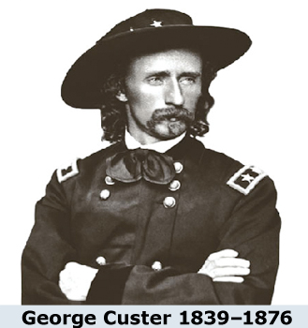
Battle of the Little Bighorn
In 1876 prospectors overran the Lakota Sioux reservation in the Dakota Territory to mine gold in the Black Hills. The Lakota saw no reason to abide by a treaty that settlers were violating, so many left the reservation to hunt near the Bighorn Mountains in Montana. The government responded by sending an expedition accompanied by Lieutenant Colonel George A. Custer and the Seventh Cavalry. Custer underestimated the fighting capabilities of the Lakota and the Cheyenne. On June 25, 1876, he launched an attack on one of the largest groups of Native American warriors ever assembled on the Great Plains.

The Native American forces rapidly defeated Custer and his more than 200 soldiers, killing them all. Newspaper accounts portraying Custer as a victim of a massacre produced a public outcry in the East, and the army stepped up its campaign on the Plains. Sitting Bull and his followers fled to Canada, but the other Lakota were forced to return to the reservation and give up the Black Hills.

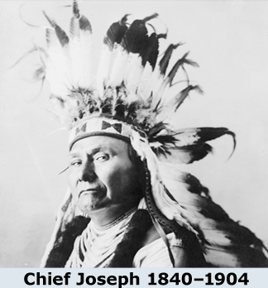
Flight of the Nez Perce
Farther west, the Nez Perce people, led by Chief Joseph, refused to be moved to a smaller reservation in Idaho in 1877. When the army came to relocate them, they fled their homes and embarked on a journey of more than 1,300 miles. Finally, in October 1877, Chief Joseph acknowledged that the struggle was over. He and his followers were then exiled to Oklahoma.

Tragedy at Wounded Knee
Native American resistance came to a final, tragic end on the Lakota Sioux reservation in 1890. Defying government orders, the Lakota continued to perform the Ghost Dance, a ritual that celebrated a hoped-for day of reckoning when settlers would disappear, the buffalo would return, and Native Americans would be reunited with their dead ancestors.

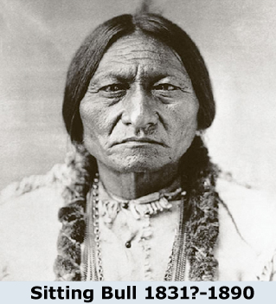
Federal authorities had banned the ceremony, fearing it would lead to violence. They blamed the latest defiance on Sitting Bull, who had returned from Canada, and sent police to arrest the chief. Sitting Bull’s supporters tried to stop the arrest. In the exchange of gunfire that followed, Sitting Bull was killed and a group of Ghost Dancers fled the reservation.

On December 29, 1890, a battle ensued at Wounded Knee Creek in South Dakota, taking the lives of 25 U.S. soldiers and approximately200 Lakota men, women, and children.

Americanization and the Dawes Act
Some Americans believed the solution was Americanization. They thought that Native Americans should be encouraged to abandon their traditional tribal culture and assimilate into American society by learning English, adopting American culture and values, and eventually American citizens. Beginning in the 1880s, the Bureau of Indian Affairs sponsored the creation of Indian boarding schools separate from reservations. By 1902, some 25 schools had been set up. Officials then pressured parents to send children to these schools. There they were required to speak English, choose an English name, dress in American-style clothes, cut their hair to match American styles, attend church, and learn vocational skills. Over time the schools became controversial. They were often underfunded and poorly maintained, and discipline was strict. Some students found the schools repressive, and many cases of abuse were reported.

A second Americanization strategy was to encourage Native Americans to abandon the reservation system and become independent landowners. In 1887 Congress passed the Dawes Act, which altered the reservation system by dividing reservation land into allotments for farming or ranching. Under the act, 160 acres were allotted to each head of household, 80 acres to each single adult, and 40 acres to each child. Any land remaining after allotments would be sold to American settlers, with the proceeds going into a trust for Native Americans. Citizenship would be granted to Native Americans who stayed on their allotments for 25 years.

While some Native Americans succeeded as farmers or ranchers, many had little training or enthusiasm for either pursuit. They often found their allotments too small to be profitable, so they leased them. In addition, some Native American groups had grown attached to their reservations and hated to see them divided into homesteads. Few stayed long enough to qualify for citizenship.

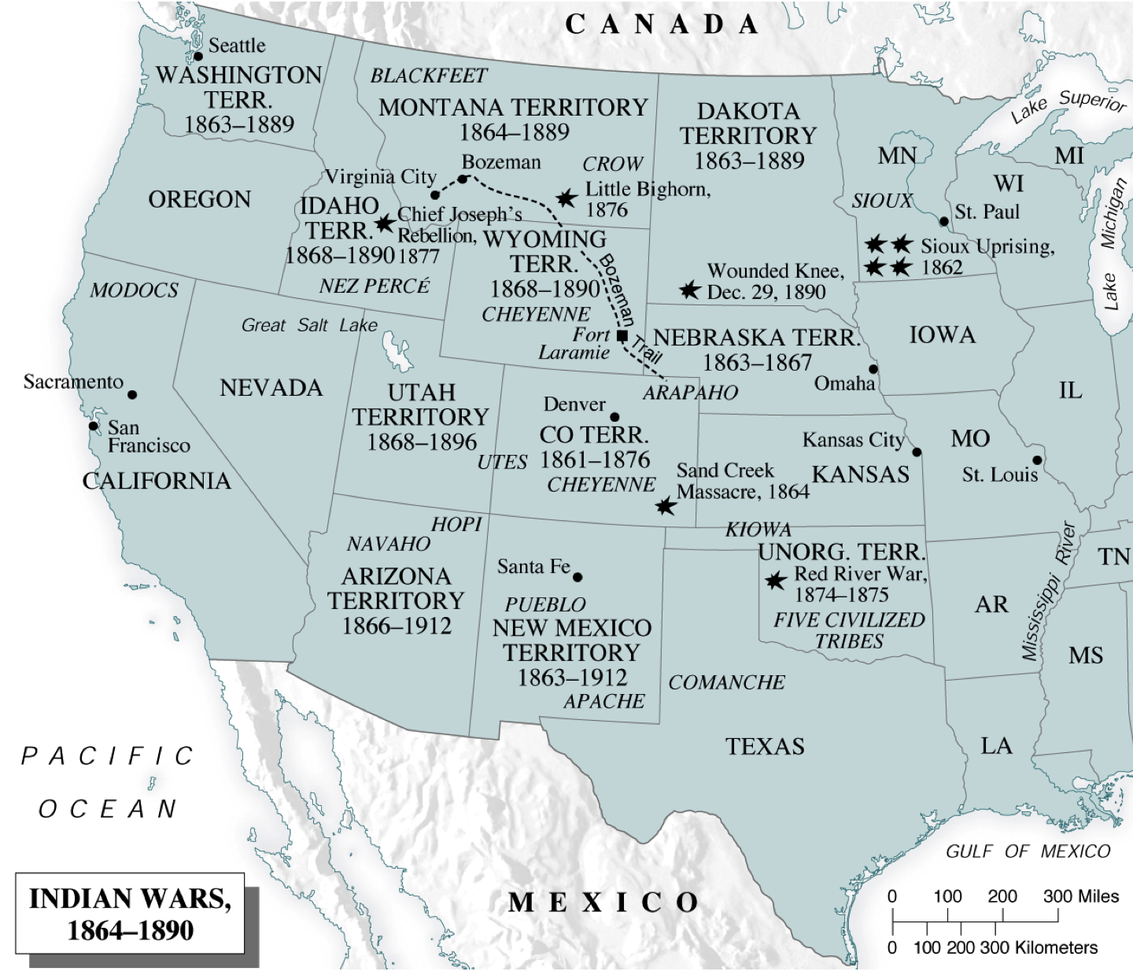
In the end, the assimilation policy proved a dismal failure. Native American culture on the Plains was doomed because it depended on buffalo for food, clothing, fuel, and shelter. When the herds were wiped out, there was no way to sustain the traditional way of life. Although the Dawes Act failed in its goals, American reformers continued to advocate for assimilation. In the early 1900s, reform groups such as the Friends of the Indians and the Indian Rights Association began to push for citizenship for all Native Americans believing it would encourage greater assimilation. Finally, in 1924 Congress passed the Citizenship Act, granting all Native Americans citizenship. In 1934 the Indian Reorganization Act reversed the Dawes Act’s policy of assimilation. It restored some reservation lands, gave Native Americans control over those lands, and permitted them to elect their own governments.

Circle the correct answer for each of the following questions.

1. What plan did the Indian Peace Commission propose in order to deal with Native American tensions in the West?
A. negotiate peace with the various tribes
B. create two large reservations to separate the Plains Indians from white settlers
C. wipe out the Plains Indians through a series of strategic attacks
D. pay the Plains Indians certain money for the land settlers were taking

2. Why were early peace treaties with Native Americans doomed to failure?
A. Only some obeyed and moved to reservations, then faced poverty and starvation.
B. Merchants wanted to move their stores to reservations against the wishes of Native Americans.
C. Settlers also wanted money from the government to not settle reservation land.
D. The Indian Peace Commission did not have the power to negotiate with individual groups of Native Americans.

3. At _________, General Custer and his men were killed by one of the largest Native American fighting forces ever assembled.
A. the Great Lakota Massacre C. the Fight for Nez Perce
B. the War of Sitting Bull D. the Battle of Little Bighorn

4. What was the main purpose of the Dawes Act of 1887?
A. to pay Native Americans for their mistreatment
B. to negotiate new reservation laws with the different groups
C. to encourage Native Americans to become farmers
D. to force Native Americans to abandon the Ghost Dance

5. Why was the Dawes Act a failure?
A. The government would not allow Native Americans to become U.S. citizens.
B. Many Native Americans did not want to or could not assimilate into the dominant culture.
C. The president reneged on the promises laid out in the Dawes Act.
D. The reservations were not large enough to allot all Native American families land.

6. What legislation reversed the provisions of the Dawes Act and gave tribes autonomy over their reservations?
A. the Indian Reorganization Act
B. the Citizenship Act
C. the Second Dawes Act
D. the Reservation Improvement Act

