Napoleon became a general at a very young age and was put in a position of authority where the generals and almost all other officers he commanded were older than him. He felt that this wasn’t a satisfactory situation and concluded that if he married a woman older than himself, he might claim to be older than he actually was and thereby obtain a little more respect from his officers. He also wanted to marry a rich, older woman.

After the battle of Toulon and after saving the Directory from the Paris mob, Napoleon was invited to a party given by one of the Directors, Paul Barras. In effect, Barras was the next best thing to being king of France at the time. Barras envisioned using Napoleon’s military talents for his own political and personal benefit. Barras also had at that time a mistress that he wanted to get rid of (Marie-Josephe-Rose de Beauharnais) because he had decided to take her best friend as his new mistress and couldn’t afford to keep both. He knew that Napoleon was looking for a wife. He therefore decided to marry his mistress off to Napoleon; however, he didn’t tell her this. He just told her that he wanted her to entertain Napoleon at the party and show an interest in him and praise his military skills. Well, this was all Napoleon needed. A beautiful woman fawning over him, apparently well-to-do, a member of the old aristocracy that had escaped the guillotine, she was older than himself but not too much (he thought), and she displayed keen interest in him (he thought). This, and a little urging from Barras after the party, was all that Napoleon needed to pursue her hand in marriage. Barras assured Napoleon that she had money, that she was a good catch, and that she would make a perfect wife for him.

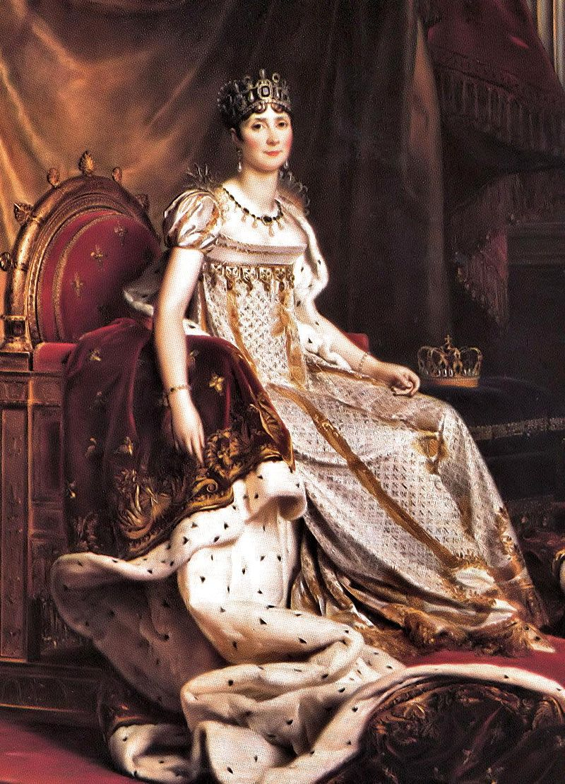
Napoleon began to pursue Rose. By the way, he didn’t like her name so he told her he would call her Josephine. He pursued and pursued and Josephine kept humoring him. Finally, Barras strongly advised her to marry Napoleon. She said she would not. Then Barras told her that he had a new mistress, that he couldn’t afford to maintain them both, that she was very expensive to maintain, and that if she didn’t marry Napoleon he would stop providing for her and she would, in effect, be thrown out on the street. This was the one thing that Josephine couldn’t bear. She was a compulsive spender. Another concern was her two children, Eugene and Hortense. Therefore, she gave in and agreed to marry Napoleon. By the way, she was much older than Napoleon thought and, although she said she was still of childbearing age, knew that she was barren and had been so for some time.

They were married and a few days later Napoleon departed to Italy. He genuinely loved Josephine at this time. She despised him and thought he was a total bore. As soon as he was gone she began playing around on him. As time went on she had a string of lovers, pretended to miss him very much in response to his daily love letters, and did everything in her power to avoid going to join him in Italy as he was constantly urging. She even went so far as to pretend she was pregnant and couldn’t travel. All this time she was attending balls and parties and committing adultery. From time to time, when Napoleon begged her to join him, she required Barras’ assistance to convince Napoleon that she should not go. During this time some of Napoleon’s officers, Murat, for example, had returned to Paris for one reason or another and had occasion to attend one of Josephine’s parties or a party that she attended. In Murat’s case, Napoleon had sent him back to Paris with the express mission of escorting Josephine to Italy, willingly or unwillingly. This was when Josephine made up the pregnancy story, which Murat took back to Napoleon. Finally, it got to the point where Napoleon was getting so edgy that Barras was afraid he would return to France and forget about the Italian Campaign. This didn’t suit Barras because he was making a lot of money out of that campaign. So he ordered Josephine to go to Napoleon. She did. Napoleon expected a pregnant Josephine. When she arrived she explained to him that she had had a miscarriage. He was torn with grief over losing his “son.”

The Italian Campaign was finally over and Napoleon returned to Paris. Josephine had to be good (or at least try to be better) while he was there. Then Napoleon decided to go to Egypt. Barras thought this was a good idea because Napoleon was beginning to become too popular. When he left, Josephine went back to her old ways. Napoleon was still genuinely in love with her and doted over her. On 19 July 1798, while marching toward Cairo in the scorching sun, Bourrienne, Napoleon’s Secretary, out of the corner of his eye, noticed Napoleon and Junot walking together. Bourrienne wrote,
“I noticed Bonaparte walking alone with Junot. I was only a short distance away, but I do not know why my eyes fastened on him during that conversation. The general’s pale face was paler than ever. His features were suddenly convulsed, a wild look came into his eyes, and several times he struck his head with his fists!”

Some fifteen minutes later, he left Junot and came toward me. I had never seen him so distraught, preoccupied. As I went to join him, he burst out with: “You are not genuinely devoted to me, or you would have told me what I have just learned from Junot. There’s a true friend for you. Josephine! And I six hundred leagues away! You should have told me! Josephine has deceived me! Damn them, I shall exterminate that whole breed of fops and coxcombs! As for her - divorce! Yes divorce - a public divorce, open scandal! I must write immediately. I know everything. It’s your fault, you should have told me!”

Bourrienne reasoned the subject of the conversation between Junot and Napoleon, had no personal knowledge of this himself, and was certain that what Junot had stated to Napoleon must have been exaggerations of the truth. They were not. The fact is that many of Napoleon’s staff officers were aware of Josephine’s activities and it was common knowledge in Paris. Junot, unlike the rest of Napoleon’s close friends, never achieved the rank of Marshal of France but stopped at general. It is believed by many historians that Napoleon never forgave Junot for telling him about Josephine and for this reason withheld the rank of Marshal from him.

This information, once he confirmed it, totally destroyed Napoleon’s love for Josephine. From this time onward, he never really loved another woman the way he had loved Josephine. When Josephine learned that Napoleon was coming back from Egypt early and that he had found out about her, she panicked. She departed with her daughter, Hortense, to meet Napoleon at the port so that she could persuade him that she had been faithful. But Napoleon landed at another port and got back to Paris ahead of them. When Josephine got back to Paris, she found that Napoleon had arrived ahead of her and had secluded himself in a room in the house. All of a sudden, after all of her affairs, Josephine realized she had finally fallen in love with Napoleon - very deeply. But she was too late. He wouldn’t see her until Hortense interceded and begged him to. Basically, he informed Josephine that she had killed his heart and that he could never love again.

They remained husband and wife but from that point onward he was not a faithful husband. Strangely, she had become a faithful wife. The tables had turned. Napoleon had mistress after mistress. Now, although Napoleon didn’t love Josephine, he did hold a deep devotion to her two children and he respected her abilities as a hostess and her persuasiveness in getting people to do things for him. He knew that while he was married to Josephine he could not produce a legitimate heir of his own, so eventually, when Hortense and his brother Louis had a son, Napoleon named him his heir.

Now that Napoleon had an heir he felt that he could divorce Josephine. Then, in December 1805, he became Emperor of France. He brought the pope to Paris to perform the coronation. Shortly after the pope’s arrival Josephine accidentally let it slip that she and Napoleon had never had a church wedding, only a civil marriage. In the eyes of the church, therefore, they were not married and had been living in sin all this time. Napoleon was furious. Josephine had trapped him. Now, in order to be crowned Emperor he had to make the marriage respectable first and had to lay aside the design for divorce. Time marches on and so do the French armies, triumphantly across Europe.
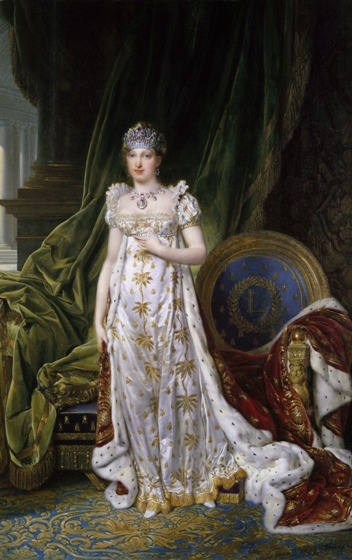
Napoleon still wanted an heir of his own blood. Therefore, he began negotiations with the Czar Alexander of Russia to marry his sister. This would serve three purposes:
1. It would create a strong alliance with another major power
2. It would help to legitimize Napoleon’s somewhat shaky claim to
royalty, and
3. It would give Napoleon a young wife whom could bear his heir.

Negotiations soon fell apart. Napoleon’s foreign minister, Talleyrand, did not want this alliance and made sure it wouldn’t occur by leaking information concerning Napoleon to the Russian Court. The Czar’s mother refused to let her daughter enter into the marriage. Therefore, Napoleon turned his sights on Austria. He arranged to marry Maria-Louisa (whom he renamed Marie Louise because he didn’t like her real name), who was the Emperor of Austria’s favorite daughter and an Archduchess of Austria. Marie Louise was not at all what Napoleon had expected. To marry Marie Louise he first had to divorce Josephine, which he did. However, he had grown to love her again - not the great love he held for her in the beginning - but a respectful love. He insisted that she retain the title of Empress and provided for her and her children.

Napoleon and Marie Louise were married in March, 1810 and they had one child, They remained married until his death, though she did not join him in exile on Elba and thereafter never saw her husband again. The couple had one child, Napoleon Francis Joseph Charles. In 1814, when Napoleon abdicated, Marie-Louise returned to Austria, taking her son with her. Napoleon never saw them again. Josephine continued to love Napoleon and later in the year, as she was dying from diphtheria, Napoleon’s name was one of the last words she uttered, if not the last. Hortense and Eugene continued to be faithful to Napoleon.

Adapted and revised from “Napoleon and Josephine,” The Napoleon Series, 1999-2005. Accessed on April 5, 2015. http://www.napoleon-series.org/research/napoleon/c_napjos.html.

To Josephine

Dec. 29, 1795
I awake all filled with you. Your image and the intoxicating pleasures of last night, allow my senses no rest.

Sweet and matchless Josephine, how strangely you work upon my heart.
Are you angry with me? Are you unhappy? Are you upset?

My soul is broken with grief and my love for you forbids repose. But how can I rest any more, when I yield to the feeling that masters my inmost self, when I quaff from your lips and from your heart a scorching flame?

Yes! One night has taught me how far your portrait falls short of yourself!

You start at midday: in three hours I shall see you again.

Till then, a thousand kisses, mio dolce amor! but give me none back for they set my blood on fire.

Richard Moore, “To Josephine,” Love Letters of Napoleon Bonaparte, 1999. Accessed on April 5, 2015. http://www.napoleonguide.com/lovejos1.htm.

