Marie Antoinette and Maine hardly trip off the tongue together, but an intrepid ship captain from the state nearly saved the life of the French queen. The deposed queen of France was imprisoned and awaiting trial in 1792 when Stephen Clough of Wiscasset arrived at the French port in Harve with a load of lumber aboard the ship Sally. Clough was working for James Swan. A colonel in the American Revolution, Swan was a Scot who emigrated to Boston and was a successful trader, particularly with France.

Swan held large tracts of land in Virginia and also acquired a group of islands off the coast of Maine, including Swan’s Island, which is named for him. In the 1780s, with mounting debts, he turned to his old friend the Marquis de Lafayette to arrange a profitable post supplying goods, including timber, to the French military.

By 1792, however, France was in disarray. The monarchy was being toppled; Lafayette was out of favor, and Clough found his ship Sally and her cargo waylaid. While he tried to sort out what was going on, his vessel drew the attention of supporters of the king, and they began to craft a plot. The royal family had been imprisoned in August and stripped of their titles in September. Their fate was up for debate, with moderates urging that they be allowed to live while radicals wanted them executed. The idea of exile in America was thrown into the debate, and it appealed to Swan.

Jean Pierre de Batz (or de Bance), Baron de Sainte-Croix, was searching for a way to rescue the royal family. He and Alexandre Gonsse de Rougeville, another counter-revolutionary, came up with a plan and approached Clough. They would arrange for the release of his ship and payment for his cargo, and in return he would ferry the royal family to America. Clough accepted the offer and, as his ship lay in the harbor, he began surreptitiously loading it with items for the royal family – furnishings, rugs, tapestries, china, etc.

King Louis XVI and Queen Marie Antoinette remained popular in America, warmly remembered for their support of the colonies in the war with England.

Time was running out, however. The radicals put the king on trial as they wanted in January of 1793. A group of 721 men controlled his fate, as they voted on whether he should be executed. When the voting ended, 361, the minimum needed, voted for execution and he was guillotined.

The sentiment against the queen was now growing more hostile. Once imprisoned, the king, queen, and their two children had all been held separately. Marie Antoinette was increasingly despised. Her profligacy, gambling, and expensive tastes were all resented by an impoverished nation struggling with massive debts.

The propagandists were working overtime to blacken her name further. They created the story that when informed that peasants were starving for lack of bread, she replied: “Let them eat cake.” The queen never said that. In fact, the story had been created and used against others before her, but the legend stuck to Marie Antoinette.

The radicals began looking for more ways to slander her and built spurious charges, including that she abused her son. Her supporters realized they needed to act quickly and sent word to her in prison that they were planning her escape. They planned to have a guard take her to the door of her prison where a carriage would meet her and take her to Clough’s ship. The message was sent in a note wrapped around the stem of a carnation flower. She managed to reply in writing by using a pin to prick holes in the paper. Sick with tuberculosis and, as some researchers believe, cancer, she was ready to leave France.

The plot backfired badly, however, as one of the guards grew afraid and revealed the note to his superiors. The revolution was by now spinning out of control. After the plot, dubbed the “Carnation Conspiracy” was discovered, Marie Antoinette’s captors had even less sympathy. They locked her in a stronger cell and guarded her even more closely.

Clough had managed to tell his wife to prepare for meeting the queen, and by some accounts many in Maine were working out what a proper reception would be. He had warned that far from being the glamorous queen they expected, they should prepare for a very weak and sickly woman. It’s not altogether clear that the plan called for the royal family to remain in Maine or even New England. Some accounts suggest that Swan actually intended to create a colony on his Virginia lands for French exiles.

The radical elements of the revolution began to turn against the moderates and the Reign of Terror got underway. Tens of thousands would be slaughtered before it would end. With the French conspirators now on the run, Clough began to realize that the chances of completing the escape were slim. In October, Marie Antoinette was tried. Her famous head of hair was cut off to give the guillotine a clear shot at her neck, and she was executed. Her body was dumped into an unmarked grave where it would remain until the monarchy was reestablished more than 10 years later.

With the queen dead – some accounts say Clough was among the crowd of thousands who witnessed it – Clough hastily put to sea, lest he be discovered as a collaborator. The French furnishings that Clough was bringing were distributed among the Americans who had supported the plan, many winding up with the Swan household in Boston (now in the Museum of Fine Arts). Others went with Clough to Wiscasset, Edgecomb, Westport, and some wound up in Henry Knox’s Thomaston mansion, probably via his son-in-law who was one of Swan’s sons.

Stories of the attempted rescue of Marie Antoinette made the rounds for years, and Clough was so moved by the experience he named a daughter after her.

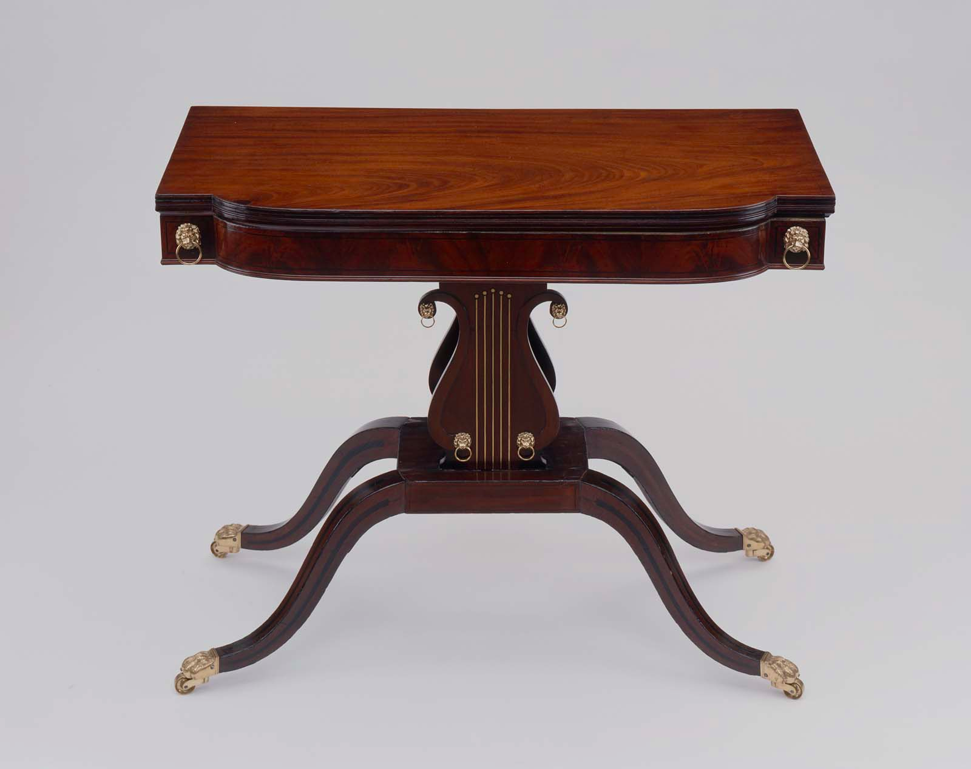
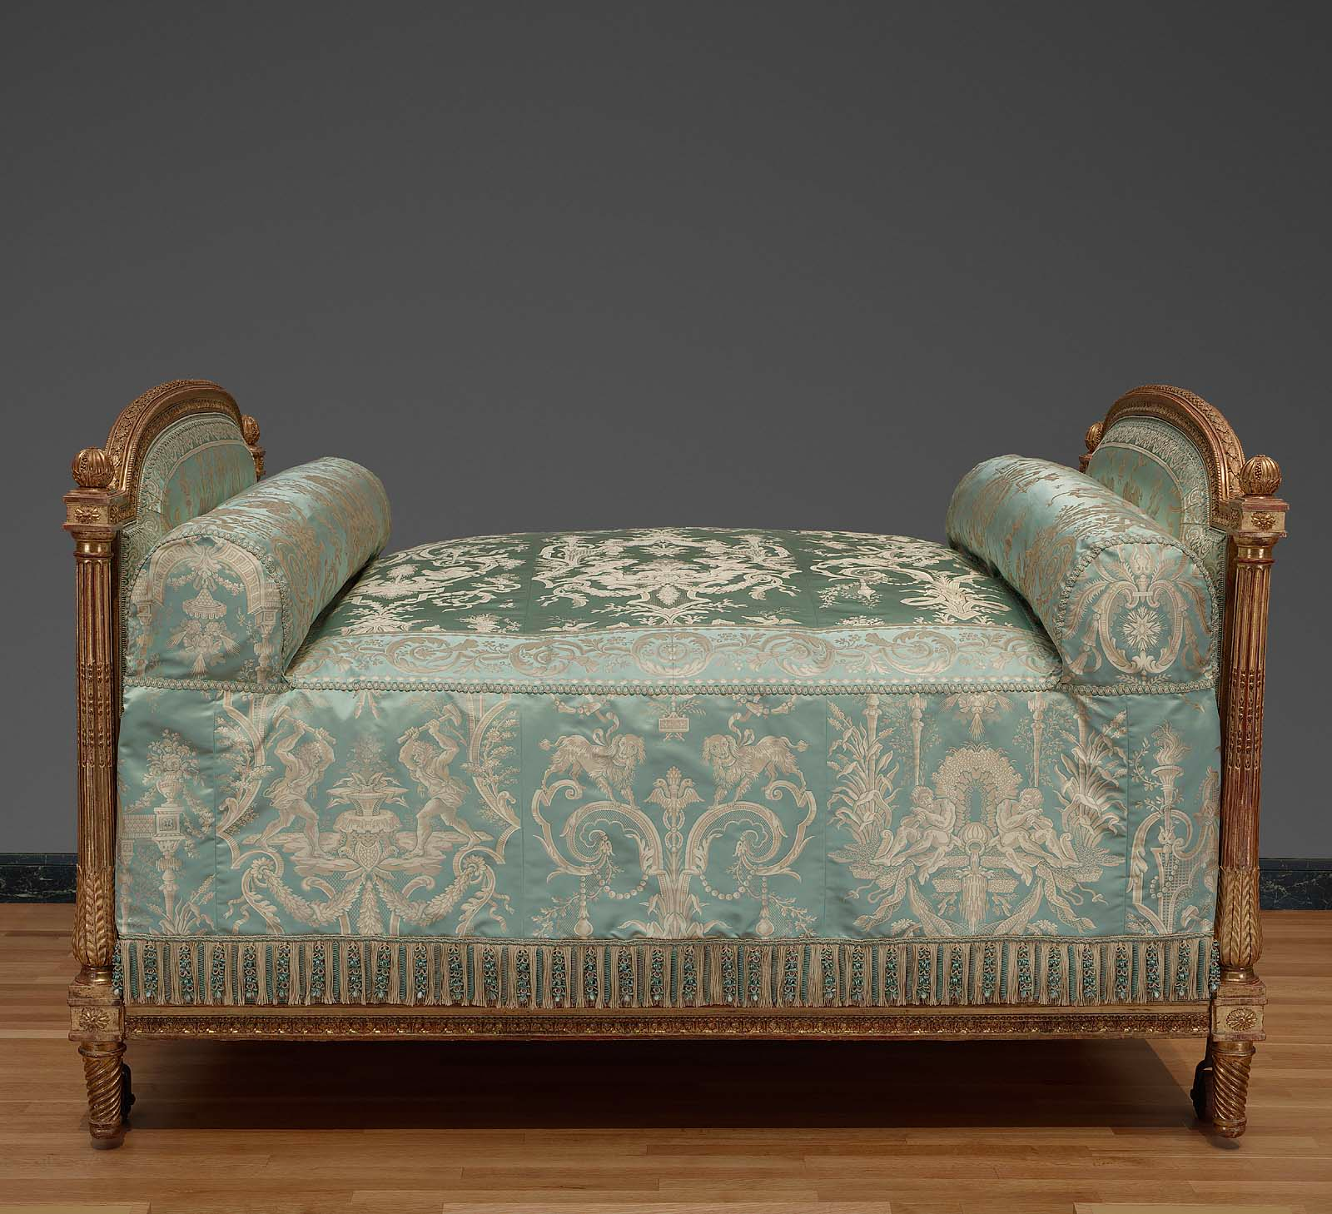

Two of the many items from The Swan Collection, Museum of Fine Arts, Boston.

Adapted and revised from “Let Them Eat Lobster: Marie Antoinette and Maine.” New England Historical Society. Accessed on December 12, 2015. http://www.newenglandhistoricalsociety.com/let-eat-lobster-marie-antoinette-maine/

