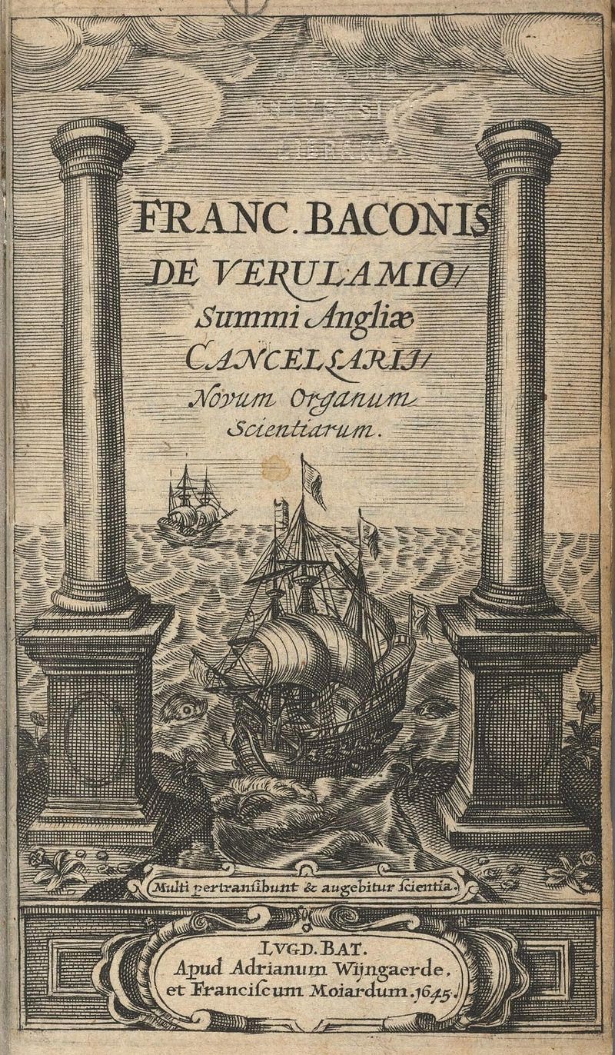
Francis Bacon (1561 – 1626) discovered and popularized the scientific method, whereby the laws of science are discovered by gathering and analyzing data from experiments and observations, rather than by using logic-based arguments, unleashing a wave of new scientific discoveries.

The title page of Novum Organum depicts a galleon passing between the mythical Pillars of Hercules that stand either side of the Strait of Gibraltar, marking the exit from the well-charted waters of the Mediterranean into the Atlantic Ocean. The Pillars, as the boundary of the Mediterranean, have been smashed through opening a new world for exploration. Bacon hopes that empirical investigation will, similarly, smash the old scientific ideas and lead to greater understanding of the world and heavens.

The Latin tag across the bottom – Multi pertransibunt & augebitur scientia – is taken from Daniel 12:4. It means: "Many will travel and knowledge will be increased.”

III
Human knowledge and human power meet in one; for where the cause is not known the effect cannot be produced. Nature to be commanded must be obeyed; and that which in contemplation is as the cause is in operation as the rule.

IV
Towards the effecting of works, all that man can do is to put together or put asunder natural bodies. The rest is done by nature working within.

VII
The productions of the mind and hand seem very numerous in books and manufactures. But all this variety lies in an exquisite subtlety and derivations from a few things already known; not in the number of axioms.

VIII
Moreover the works already known are due to chance and experiment rather than to science; for the sciences we now possess are merely systems for the nice ordering and setting forth of things already invented; not methods of invention or directions for new works.

XI
As the sciences which we now have do not help us in finding out new works, so neither does the logic which we now have help us in finding out new sciences.

XII
The logic now in use serves rather to fix and give stability to the errors which have their foundation in commonly received notions than to help the search after truth. So it does more harm than good.

XIV
The syllogism consists of propositions, propositions consists of words, words are symbols of notions. Therefore if the notions themselves (which is the root of the matter) are confused and over-hastily abstracted from the facts, there can be no firmness in the superstructure. Our only hope therefore lies in a true induction.

XIX
There are and can be only two ways of searching into and discovering truth. The one flies from the senses and particulars to the most general axioms, and from these principles, the truth of which it takes for settled and immovable, proceeds to judgment and to the discovery of middle axioms. And this way is now in fashion. The other derives axioms from the senses and particulars, rising by a gradual and unbroken ascent, so that it arrives at the most general axioms last of all. This is the true way, but as yet untried.

XXII
Both ways set out from the senses and particulars, and rest in the highest generalities; but the difference between them is infinite. For the one just glances at experiment and particulars in passing, the other dwells duly and orderly among them. The one, again, begins at once by establishing certain abstract and useless generalities, the other rises by gradual steps to that which is prior and better known in the order of nature.

XXIV
It cannot be that axioms established by argumentation should avail for the discovery of new works; since the subtlety of nature is greater many times over than the subtlety of argument. But axioms duly and orderly formed from particulars easily discover the way to new particulars, and thus render sciences active.

XXV
The axioms now in use, having been suggested by a scanty and manipular experience and a few particulars of most general occurrence, are made for the most part just large enough to fit and take these in: and therefore it is no wonder if they do not lead to new particulars. And if some opposite instance, not observed or not known before, chance to come in the way, the axiom is rescued and preserved by some frivolous distinction; whereas the truer course would be to correct the axiom itself.

XXXI
It is idle to expect any great advancement in science from the superinducing and engraving of new things upon old. We must begin anew from the very foundations, unless we would revolve for ever in a circle with mean and contemptible progress.

XXXVI
One method of delivery alone remains to us; which is simply this: We must lead men to the particulars themselves, and their series and order; while men on their side must force themselves for awhile to lay their notions by and begin to familiarise themselves with facts.

XLVI
The human understanding when it has once adopted an opinion (either as being the received opinion or as being agreeable to itself) draws all things else to support and agree with it. And though there be a greater number and weight of instances to be found on the other side, yet these it either neglects and despises, or else by some distinction sets aside and rejects; in order that by this great and pernicious predetermination the authority of its former conclusions may remain inviolate. And therefore it was a good answer that was made by one who when they showed him hanging in a temple a picture of those who had paid their vows as having escaped shipwreck, and would have him say whether he did not now acknowledge the power of the gods,-"Aye," asked he again, "but where are they painted that were drowned, after their vows?" And such is the way of all superstition, whether in astrology, dreams, omens, divine judgments, or the like; wherein men, having a delight in such vanities, mark the events where they are fulfilled, but where they fail, though this happen much oftener, neglect and pass them by. But with far more subtlety does this mischief insinuate itself into philosophy and the sciences; in which the first conclusion colours and brings into conformity with itself all that come after, though far sounder and better. Besides, independently of that delight and vanity which I have described, it is the peculiar and perpetual error of human intellect to be more moved and excited by affirmatives than by negatives; whereas it ought properly to hold itself indifferently disposed towards both alike. Indeed in the establishment of any true axiom, the negative instance is the more forcible of the two.

C
But not only is a greater abundance of experiments to be sought for and procured, and that too of a different kind from those hitherto tried; an entirely different method, order, and process for carrying on and advancing experience must also be introduced. For experience, when it wanders in its own track, is, as I have already remarked, mere groping in the dark, and confounds men rather than instructs them. But when it shall proceed in accordance with a fixed law, in regular order, and without interruption, then may better things be hoped of knowledge.

CIV
The understanding must not however be allowed to jump and fly from particulars to remote axioms and of almost the highest generality (such as the first principles, as they are called, of arts and things), and taking stand upon them as truths that cannot be shaken, proceed to prove and frame the middle axioms by reference to them; which has been the practice hitherto; the understanding being not only carried that way by a natural impulse, but also by the use of syllogistic demonstration trained and inured to it. But then, and then only, may we hope well of the sciences, when in a just scale of ascent, and by successive steps not interrupted or broken, we rise from particulars to lesser axioms; and then to middle axioms, one above the other; and last of all to the most general. For the lowest axioms differ but slightly from bare experience, while the highest and most general (which we now have) are notional and abstract and without solidity. But the middle are the true and solid and living axioms, on which depend the affairs and fortunes of men; and above them again, last of all, those which are indeed the most general; such I mean as are not abstract, but of which those intermediate axioms are really limitations.
The understanding must not therefore be supplied with wings, but rather hung with weights, to keep it from leaping and flying. Now this has never been done; when it is done, we may entertain better hopes of the sciences.

CV
In establishing axioms, another form of induction must be devised than has hitherto been employed; and it must be used for proving and discovering not first principles (as they are called) only, but also the lesser axioms, and the middle, and indeed all. For the induction which proceeds by simple enumeration is childish; its conclusions are precarious, and exposed to peril from a contradictory instance; and it generally decides on too small a number of facts, and on those only which are at hand. But the induction which is to be available for the discovery and demonstration of sciences and arts, must analyse nature by proper rejections and exclusions; and then, after a sufficient number of negatives, come to a conclusion on the affirmative instances; which has not yet been done or even attempted, save only by Plato, who does indeed employ this form of induction to a certain extent for the purpose of discussing definitions and ideas. But in order to furnish this induction or demonstration well and duly for its work, very many things are to be provided which no mortal has yet thought of: insomuch that greater labour will have to be spent in it than has hitherto been spent on the syllogism. And this induction must be used not only to discover axioms, but also in the formation of notions. And it is in this induction that our chief hope lies.

CVI
But in establishing axioms by this kind of induction, we must also examine and try whether the axiom so established be framed to the measure of those particulars only from which it is derived, or whether it be larger and wider. And if it be larger and wider, we must observe whether by indicating to us new particulars it confirm that wideness and largeness as by a collateral security; that we may not either stick fast in things already known, or loosely grasp at shadows and abstract forms; not at things solid and realised in matter. And when the process shall have come into use, then at last shall we see the dawn of a solid hope.]

The following is Aphorism X from the Second Book of Aphorisms.
Now my directions for the interpretation of nature embrace two generic divisions; the one how to educe and form axioms from experience; the other how to deduce and derive new experiments from axioms. The former again is divided into three ministrations; a ministration to the sense, a mainstration to the memory, and a ministration to the mind or reason.

For first of all we must prepare a Natural and Experimental History, sufficient and good; and this is the foundation of all; for we are not to imagine or suppose, but to discover, what nature does or may be made to do.

But natural and experimental history is so various and diffuse, that it confounds and distracts the understanding, unless it be ranged and Presented to view in a suitable order. We must therefore form Tables and Arrangements of Instances, in such a method and order that the understanding may be able to deal with them.

And even when this is done, still the understanding, if left to itself and its own spontaneous movements, is incompetent and unfit to form axioms, unless it be directed and guarded. Therefore in the third place we must use Induction, true and legitimate induction, which is the very key of interpretation.

