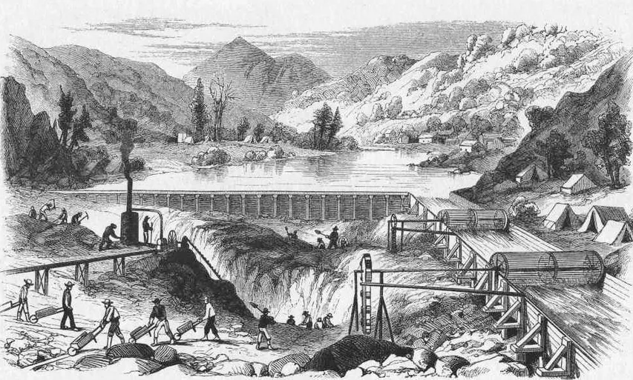

*Gold miners excavate a California riverbed in this 1850s Harper’s Weekly illustration.*

Come March or April of each year, after our umpteenth snowstorm hits and we swear we may never see the sun again, many Mainers start grumbling about fleeing the state for good in search of warmth.

Those are usually empty threats, as we push back memories of the winter hardships once the summer rolls around. But that wasn’t the case during the War of 1812 and its aftermath, when the storied allure of the American west - which at the time was only as far as Ohio - was all the more tempting when compared to a string of brutally cold Maine winters.

In his book “Liberty Men and Great Proprietors,” author Alan Taylor reportedly estimated that 20,000 people left Maine during the so-called “Ohio Fever” during a time when the district - it wasn’t a state yet - had less than 230,000 people.

At about 9 percent of the population, that would be like if more than 115,000 people poured out of the state in a wave today.

Like with the citizens of many states, the promise of gold and new frontiers continued to attract Mainers through the middle of the 19th century. Those with expertise in the lumber industry found their skills particularly useful in new communities seeking to grow economies and construct buildings.

What many people may not realize today is that Mainers following the westward trail of opportunity ended up as key figures in the development of several prominent American cities and states, helping transform the country as they went.

Three Minneapolis mayors were from Maine in the 1860s and 1870s, for instance. In the mid- to late 19th century, three San Francisco mayors, two California governors, two Washington governors, one Oregon governor and one Chicago mayor had Maine roots.

Three brothers from one Livermore family - the Washburns - became 19th century congressmen representing Minnesota, Illinois and Wisconsin, respectively (one of the brothers, Israel Washburn, Jr., stayed in Maine and went to the U.S. House of Representatives from here, while another would move to California and invent an early version of the typewriter).

And of course, most people from Portland, Maine, are quick to point out that Portland, Oregon, has that name because Maine migrant Francis Pettygrove won the naming rights in an 1845 coin toss.

Here are a few other ways those Maine migrants helped build the America we know today, for better or for worse:

**San Francisco is called, well, San Francisco**

After Pettygrove, perhaps the first prominent Mainer to put his stamp on the Old West in a lasting way was Washington Allon Bartlett, a Navy officer aboard the sloop USS Portsmouth when the Mexican-American War broke out.

Having the somewhat unusual skill of being able to speak fluent Spanish, Bartlett was tapped to take charge of the diverse coastal city of Yerba Buena soon after the United States claimed the territory of California in 1846.

The first to be formally elected mayor of the new American city just a few months later, Bartlett would go on to change the name of Yerba Buena to San Francisco.

After the war and his mayoral term, Bartlett would reportedly conduct the first major survey of the Columbia River, a key border waterway between Washington and Oregon.

**Minnesota’s Twin Cities became twins and a titan of finance was born**

After building up some wealth as a Bangor lumber merchant, Dorilus Morrison took his trade to the forested Minnesota, where he would grow his prominence and serve as a state senator and two terms as Minneapolis mayor.

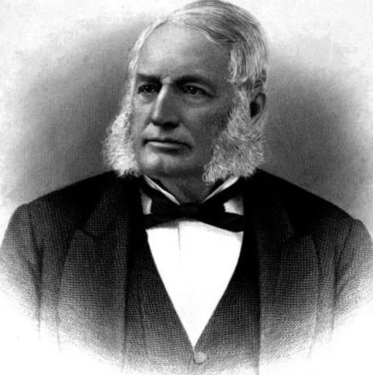

Morrison led the construction of the city’s first street car line in the 1870s and, rallying fellow area businessmen to the cause, fought for the line to be connected to one in neighboring St. Paul, establishing a crucial transportation bond between the two places.

The newly established Twin City Rapid Transit would flourish for nearly a century, and serve as a predecessor to today’s bus and light rail system that connects

*Dorilus Morrison* Minneapolis and St. Paul.

Morrison was also the founding president of the Northwestern National Bank of Minneapolis, which decades later would be among the financial institutions to survive the Great Depression and become what we know today as Wells Fargo.

**There’s a USC-UCLA sports rivalry**

Nothing’s quite as American as big time college football rivalries — they draw huge crowds, drive up television ratings and play a significant role in the country’s fall entertainment landscape.

The rivalry between University of Southern California and University of California-Los Angeles is one of the most storied and intense in American college sports.

According to the California State Library, in the four years Kennebunkport native George C. Perkins served as governor of the state — 1880-1883 — both of the schools were established, changing the country’s higher education and, eventually, sports landscapes forever.

Perkins would go on to represent California for 22 years in the U.S. Senate, where he became known as an unapologetic pro-business politician.

*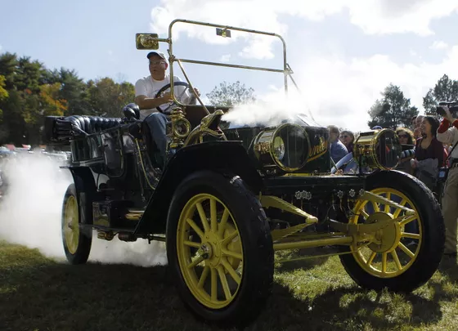***Fear-based advertising campaigns became a thing**

While public attacks through the media go back to the very infancy of media, the desperate and negative advertising campaign launched by the Stanley Motor Carriage Co. against the nascent gas-powered automobiles is considered among the earliest examples of what’s now widely known as a “fear, uncertainty and doubt” campaign.

*Collector Joe Shukay drives off in a 1911 Stanley Steamer at the Rockville, Maryland, annual antique and classic car show October 20, 2012. (Reuters photo by Gary Cameron)*

The Stanley twins, Freelan and Francis, were born in 1849 in Kingfield and would develop their groundbreaking steam-powered automobile just before the turn of the 20th century.

While their innovative company would be based no farther than Massachusetts, Freelan became a key figure in Colorado, establishing the lavish Stanley Hotel, a magnet for the American elite and ultimately the inspiration for Stephen King’s spooky bestseller “The Shining.”

But long before the King of Horror would use a Stanley creation to strike fear in readers, the brothers’ company would use the primal emotion to drive sales. According to StanleyMotorCarriage.com, the company loudly derided the gas-powered alternatives in advertisements as “internal explosion engines,” opting to try and convince buyers their rivals’ products were rolling bombs instead of highlighting any real benefits of their own steam-powered cars.

Today, these types of coordinated fear campaigns are all-too-common, but at the time, they were still a somewhat new departure from advertisers’ long history of over-promising miracles.

The Stanley campaign didn’t work. Cheaper, mass produced automobiles like the Ford Model-T squeezed the Stanley steamers from the marketplace and the Stanley plant closed for good in 1924.

**Schools became publicly funded through taxes**

Throughout most of Washington’s then-brief history, local education was funded largely by the sales of government-owned acreage designated for schools.

That method of fundraising was unsustainable and, because certain areas of the state were more highly coveted than others, created dramatic inequality between the resources available to different schools.

Gov. John R. Rodgers - who came to the state from Brunswick, Maine, after a circuitous migration west that included stints in Massachusetts, Mississippi, Illinois and Kansas — ushered the so-called “Barefoot Schoolboy Act” into law in 1895, establishing for the first time a form of property tax that would be dedicated to funding local schools.

Under the new law, the taxes were divided by child - $6 per student, at the time - and not by district. Although the law isn’t a perfect match for the systems of public education funding seen throughout the country today, it’s certainly now common for property taxes to be dedicated to local education, and for state funding - like it is in Maine - to be allocated based on per-pupil costs.

Of course, these aren’t the only ways Mainers went out and changed the country - or the world - around them, but serve as a few good examples of the impacts made by our statesmen in forming the America we take for granted today.

Seth Koenig. “Down East Out West: How the Maine Migration Helped Form the Rest of America.” *Bangor Daily News*. July 15, 2015. <http://thinkmaine.bangordailynews.com/2015/07/15/history-and-politics/down-east-out-west-how-the-maine-migration-helped-form-the-rest-of-america/>