DIRECTIONS: Read the following handout thoroughly, using a highlighter to highlight any information you think might be historically important. Write a note in the margins next to the highlighted text that will help you remember the information.

Would you sail into the unknown?
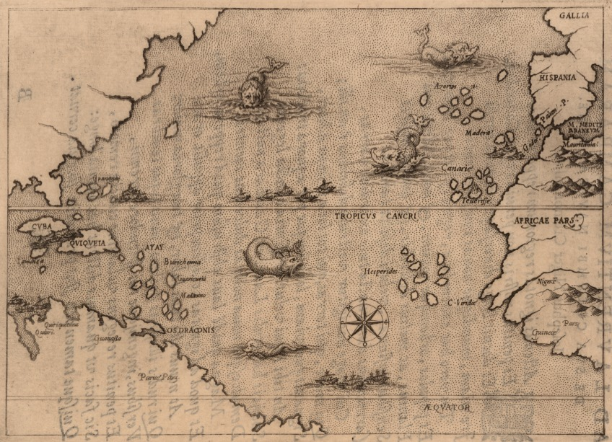
It is a gray morning in 1430. You are standing on a dock in the European country of Portugal, staring out at the mysterious Atlantic Ocean. You have been asked to go on a voyage of exploration. Yet, like most people at the time, you have no idea what lies beyond the horizon. The maps that have been drawn show some of the dangers you might face. And you’ve heard the terrifying stories of sea monsters and shipwrecks. You also have heard that riches await those who help explore and claim new lands. Now, you must decide whether to go.

Map illustrating the voyages of Christopher Columbus, by Lorenzo Gambara, 1500s

By the early 1400s, Europeans were ready to venture beyond their borders, encouraged by the new spirit of adventure and curiosity born during the Renaissance. These explorations began a long process that would bring together the peoples of many different lands and permanently change the world.

For “God, Glory, and Gold”
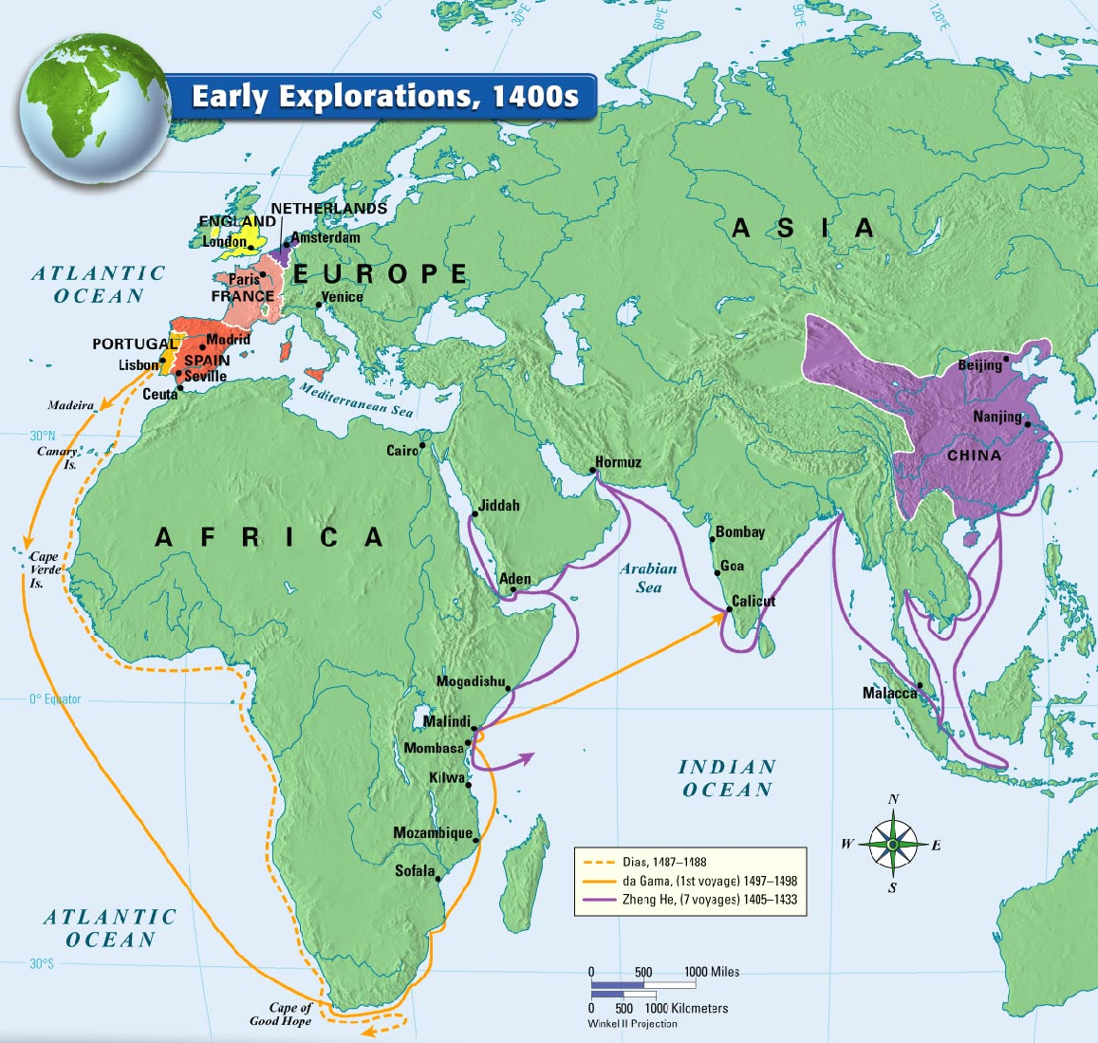
Europeans had not been completely isolated from the rest of the world before the 1400s. Beginning around 1100, European crusaders battled Muslims for control of the Holy Lands in Southwest Asia. In 1275, the Italian trader Marco Polo reached the court of Kublai Khan in China. For the most part, however, Europeans had neither the interest nor the ability to explore foreign lands. That changed by the early 1400s. The desire to grow rich and to spread Christianity, coupled with advances in sailing technology, spurred an age of European exploration.

Europeans Seek New Trade Routes
The desire for new sources of wealth was the main reason for European exploration. Through overseas exploration, merchants and traders hoped ultimately to benefit from what had become a profitable business in Europe: the trade of spices and other luxury goods from Asia. The people of Europe had been introduced to these items during the Crusades, fought between Christians and Muslims from 1096 to 1270. After the Crusades ended, Europeans continued to demand such spices as nutmeg, ginger, cinnamon, and pepper, all of which added flavor to the bland foods of Europe. Because demand for these goods was greater than the supply, merchants could charge high prices and thus make great profits.
The Muslims and the Italians controlled trade from East to West. Muslims sold Asian goods to Italian merchants, who controlled trade across the land routes of the Mediterranean region. The Italians resold the items at increased prices to merchants throughout Europe.

Traders from other regions of Europe did not like this arrangement, as paying such high prices to the Italians severely cut into their own profits. By the 1400s, European merchants - as well as the new monarchs of England, Spain, Portugal, and France - sought to bypass the Italian merchants. This meant finding a sea route directly to Asia.

The Spread of Christianity
The desire to spread Christianity also motivated Europeans to explore. The Crusades had left Europeans with a taste for spices, but more significantly with feelings of hostility between Christians and Muslims. European countries believed that they had a sacred duty not only to continue fighting Muslims, but also to convert non-Christians throughout the world.

Europeans hoped to obtain popular goods directly from the peoples of Asia. They also hoped to Christianize them. Bernal Díaz del Castillo, an early Spanish explorer, explained his motives: “To serve God and His Majesty, to give light to those who were in darkness and to grow rich as all men desire to do.”
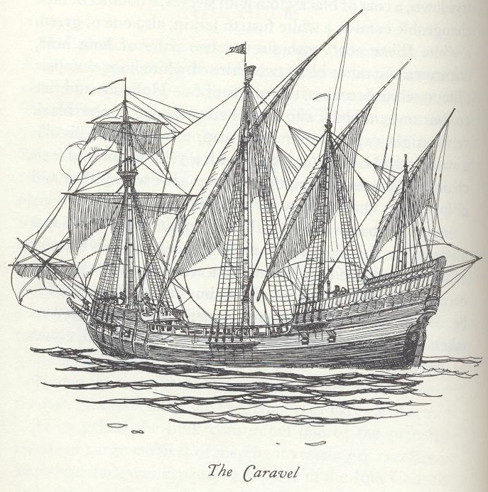
Technology Makes Exploration Possible
While “God, glory, and gold” were the primary motives for exploration, advances in technology made the voyages of discovery possible. During the 1200s, it would have been nearly impossible for a European sea captain to cross 3,000 miles of ocean and return again as European ships could not sail against the wind. In the 1400s, shipbuilders designed a new vessel, the caravel. The caravel was sturdier than earlier vessels and triangular sails adopted from the Arabs allowed it to sail effectively against the wind.
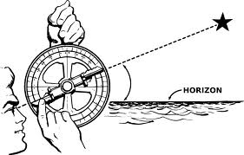
Europeans also improved their navigational techniques. To better determine their location at sea, sailors used the Muslim astrolabe, a brass circle with carefully adjusted rings marked off in degrees, used to sight the stars, and calculate latitude, or how far north or south of the equator the ship was. Explorers were also able to more accurately track direction by using a magnetic compass, a Chinese invention.

Portugal Leads the Way
Located on the Atlantic Ocean at the southwest corner of Europe, Portugal was the first European country to establish trading outposts along the west coast of Africa. Eventually, Portuguese explorers pushed farther east into the Indian Ocean and became the leader in developing and applying new sailing innovations.

The Portuguese Explore Africa
Portugal took the lead in overseas exploration in part due to strong government support. The nation’s most enthusiastic supporter of exploration was Prince Henry, the son of Portugal’s king. Henry’s dreams of overseas exploration began in 1415 when he helped conquer the Muslim city of Ceuta in North Africa. There, he had his first glimpse of the dazzling wealth that lay beyond Europe. In Ceuta, the Portuguese invaders found exotic stores filled with pepper, cinnamon, cloves, and other spices. In addition, they encountered large supplies of gold, silver, and jewels.

Henry returned to Portugal determined to reach the source of these treasures in the East. The prince also wished to spread the Christian faith. In 1419, Henry founded a navigation school on the southwestern coast of Portugal. Mapmakers, instrument makers, shipbuilders, scientists, and sea captains gathered there to perfect their trade.

Within several years, Portuguese ships began sailing down the western coast of Africa. By the time Henry died in 1460, the Portuguese had established a series of trading posts along western Africa’s shores. There, they traded with Africans for such profitable items as gold and ivory. Eventually, they traded for African captives to be used as slaves. Having established their presence along the African coast, Portuguese explorers plotted their next move. They would attempt to find a sea route to Asia.

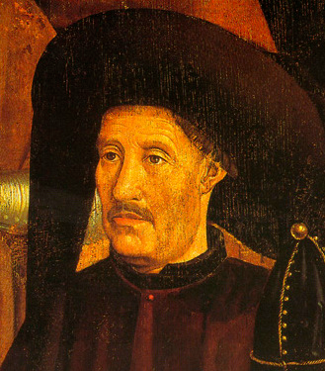
Prince Henry 1394–1460
Historians call Prince Henry “the Navigator” due to his role in promoting Portuguese exploration. A devout Catholic, Henry wanted “to make increase in the faith of our lord Jesus Christ and bring to him all the souls that should be saved” and although he never went on voyages of discovery, Henry was consumed by the quest to find new lands and to spread Christianity. Henry used his own fortune to organize more than 14 voyages along the western coast of Africa, previously unexplored by Europeans. As a result, Henry died in debt. The Portuguese crown spent more than 60 years paying off his debts.

Portuguese Sailors Reach Asia
The Portuguese believed that to reach Asia by sea, they would have to sail around the southern tip of Africa. In 1488, Portuguese captain Bartolomeu Dias ventured far down the coast of Africa until he and his crew reached the tip. As they arrived, a huge storm rose and battered the fleet for days. When the storm ended, Dias realized his ships had been blown around the tip to the other side. Dias explored the southeast coast of Africa and then considered sailing to India. However, his crew was exhausted and food supplies were low. As a result, the captain returned home.

With the tip of Africa finally rounded, the Portuguese continued pushing east. In 1497, Portuguese explorer Vasco da Gama began exploring the east African coast. In 1498, he reached the port of Calicut, on the southwestern coast of India. Da Gama and his crew were amazed by the spices, rare silks, and precious gems that filled Calicut’s shops. The Portuguese sailors filled their ships with such spices as pepper and cinnamon and returned to Portugal in 1499. Their cargo was worth 60 times the cost of the voyage. Da Gama’s remarkable voyage of 27,000 miles had given Portugal a direct sea route to India.

Spain Also Makes Claims
As the Portuguese were establishing trading posts along the west coast of Africa, Spain watched with increasing envy. The Spanish monarchs also desired a direct sea route to Asia.

In 1492, an Italian sea captain, Christopher Columbus, convinced Spain to finance a bold plan: finding a route to Asia by sailing west across the Atlantic Ocean. In October of that year, Columbus reached an island in the Caribbean. He was mistaken in his thought that he had reached the East Indies. But his voyage would open the way for European colonization of the Americas - a process that would forever change the world. The immediate impact of Columbus’s voyage, however, was to increase tensions between Spain and Portugal.

The Portuguese believed that Columbus had indeed reached Asia. Portugal suspected that Columbus had claimed for Spain lands that Portuguese sailors might have reached first. The rivalry between Spain and Portugal grew more tense. In 1493, Pope Alexander VI stepped in to keep peace between the two primarily Catholic nations. He suggested an imaginary dividing line, drawn north to south, through the Atlantic Ocean. All lands to the west of this line, known as the Line of Demarcation, would be Spain’s. These lands included most of the Americas. All lands to the east of the line would belong to Portugal.

Portugal complained that the line gave too much to Spain. So it was moved farther west to include parts of modern-day Brazil for the Portuguese. In 1494, Spain and Portugal signed the Treaty of Tordesillas, in which they agreed to honor the line. The era of exploration and colonization was about to begin in earnest.

Trading Empires in the Indian Ocean
With da Gama’s voyage, Europeans had finally opened direct sea trade with Asia. They also opened an era of violent conflict in the East. European nations scrambled to establish profitable trading outposts along the shores of South and Southeast Asia. And all the while they battled the region’s inhabitants, as well as each other.

Portugal’s Trading Empire
In the years following da Gama’s voyage, Portugal built a bustling trading empire throughout the Indian Ocean. As the Portuguese moved into the region, they took control of the spice trade from Muslim merchants. In 1509, Portugal extended its control over the area when it defeated a Muslim fleet off the coast of India in the Battle of Diu, a victory made possible by the cannons they had added aboard their ships.

Portugal strengthened its hold on the region by building a fort at Hormuz in 1514. It established control of the Straits of Hormuz, connecting the Persian Gulf and Arabian Sea, and helped stop Muslim traders from reaching India.

In 1510, the Portuguese captured Goa, a port city on India’s west coast. They made it the capital of their trading empire. They then sailed farther east to Indonesia, also known as the East Indies. In 1511, a Portuguese fleet attacked the city of Malacca on the west coast of the Malay Peninsula. In capturing the town, the Portuguese seized control of the Strait of Malacca. Seizing this waterway gave them control of the Moluccas. These were islands so rich in spices that they became known as the Spice Islands.

In convincing his crew to attack Malacca, Portuguese sea captain Afonso de Albuquerque stressed his country’s intense desire to crush the Muslim-Italian domination over Asian trade:

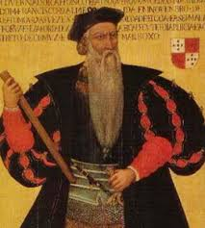
If we deprive them [Muslims] of this their ancient market there, there does not remain for them a single port in the whole of these parts, where they can carry on their trade in these things. . . . I hold it as very certain that if we take this trade of Malacca away out of their hands, Cairo and Mecca are entirely ruined, and to Venice will no spiceries… [be]… conveyed except that which her merchants go and buy in Portugal.

Afonso de Albuquerque,
The Commentaries of the Great Afonso Dalbuquerque

Portugal did break the old Muslim-Italian domination on trade from the East, much to the delight of European consumers. Portuguese merchants brought back goods from Asia at about one-fifth of what they cost when purchased through the Arabs and Italians. As a result, more Europeans could afford these items.

In time, Portugal’s success in Asia attracted the attention of other European nations. As early as 1521, a Spanish expedition led by Ferdinand Magellan arrived in the Philippines. Spain claimed the islands and began settling them in 1565. By the early 1600s, the rest of Europe had begun to descend upon Asia. They wanted to establish their own trade empires in the East.

Other Nations Challenge the Portuguese
Beginning around 1600, the English and Dutch began to challenge Portugal’s dominance over the Indian Ocean trade. The Dutch Republic, also known as the Netherlands, was a small country situated along the North Sea in northwestern Europe. Since the early 1500s, Spain had ruled the area. In 1581, the people of the region declared their independence from Spain and established the Dutch Republic.
In a short time, the Netherlands became a leading sea power. By 1600, the Dutch owned the largest fleet of ships in the world - 20,000 vessels. Pressure from Dutch and also English fleets eroded Portuguese control of the Asian region. The Dutch and English then battled one another for dominance of the area.

Both countries had formed an East India Company to establish and direct trade throughout Asia. These companies had the power to mint money, make treaties, and even raise their own armies. The Dutch East India Company was richer and more powerful than England’s company. As a result, the Dutch eventually drove out the English and established their dominance over the region.
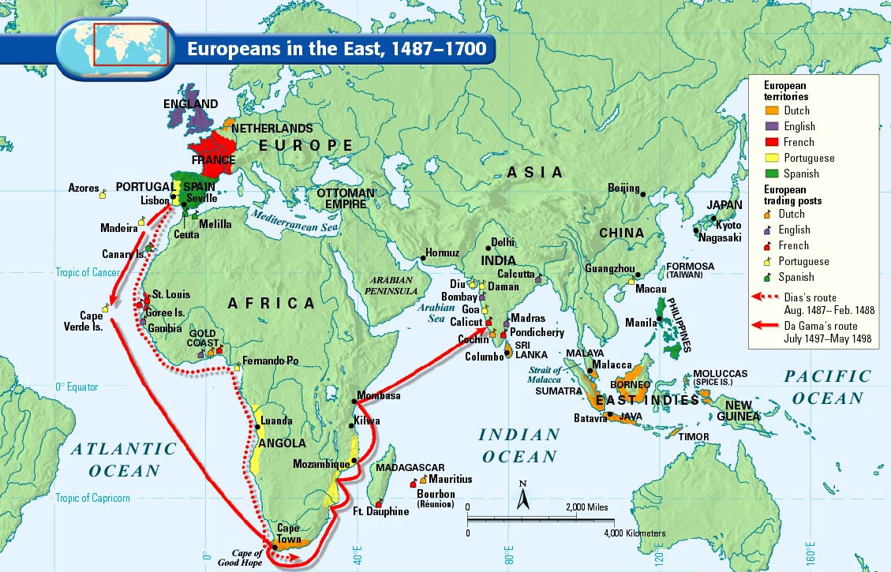
Dutch Trade Outposts
In 1619, the Dutch established their trading headquarters at Batavia on the island of Java. From there, they expanded west to conquer several nearby islands. In addition, the Dutch seized both the port of Malacca and the valuable Spice Islands from Portugal. Throughout the 1600s, the Netherlands increased its control over the Indian Ocean trade. With so many goods from the East traveling to the Netherlands, the nation’s capital, Amsterdam, became a leading commercial center. By 1700, the Dutch ruled much of Indonesia and had trading posts in several Asian countries. They also controlled the Cape of Good Hope on the southern tip of Africa, which was used as a resupply stop.
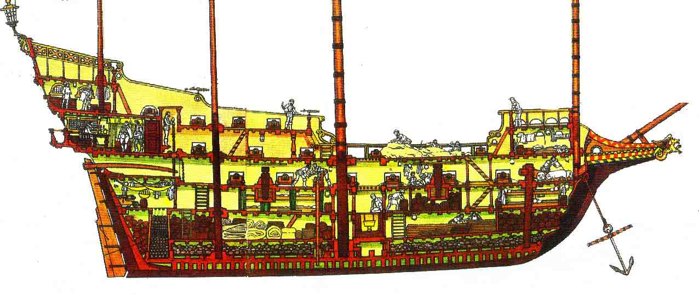
A Ship’s Rations
The captain of a 17th-century sailing vessel, with a crew of 190 sailors, would normally order the following food items for a three-month trip:
- 8,000 pounds of salt beef; 2,800 pounds of salt pork; 600 pounds of salt cod; a few beef tongues
- 15,000 brown biscuits; 5,000 white biscuits
- 30 bushels of oatmeal; 40 bushels of dried peas; 1 1/2 bushels of mustard seed
- 1 barrel of salt; 1 barrel of flour
- 11 small wooden casks of butter; 1 large cask of vinegar
- 10,500 gallons of beer; 3,500 gallons of water; 2 large casks of cider

British and French Traders
By 1700 also, Britain and France had gained a foothold in the region. Having failed to win control of the larger area, the English East India Company focused much of its energy on establishing outposts in India. There, the English developed a successful business trading Indian cloth in Europe. In 1664, France also entered the Asia trade with its own East India Company. It struggled at first, as it faced continual attacks by the Dutch. Eventually, the French company established an outpost in India in the 1720s. However, it never showed much of a profit.

As the Europeans battled for a share of the profitable Indian Ocean trade, their influence inland in Southeast Asia remained limited. European traders did take control of many port cities in the region. But their impact rarely spread beyond the ports. From 1500 to about 1800, when Europeans began to conquer much of the region, the peoples of Asia remained largely unaffected by European contact. European traders who sailed farther east to seek riches in China and Japan had even less success in spreading Western culture.

