The Index of Prohibited Books specified that works such as the Koran, the Talmud, works by Luther and Calvin and books that contained themes on necromancy, superstition, divination and sexuality were forbidden.

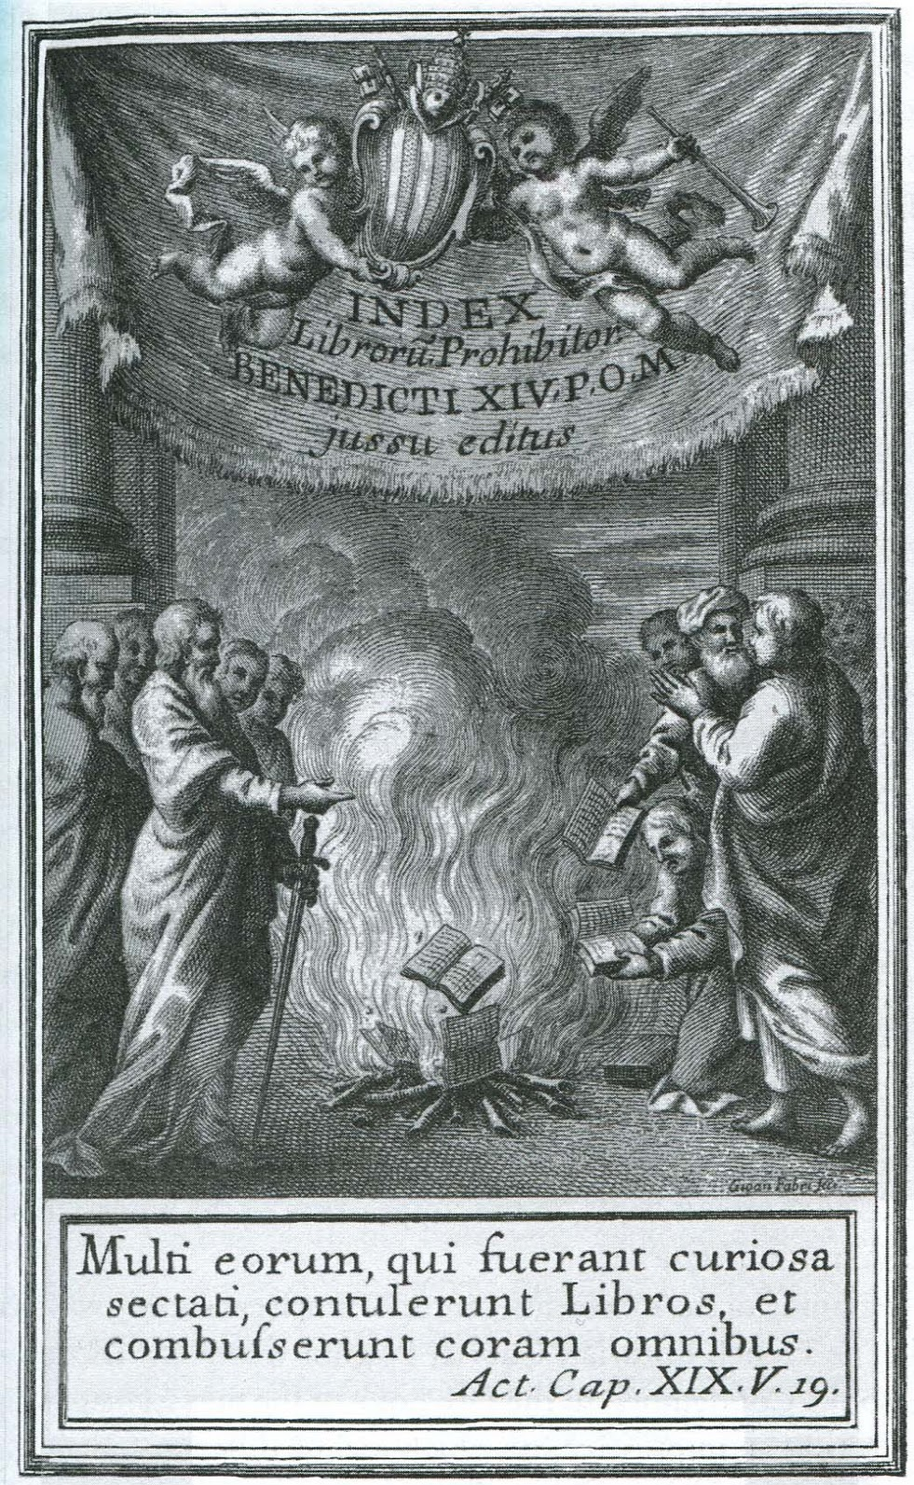

Image of the "Rome edition of the Catholic 'Index of Prohibited Books.'”

