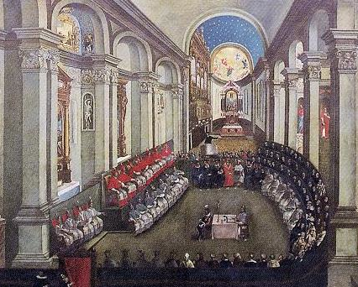

The Council of Trent meeting in Santa Maria Maggiore church, Trento (Trent).
(Artist unknown; painted late 17th century.)

