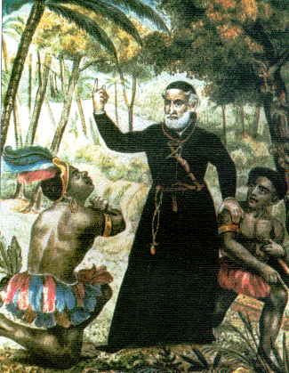

Anthony Vieira:
a colorful Jesuit of the 17th century who worked among the Amazon Indians

