Who can register and vote in Maine?
To register, you must be a United States citizen, at least 17 years of age, and have established a fixed principal home in Maine. To vote in a Referendum or General Election, you must be registered in the community where you reside, and be at least 18 years of age. A 17 year old may vote in a Primary Election, if that person will be 18 by the General Election.

How do I register to vote?
You fill out a voter registration card. See the sample card and instructions below.

Where do I go to register?
You can register to vote at your town office or city hall, through any Motor Vehicle branch office, in most state & federal social service agencies, or at voter registration drives.
Completed voter registration cards may be hand delivered or mailed to your town office or city hall, or sent to the Secretary of State's Office in Augusta.

Is there a deadline for registering?
There is no cut-off date for registering to vote in person at your town office or city hall. If you want to register to vote by mail or through a voter registration drive, the cut-off date is the close of business on the 21st day before the election. That date is Tuesday, October 13, 2015 for the Referendum Election.

When is the next election?
The November 3, 2015, Referendum Election, is the next statewide election.

Where do I go to vote?
Every town and city has its own places where people vote, called voting places or "the polls". You can call your town office or city hall to find out where you vote. Voting places open between 6:00 a.m. and 10:00 a.m., depending on the population of the town. Local officials can give you the exact opening time for your community. All voting places close at 8:00 p.m. on Election Day.

How do I mark a ballot?
Each ballot tells you how to mark your choices. If you have a question, ask an election official. If you make a mistake, fold your ballot and give it to an election official. The election official will give you another ballot.

Can I have help voting?
Yes. If you need help reading or marking the ballot, you may ask a relative or friend for assistance. The helper does not have to be a voter or old enough to vote. An election official can also help you read or mark a ballot. However, your employer or union official cannot help you vote.

Do I need to go to the polls on Election Day to vote?
No. Any registered voter may cast an absentee ballot instead of voting in person at the voting place.
You do not need to have a specific reason or be unable to vote at the voting place on Election Day to use an absentee ballot. Call your town or city clerk for an application and assistance.

THE MAINE VOTER REGISTRATION CARD
All required items on the card must be completed or it may be rejected.

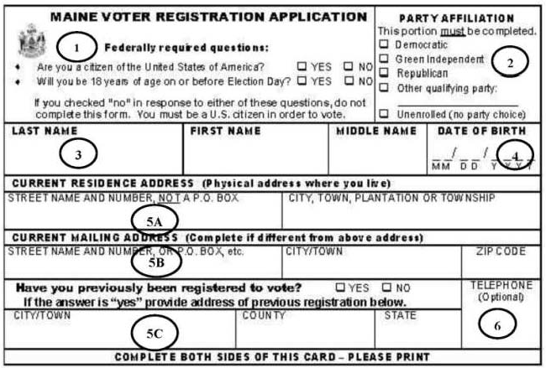

1. Federally required questions. (Required)
A person who is not a U.S. Citizen is not eligible to register to vote. A person who is at least 17 years of age may register to vote, but must be at least 18 years of age to vote in a Municipal, General or Referendum election.

2. Party affiliation. (Required) Voters must check the box if they want to be a member of one of the three qualified political parties in Maine, in order to participate in party primaries, caucuses, conventions or other political party activities. Voters who check “Other qualifying party” (with or without writing a designation on the line provided) and voters who choose Unenrolled (no party choice) will be designated as “U” on the voting list and will not be eligible to vote in party primaries, caucuses and conventions, but can vote in other elections.

3. Name of Voter. (Required) A voter must provide the voter’s legal name, as follows:
Last name (surname) must be listed (Suffixes, such as Sr., Jr., II, etc, may be included) and First name and the middle name or initial; or
First initial and full middle name; or
First name only

4. Date of Birth. (Required) Voters must be at least 18 years of age in order to vote. Under Maine law, 17-year olds may pre-register (and enroll if desired).

5. Current residence address. (Required) Voters must provide the current street address or physical location where they have established their residence. This cannot be a P.O. Box.
A. Current mailing address. (If applicable) The mailing address is required only if it is different from the residence address, and is where the voter receives mail. This can be a P.O. Box.
B. Previous registration address. (Required) If a voter previously has been registered to vote, the voter must check the “YES” box and must provide municipality, county and state of previous registration. If never registered, the voter must check the “NO” box.

6. Telephone number. (Optional) If a voter provides a phone number, it becomes public information. A voter whose phone number is unpublished is cautioned against listing it on the application.

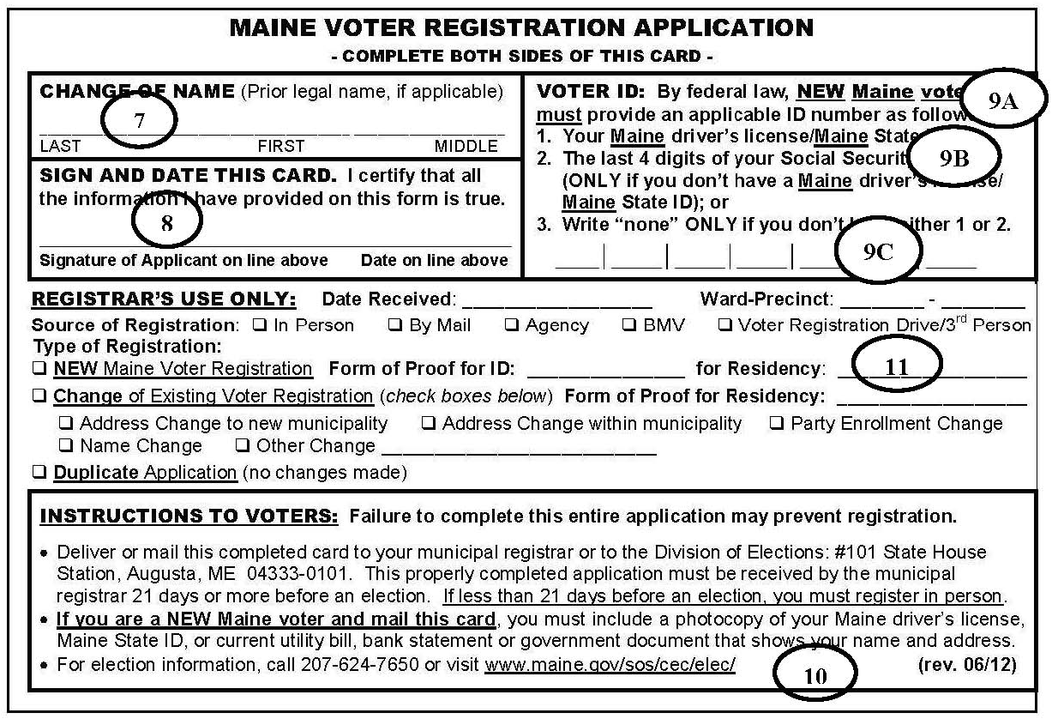
7. Change of name. (If applicable) This information is required only if the voter’s legal name has been changed since registering to vote in Maine.

8. Voter’s Signature. (Required) Voters must sign their legal name below the statement certifying that all the provided information is true.

9. Voter ID or Unique ID Number. (For new Maine voters only) The purpose of the voter ID number is to uniquely designate each new voter in the computerized statewide voter registration list. If the person is already registered to vote in Maine, this number is not required.
A. Driver’s License Number. New voters who have a valid Maine Driver’s License or a Maine State ID must list that number.
B. Social Security Number. New voters who do not have a valid Maine Driver’s License or Maine State ID, must list the last four digits of their Social Security Number.
C. NONE. This designation may be used only by voters who do not have a Maine Driver’s License/State ID or a Social Security Number.

10. Instructions to Voters. New voters who register by mail must provide a copy of certain identity documents with the completed registration form. The mail-in registrant may submit a copy of a Maine Driver’s License or other valid photo ID, a current utility bill, a bank statement, a paycheck stub or other government document that shows the voter’s current name and address.

11. For registrar’s use only. This space must be completed only by the municipal registrar.

NOTE: If required information is omitted, the registrar must notify the applicant that the application is incomplete and must later reject the application of the required information is not provided. If optional information is omitted, the registrar must still process and accept the application.

