PrepUS History
Unit 1 – The American Revolution
The Patriot Movie Questions

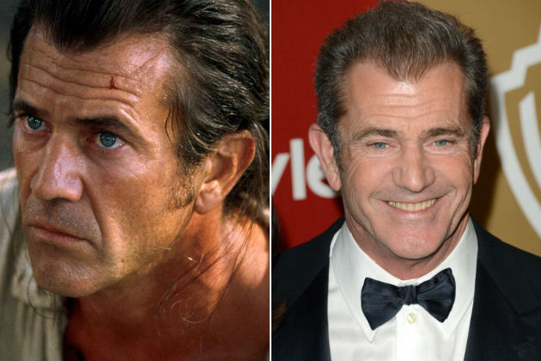
Benjamin Martin

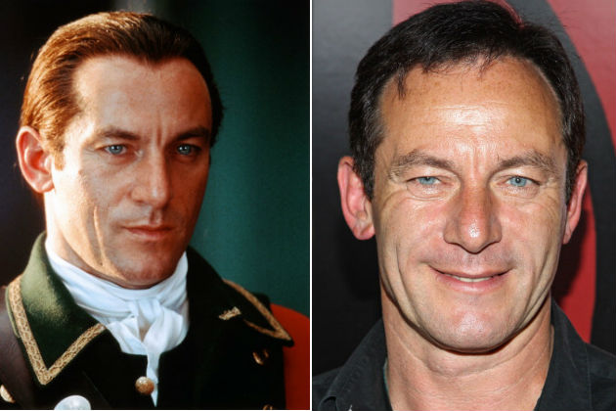
Col. William Tavington

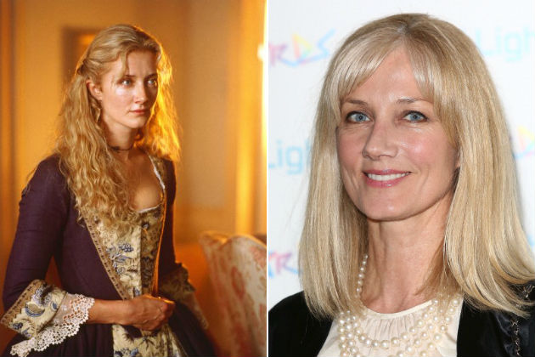
“Aunt” Charlotte Selton

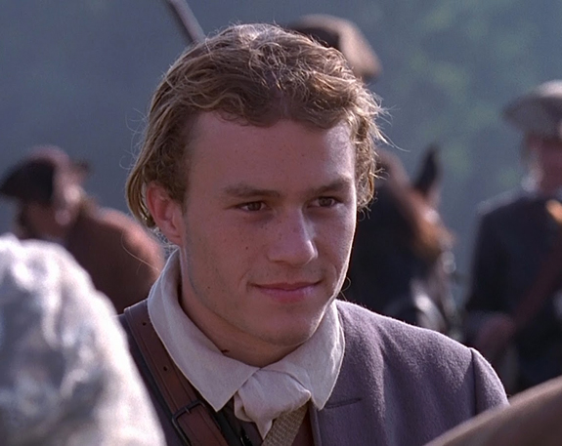
Gabriel Martin

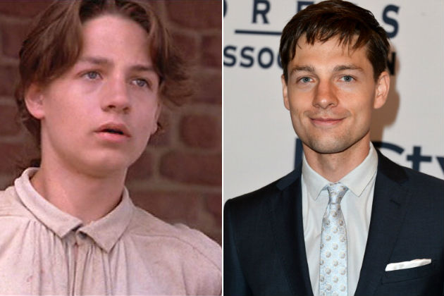
Thomas Martin
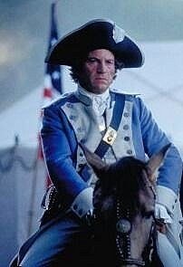
Jean Villeneuve

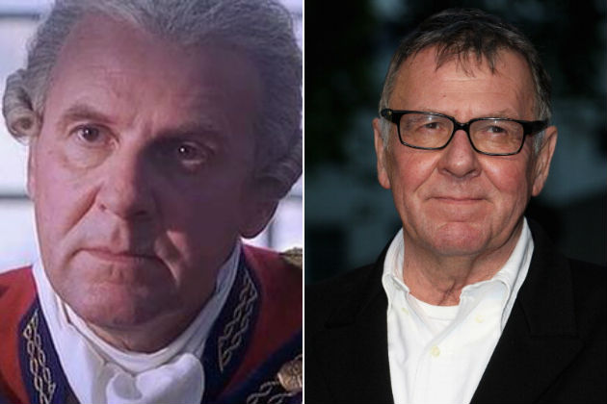
Gen. Lord Charles Cornwallis

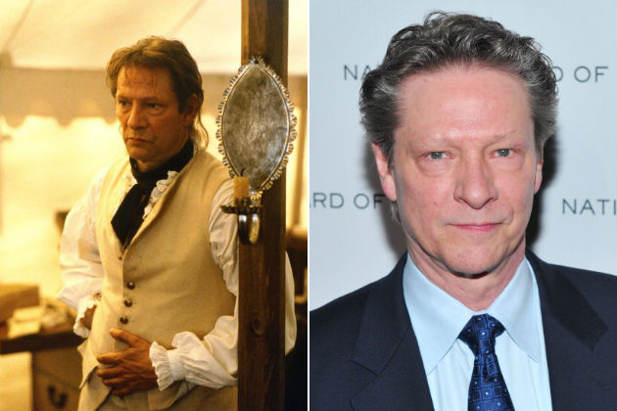
Col. Harry Burwell

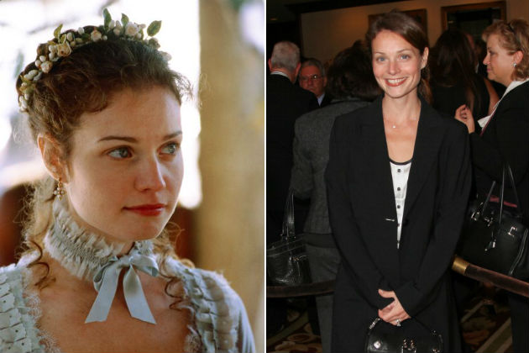
Anne Howard

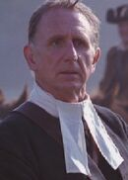
Reverend Oliver

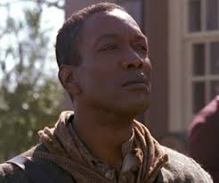
Occam

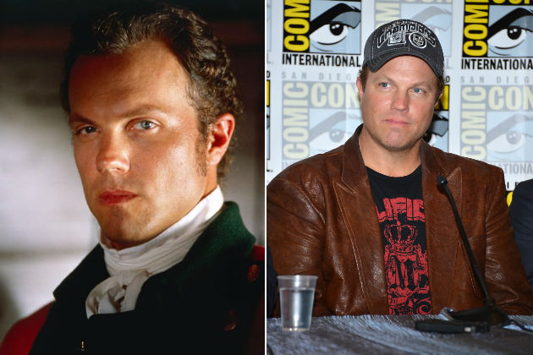
Capt. Wilkins

1. What is the setting of this movie (where and when is it taking place)?

2. Why are the boys so excited to read the mail? What information do they want?

3. How does Martin feel about independence?

4. What does Martin mean when he says, “I’m a parent. I don’t have the luxury of principles?”

5. What do Tavington and his men do with:

the freedmen working for Martin?

Martin’s son Thomas?

Martin’s home?

the wounded Patriots?

Martin’s son Gabriel?

6. What do Martin and his sons Nathan and Samuel do when the British take Gabriel?

7. Why do Martin and Gabriel leave the others at Aunt Charlotte’s house?

8. Why do Martin and Gabriel split up (what are they going to do)?

9. What does British Gen. Cornwallis tell Tavington about how he has been “conducting himself?”

10. What is “full quarter?” Why do Martin and Gabriel argue about it? What do they decide?

11. Who is the owner of the dogs, journal, and other property that Martin and his men capture?

12. Where do Martin and his men get their supplies? How are they going to pay for them?

13. How does Martin get his men back from Cornwallis?

14. Why does Tavington ask Captain Wilkins (the Loyalist) where Martin would hide his children?

15. Why does Martin give the men in his militia leave?

16. What happens to Anne and the others in Pembroke?

17. What happens to Gabriel?

18. What does Martin carry with him into the battle at Cowpens? Why is it so special?

19. What do Martin and Villeneuve (the French soldier) have in common?

20. Near the end of the movie, Martin says “Vive la France” and Villeneuve says “Vive la libertie.” What does each one of these statements mean? Why do they say them?

