RUDY GIULIANI
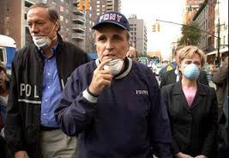
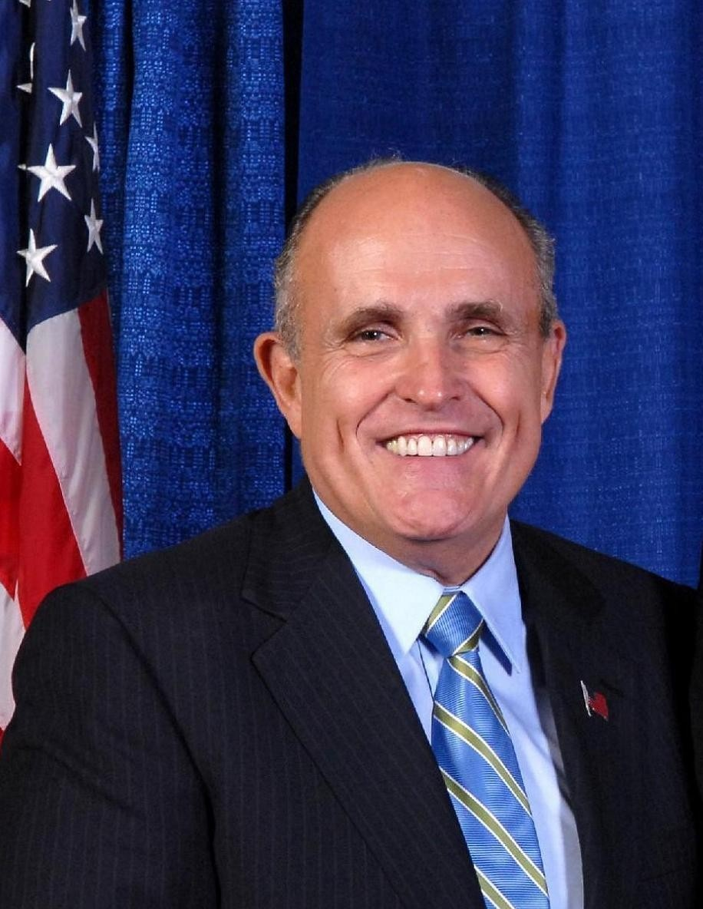

Rudy Giuliani (1944-) served as the Republican mayor of New York City from 1994 until 2001. A prosecutor by trade, he presided over steep declines in both violent and quality-of-life crime. He was also widely praised for his leadership in the wake of the September 11, 2001, terrorist attack on the World Trade Center. Nonetheless, some New Yorkers opposed his abrasive style of governing. Giuliani ran for president in 2008 but dropped out after disappointing showings in the first few primaries.

RUDY GIULIANI’S EARLY YEARS
A grandson of Italian immigrants, Rudolph “Rudy” William Giuliani was born on May 28, 1944, in the New York City borough of Brooklyn. In 1951 his family moved to Garden City, Long Island, where he attended a local parochial school. He then continued his Catholic education at Bishop Loughlin Memorial High School in Brooklyn and at Manhattan College in the Bronx, from which he received a political science bachelor’s degree in 1965. Three years later, Giuliani graduated magna cum laude from New York University School of Law.

RUDY GIULIANI AS MAYOR OF NEW YORK
Giuliani resigned from his prosecutor position in January 1989 and began campaigning for mayor of New York City. Despite narrowly losing that year to Manhattan Borough President David Dinkins, who was sworn in as the city’s first black mayor, he eked out a victory in a 1993 rematch. This marked the first time a Republican had been elected to the office since 1965. “As of this moment, the expressions of cynicism—New York is not governable, New York is not manageable, New York is not worth it—all of these I declare politically incorrect,” Giuliani, who ran on a law-and-order platform, said in his inaugural speech. He would go on to easily win reelection in 1997.

Though crime was already falling in the second half of Dinkins’ tenure, that trend rapidly accelerated under Giuliani. During his eight years in office, violent crime was cut roughly in half and murders went down an astounding 67 percent. A believer in the so-called “broken windows” theory, which holds that minor signs of disorder can lead to an increase in serious infractions, Giuliani also cracked down on graffiti, public urination, X-rated theaters, sidewalk vending, subway turnstile jumping and even jaywalking. Moreover, he implemented a computer-based crime measurement system called CompStat that was later replicated by police departments nationwide.

Critics, meanwhile, accused the mayor of aggravating race relations, of valuing loyalty over competence in his subordinates, of self-promotion and of supporting questionable policing tactics. Tensions particularly heated up after four white plainclothes detectives gunned down unarmed African immigrant Amadou Diallo in March 1999. Giuliani also stirred up controversy by dismantling an affirmative action program for minority and women contractors, trimming hundreds of thousands of New Yorkers from the welfare rolls and trying to defund the Brooklyn Museum because of an exhibit he considered anti-Catholic.

RUDY GIULIANI AND THE SEPTEMBER 11 ATTACKS
In 2000 Giuliani ran for the U.S. Senate against first lady Hillary Rodham Clinton. He withdrew that May, however, after being diagnosed with prostate cancer and after reports surfaced that he was having an extramarital affair with drug company executive Judith Nathan. He wed Nathan in 2003—it was the third marriages for both—following an acrimonious divorce from his second wife, with whom he had two children.

On September 11, 2001, al-Qaeda terrorists killed nearly 3,000 people by flying hijacked planes into the World Trade Center’s two towers. Giuliani immediately took charge of rescue and recovery efforts, acting decisively and with poise under pressure to calm the city. In appreciation of those leadership efforts, media personalities dubbed him “America’s Mayor,” Time magazine named him “Person of the Year” and Queen Elizabeth II awarded him an honorary knighthood. Barred by term limits from running for a third term, Giuliani actively sought an unprecedented extension of at least three months. State and city legislators refused to consider his request, however, and on January 1, 2002, billionaire businessman Michael Bloomberg replaced him as mayor.

