Directions:
1. Read the following article thoroughly, highlighting any information you think might be historically important.

2. Write a vocabulary word/name/event title/special notation in the margin next to any text you have highlighted (be sure to write the definition of any words you may not know).

The Reformation in Europe: An Introduction
The Protestant Reformation is the name given to the religious reform movement that divided western Christianity into Catholic and Protestant groups. Martin Luther’s bold attempts to reform the Church led to new forms of Christianity. Although Luther did not see himself as a rebel, the spread of Protestantism ignited decades of bloody religious conflict and ended a thousand years of domination by the Catholic Church.

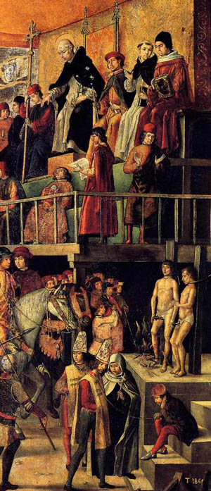
The Cathars Challenge the Catholic Church in Medieval Europe
By the year 1200, Roman Catholicism had been the dominant religion of Europe for over 800 years. In most of Europe, the pope in the Vatican remained the undisputed religious leader. In the 1100s, however, a serious challenge to the Roman Church developed in southern France. The Cathars believed in a strong division between good and evil and thought there was a good God who created our souls and a bad God who imprisoned our souls inside physical bodies, which were always evil. The leading Cathars called themselves “perfects” and tried to live without property, marriage, or sex. Most importantly, the Cathars believed they were the true Christians and the Catholic Church was a false church, founded by the devil. The new religion began to attract a large following and many dukes and local leaders in southern France protected Cathar believers. This threatened the pope and Church leaders felt something needed to be done.

The Coming of the Inquisition
In 1232, Pope Gregory IX set up a system of special religious courts called the Inquisition to end heresy once and for all. Gregory authorized the leaders of the Dominican religious order to send out friars to find and question heretics. Those who refused to recant, or confess their heresy, were burned alive. The Inquisition dominated the thinking of much of Europe over the next 200 years, becoming a permanent system of religious control (and completely wiping out the Cathars).

French inquisitor Bernard Gui described the purpose of the Inquisition this way:

Heresy cannot be destroyed unless heretics are destroyed and … their defenders and [supporters] are destroyed, and this is effected in two ways: … they are converted to the true Catholic faith, or … burned.

How Did the Inquisition Work?
When the Inquisition came to a suspected area, the local bishop assembled the people to hear the inquisitor preach against heresy. He would announce a grace period of up to a month for heretics to confess their guilt, recant, and inform on others. During this period, the Inquisition would collect accusations. If two witnesses under oath accused someone of heresy, the accused person would be summoned to appear. Opinions, prejudices, rumors, and gossip were all accepted as evidence. The accused was not told the names of the accusers, nor the exact charges. Inquisitors examined the accused in secret. Anyone who refused to confess was assumed to be guilty. No lawyers were allowed, because it was considered heresy to defend a heretic.

The only possible escape was to recant as quickly as possible and name the names of other heretics. Those who recanted immediately might receive a fairly light sentence such as saying prayers, fasting, being whipped in public, or making a pilgrimage. Some who recanted were forced to wear a yellow cross of felt sewn on all their clothing. The cross marked them as a former heretic, and many people would stay away from them in fear. Many who refused to recant right away were sentenced to prison for life. If they refused to recant at all, the Inquisition turned them over to government authorities to be burned alive. Some inquisitors were so thorough that they went after the dead. If a dead person was accused of heresy, his or her bones could be dug up and burned.

For most accused heretics, there was no appeal. A few rich or powerful people might beg the pope to change a sentence, but for most of the condemned, the sentence was final. The families of those sent to prison or to the stake lost their property.

The Inquisition Spreads
After completely wiping out the Cathar heresy, the Inquisition spread to other parts of Europe. In Spain, thousands of Jewish and Muslim settlers had been forced to convert to Christianity in order to take part in business and government. These converts, or conversos, made up a large part of the wealthy and influential class of Spain, which produced jealousy and anti-Semitic prejudice in many Spaniards. In the 1400s, rumors spread that most conversos continued to practice their Jewish beliefs. Anti-converso riots erupted in Toledo and other cities.

By the late 1400s, King Ferdinand of Aragon and Queen Isabella of Castille had united all of Spain into a single kingdom, but the conversos riots were upsetting their unified kingdom. Instead of attacking the rioters who were causing religious bigotry, however, the king and queen decided to attack the conversos. Pope Sixtus IV gave the Spanish rulers permission to set up their own Inquisition, to be controlled by the crown, not the pope. In 1483, Isabella and Ferdinand appointed Tomas de Torquemada, a Dominican friar who had preached for years against the conversos, as inquisitor-general of the Inquisition throughout Spain. The Spanish Inquisition was ferocious in dealing with heretics, especially in the early years under Torquemada. Within 10 years, over 2,000 people had been burned at the stake, with another 15,000 suffering other penalties.
An Auto-da-fe
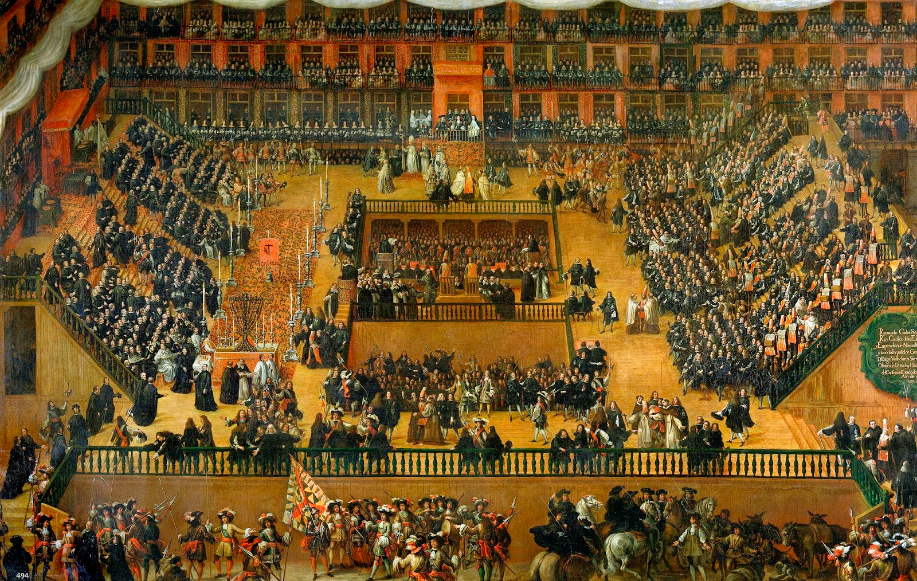
The final public ceremony of the Spanish Inquisition was called an auto-da-fe, or “act of faith.” Crowds would gather in a public square, often facing a cathedral. In the center of the square, there were a dozen wooden stakes where the heretics were to be burned. A bishop came out and shouted out the names of the condemned. Then the heretics were led out, wearing black robes decorated with red demons and flames. Officials of the government tied them to the stake. Anyone who repented would be strangled to death before the fires were lit. Most, however, stood silent or defiant. The fires were lit, and the square echoed with the screams of heretics and of the crowd.

Christian Humanism
In Germany, however, local princes often refused to cooperate with the Inquisition. They insisted on maintaining their own power and didn’t like outsiders from Rome holding court on their territory. They were also influenced by Christian humanism, or Northern Renaissance humanism, inspired by the new classical learning that was part of Italian Renaissance humanism in the second half of the fifteenth century. The major goal of this Christian humanism was the reform of the Catholic Church. The Christian humanists believed in the ability of human beings to reason and improve themselves and thought that if people read the classics, and especially the fundamental teachings of Christianity in the Bible, they would become more sincerely religious. This religious feeling would bring about a push to reform both the Church and society.

The best-known Christian humanist was Desiderius Erasmus, who believed that Christianity should show people how to live good lives on a daily basis, not just provide beliefs that might help them be saved. Stressing the inwardness of religious feeling, Erasmus thought the external forms of medieval religion, such as pilgrimages, fasts, and relics, were not all that important. He believed that the Catholic Church needed to return to the simpler days of early Christianity.

Erasmus wanted to educate people in the works of Christianity and worked to criticize the abuses in the Church. In his satire The Praise of Folly, written in 1509, Erasmus humorously criticized society’s moral and religious state and called for a simpler, purer faith. In this passage, he satirizes what he views as the folly of clergy who encourage the practice of visiting the shrines of saints:

[They] attribute strange virtues to the shrines and images of saints and martyrs, and so would make their credulous proselytes believe, that if they pay their devotion to St. Christopher in the morning, they shall be guarded and secured the day following from all dangers and misfortunes: if soldiers, when they first take arms, shall come and mumble over such a set prayer before the picture of St. Barbara, they shall return safe from all engagements.
—from The Praise of Folly
Erasmus sought reform within the Catholic Church. His intention was not to have people break away from it. His ideas, however, prepared the way for the Reformation. As people of his day said, “Erasmus laid the egg that Luther hatched.”

Need for Reform
By 1500, additional forces weakened the Church. Critics of the Catholic Church claimed that its leaders were corrupt. The popes who ruled during the Renaissance patronized the arts, spent extravagantly on personal pleasure, and fought wars. Pope Alexander VI, for example, admitted that he had fathered several children. Many popes were too busy pursuing worldly affairs to have much time for spiritual duties. The lower clergy had problems as well. Many priests and monks were so poorly educated that they could scarcely read, let alone teach people. Others broke their priestly vows by marrying, and some drank to excess or gambled.

Although the leaders of the Church were failing to meet their responsibilities, ordinary people still desired meaningful religious expression and assurance of their acceptance into Heaven. Many people secured their salvation through the purchase of indulgences. An indulgence was a document sold by the Church and signed by the pope or another church official that released the bearer from all or part of the punishment for sin.

The Renaissance emphasis on the secular and the individual challenged Church authority. The printing press spread these secular ideas. In addition, some rulers began to challenge the Church’s political power. In Germany, which was divided into many competing states, it was difficult for the pope or the emperor to impose central authority. Finally, northern merchants resented paying church taxes to Rome. Spurred by these social, political, and economic forces, a new movement for religious reform began in Germany. It then swept much of Europe.

Influenced by reformers, people had come to expect higher standards of conduct from priests and church leaders. In the late 1300s and early 1400s, John Wycliffe of England and Jan Hus of Bohemia had advocated Church reform. They denied that the pope had the right to worldly power. They also taught that the Bible had more authority than Church leaders did. In the 1500s, Christian humanists like Desiderius Erasmus and Thomas More added their voices to the chorus of criticism. In addition, many Europeans were reading religious works and forming their own opinions about the Church. The atmosphere in Europe was ripe for reform by the early 1500s.

Now go back through the reading to identify the political, social, economic, and religious causes of the Protestant Reformation to complete the chart.

Political Causes of the Reformation | Social Causes of the Reformation
Economic Causes of the Reformation | Religious Causes of the Reformation

