9-11 Operatives

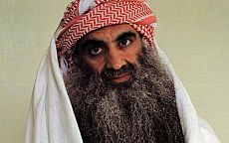
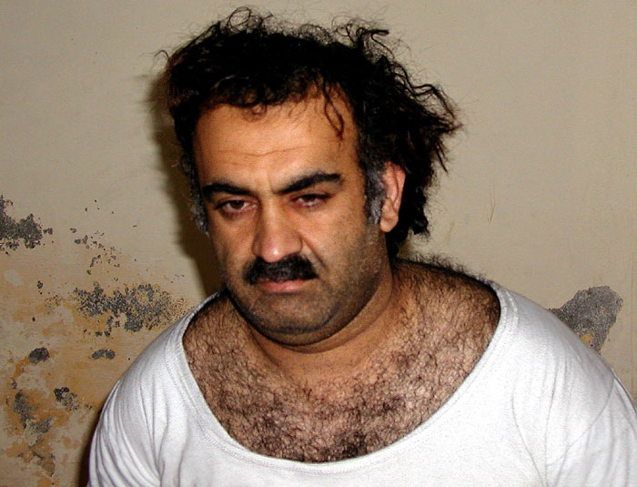
(left) Khalid Sheikh Mohammed after his capture in Pakistan on March 1, 2003

(right) Khalid Shaikh Mohammed photographed by the Red Cross while in captivity in Guantanamo, July 2009

Khalid Sheikh Mohammed: Born in Kuwait in 1964 or 1965, Mohammed is alleged to be "one of the principal architects of the 9/11 attacks." He was captured in March 2003 in Pakistan, and has been in the prison at Guantanamo Bay, Cuba, ever since.

In March 2007, he confessed to his role in the 9/11 attacks, saying, "I was responsible for the 9/11 operation, from A to Z," CNN reported. He also confessed to a role in 29 other operations, including the 1993 World Trade Center car bombing, and the Lockerbie bombing. He is still in Gitmo, and is still undergoing trial by military commission for war crimes.

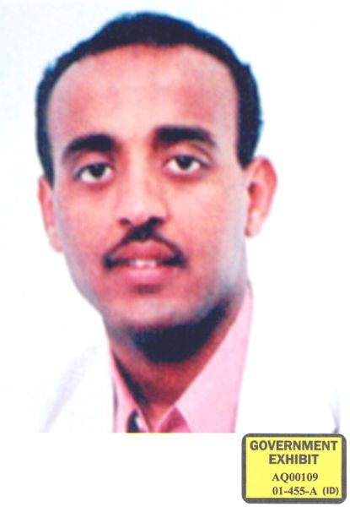
The 20th hijacker, Ramzi Bin al-Shibh: Shibh, another key player in the September 11 attacks, is accused of wiring money and passing information between the hijackers and al-Qaeda leaders. He was originally supposed to be one of the hijackers on the planes, but failed to obtain an entrance visa to the U.S. He is sometimes called the 20th hijacker.

He was captured in Pakistan on September 11, 2002, and after being held in Morocco, was transferred to Guantanamo Bay in September 2006. He is classified as one of the "high-value" detainees, along with Khalid Sheikh Mohammed. As of May 2011, he announced that he was ready to stand trial and wants to represent himself before the military commissions.

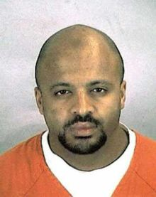
Zacarias Moussaoui: Moussaoui was the first suspected terrorist to be tried in connection with the 9/11 attacks, and the only suspect to have been tried in the United States. Born in France, Moussaoui is also often called the 20th hijacker of the four planes, but prosecutors could not effectively link him to the 19 other hijackers. He took flying lessons at the Airman Flight School in Oklahoma, the same school at which hijackers Mohamed Atta and Marwan al-Shehhi took lessons. His flight instructor was suspicious about Moussaoui's intentions and called the FBI.

He was arrested on August 16, 2001, before the attacks took place, on charges of immigration violation, and in December of 2011 was indicted on charges of conspiracy to commit terrorism, to use weapons of mass destruction, and to murder US employees, among other charges.

He is currently serving a life sentence without parole at the Federal ADX Supermax Prison in Florence, Colorado. He has since claimed that he was not involved in the September 11 attacks.

