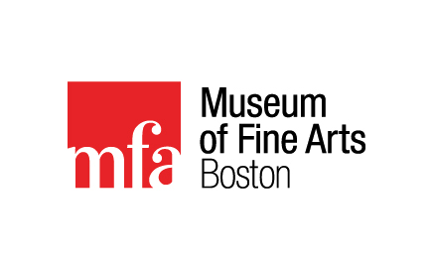
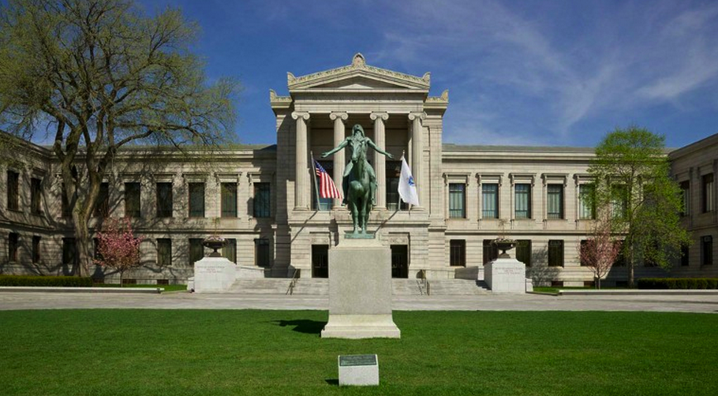

Museum of Fine Arts Field Trip
(Boston)
Friday, November 6th, 2015

On Friday, November 6th, BHS European History students will have the opportunity to participate in a field trip to the Museum of Fine Arts in Boston.

Students will travel via motorcoach from BHS to Boston, where we will spend three hours at the Museum of Fine Arts viewing some of the finest examples of Medieval and Renaissance Art in the United States. During that time students will complete a brochure and scavenger hunt created by their instructors (Mrs. Wagner & Mr. Stewart).

Students will then travel via the bus to Quincy Market and Faneuil Hall where they will have the opportunity to see this historic marketplace, first built in 1742 but still the bustling centerpiece of Boston’s eateries and tourist industry. Students will have approximately two hours to explore the market area and eat lunch (either brought from home or purchased at the market).

To secure a seat students must return this signed permission slip along with $35.00 check or cash to Mrs. Wagner by Friday, October 23rd (please make checks payable to BHS).

Parents: Please let us know if you are interested in helping us chaperone this trip!
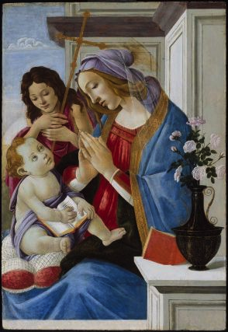

Itinerary

7:30 AM Depart Brunswick High
(bring a morning snack to eat en route)

10:30-1:30 Tour MFA Boston

2:00-3:30 Lunch at Quincy Market/Faneuil Hall

3:30PM Depart Boston

6:00PM Arrive in Brunswick
Virgin and Child with Saint John the Baptist
Tempera on panel, about 1500
Sandro Botticelli, Italian (Florentine),
1444 or 1445–1510
part of the MFA Renaissance Italy collection

__________________________________ has my permission to participate in the BHS field
Student’s Name trip to the Museum of Fine Arts, Boston.

__________________________________
Parent/Guardian Signature

