DIRECTIONS: Read the following handout thoroughly, using a YELLOW highlighter to highlight any important vocabulary/terms/names/events that you think might be historically important. Write a note in the margins next to the highlighted text that will help you remember the information.

The Battle of Bosworth
In 1485, Henry Tudor landed at Milford Haven. He marched across Wales and England to meet Richard III's forces at the Battle of Bosworth Field in Leicestershire. In the battle Richard III was killed and Henry was crowned King Henry VII at the top of Crown Hill, near the village of Stoke Golding.

Having secured parliamentary recognition of his title as King of England he married Elizabeth of York thus uniting the House of Lancaster and the House of York. He adopted the Tudor rose as the emblem of England, combining the white rose of York with the red rose of Lancaster to symbolise an end to the dynastic war.

Consolidated Power
Henry VII's grip on power was far from secure. His claim to the throne was shaky and he was plagued by plots and conspiracies. He consolidated his position with a treaty with France that opened up trade between the two countries. His most important treaty was the 'Magnus Intercursus' or 'Great Intercourse', signed with the Netherlands, securing England's textile exports.

In 1503 he arranged the marriage of his daughter, Margaret Tudor, to James IV of Scotland in order to secure peace between the two countries. The marriage meant that James IV's descendants would have a claim to the English throne.

Henry also secured a marriage between his eldest son, Arthur, and the Spanish princess, Catherine of Aragon, in 1501. But in 1502 the 15-year-old Arthur Tudor died suddenly at Ludlow Castle, leaving Catherine a widow and making his younger brother, Henry, the new heir to the throne. It was suggested that Catherine should marry the young Henry instead, but this wasn't agreed upon during Henry VII's lifetime due to wrangling over Catherine's dowry.

Tudor State
Henry VII rebuilt the royal finances by avoiding war, promoting trade and enforcing royal taxes to the point of ruthlessness. This meant he was able to leave a fortune to his son, the future Henry VIII.

Henry VII began the work of building a modern administration. The Royal Council was reborn as the Court of Star Chamber, set up to deal with judicial matters. Arrangements were made to promote better order in Wales and the north through the creation of special councils and more powers were entrusted to the justices of the peace.

The combined impact of Henry VII's reforms would increase significantly the power of the King and open the way for medieval rule, with its local law and customs, to be gradually supplanted by a more centralised Tudor state.

Death
Henry VII died of tuberculosis on 21 April 1509 and was buried at Westminster Abbey. He left a safe throne, a solvent government and a prosperous and reasonably united country. Henry VII was succeeded by his second son, Henry VIII.

Henry VIII
Henry, the second son of King Henry VII and Elizabeth of York, was born on 28 June 1491 at Greenwich Palace. After the death of his elder brother Arthur in 1502, Henry became heir to the English throne.

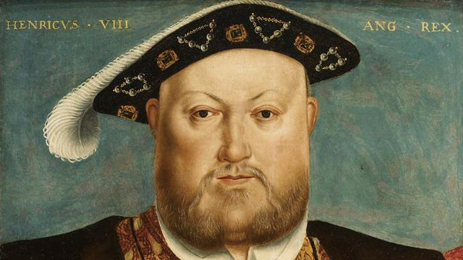
King of England
When Henry VII died in 1509, this popular eighteen-year-old prince, known for his love of hunting and dancing, became King Henry VIII. Soon after he obtained the papal dispensation required to allow him to marry his brother's widow, Catherine of Aragon.

In the first years of his reign Henry VIII effectively relied on Thomas Wolsey to rule for him, and by 1515 Henry had elevated him to the highest role in government: Lord Chancellor.

In 1521 Pope Leo X conferred the title of Defender of the Faith on Henry for his book 'Assertio Septem Sacramentorum', which affirmed the supremacy of the Pope in the face of the reforming ideals of the German theologian, Martin Luther.

Military might
Henry VIII's early military campaigns began when he joined Pope Julius II's Holy League against France in 1511. Wolsey proved himself to be an outstanding minister in his organisation of the first French campaign and while the Scots saw this war as an opportunity to invade England, they were defeated at Flodden in 1513. However war with France ultimately proved expensive and unsuccessful.

Henry VIII is known as the 'father of the Royal Navy.' When he became king there were five royal warships. By his death he had built up a navy of around 50 ships. He refitted several vessels with the latest guns including the Mary Rose, which sank in 1545.

Henry also built the first naval dock in Britain at Portsmouth and in 1546 he established the Navy Board. This set up the administrative machinery for the control of the fleet.

A male heir
Henry was acutely aware of the importance of securing a male heir during his reign. He was worried that he had only one surviving child, Mary, to show for his marriage to Catherine, who was now in her 40s. So the king asked Cardinal Wolsey to appeal to Pope Clement VII for an annulment and it soon became clear he wanted to marry Anne Boleyn, who had been a lady-in-waiting to his first wife.

But, unwilling to anger Catherine of Aragon's nephew – the most powerful ruler in Europe, the Holy Roman Emperor Charles V – the Pope refused. Thomas Wolsey's ascendancy was cut short by this failure.

In 1533, Henry VIII broke with the church and married the now pregnant Anne Boleyn in a secret ceremony. Henry was excommunicated by the Pope. The English reformation had begun.

Head of the Church
After Wolsey's downfall, Thomas Cromwell became Henry's chief minister and earned the confidence of the King by helping him to break with Rome and establish Henry VIII as head of the Church of England. This act also brought him much needed wealth through the dissolution of the well-funded monasteries. Over four years Cromwell ordered that 800 monasteries be disbanded and their lands and treasures taken for the crown.

The cultural and social impact was significant, as much of the land was sold to the gentry and churches and monasteries were gutted and destroyed. Henry's personal religious beliefs remained Catholic, despite the growing number of people at court and in the nation who had adopted Protestantism.

Katherine Parr
To Be Useful in All That I Do

BORN: 1512; MARRIED: 12 JULY 1543; WIDOWED: 28 JANUARY 1547; DIED: 5 SEPTEMBER 1548

There has probably been more interest in the wives of Henry VIII than in the King himself, although it is impossible not to wonder about the man that brought these six women together in history. Their lives were all unique, yet all had fates ultimately decided by the same man. Two were divorced, with one getting a much better deal than the other. Two were beheaded, one falsely accused, the other probably not. One died shortly after giving birth to the male heir Henry so desperately longed for. One survived as his widow.
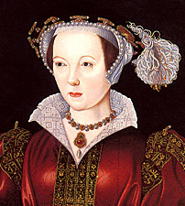
Katherine Parr, the last of Henry's wives was a different choice for the aging King. She was the daughter of Thomas Parr of Kendal, a modest country squire who had distinguished himself in the service of both Henry VII and Henry VIII. Thomas Parr died in 1517 and his widow chose not to remarry. She encouraged the education and advancement of her children, a trait Katherine would show in her treatment of her future step-children. Katherine's brother, William, was given the title of Marquess of Northhampton in 1547.

Katherine was first married to Sir Edward Burough, but was widowed shortly after in 1529. Her second husband was Sir John Nevill, Lord Latimer. He was a wealthy landowner in Yorkshire and had an estate there called Snape Hall. He died in 1542 and had no children by Katherine.

By this time, Katherine was becoming well known for her learning and overall sensitive and caring nature. She was also gaining an interest in the rising Protestant faith.

Not much is known about Henry's courtship of Katherine. However, before the King stepped in, she may have been considering marrying Thomas Seymour, brother to the late Queen Jane and uncle to Prince Edward. Katherine rejected Seymour's proposal in order to marry the King, although she probably didn't have much of a choice in the matter. 18 months had gone by since Kathryn Howard's execution by the time Henry and Katherine Parr were married on July 12, 1543.

Henry's health had been declining such that his last wife must have been as much a nurse as anything else. Katherine managed to soothe the King's temper and bring his family closer together. Although the Queen was scarcely older than the Princess Mary, she, along with Elizabeth and Edward, saw Katherine as a stabilizing mother figure. Katherine arranged for the best tutors for the children and encouraged them in their learning.

Katherine's interest in Protestants almost proved to be her undoing. Factions at court were envious of the Queen's influence on Henry and sought to destroy her by linking her with the 'heretical' religious reformers. But Katherine wisely made a show of her submissiveness to the King when confronted and probably saved her life. Katherine outlived Henry, who died January 28, 1547.

Prince Edward succeeded as Edward VI. His older uncle, Edward Seymour, Lord Somerset, became Protector since the young king was not yet 10 years old. The other Seymour brother, Thomas, once again sought the hand of Katherine Parr, and this time she was free to accept.

Katherine was soon pregnant with Seymour's child, and gave birth to a daughter named Mary at Sudeley Castle on August 30, 1548. Unfortunately, Katherine did not recover from the childbirth and died on September 5. Katherine Parr is buried at St. Mary's Church at Sudeley Castle.

