DIRECTIONS: Read the following handout thoroughly, using a YELLOW highlighter to highlight any important vocabulary/terms/names/events that you think might be historically important. Write a note in the margins next to the highlighted text that will help you remember the information.

The Battle of Bosworth
In 1485, Henry Tudor landed at Milford Haven. He marched across Wales and England to meet Richard III's forces at the Battle of Bosworth Field in Leicestershire. In the battle Richard III was killed and Henry was crowned King Henry VII at the top of Crown Hill, near the village of Stoke Golding.

Having secured parliamentary recognition of his title as King of England he married Elizabeth of York thus uniting the House of Lancaster and the House of York. He adopted the Tudor rose as the emblem of England, combining the white rose of York with the red rose of Lancaster to symbolise an end to the dynastic war.

Consolidated Power
Henry VII's grip on power was far from secure. His claim to the throne was shaky and he was plagued by plots and conspiracies. He consolidated his position with a treaty with France that opened up trade between the two countries. His most important treaty was the 'Magnus Intercursus' or 'Great Intercourse', signed with the Netherlands, securing England's textile exports.

In 1503 he arranged the marriage of his daughter, Margaret Tudor, to James IV of Scotland in order to secure peace between the two countries. The marriage meant that James IV's descendants would have a claim to the English throne.

Henry also secured a marriage between his eldest son, Arthur, and the Spanish princess, Catherine of Aragon, in 1501. But in 1502 the 15-year-old Arthur Tudor died suddenly at Ludlow Castle, leaving Catherine a widow and making his younger brother, Henry, the new heir to the throne. It was suggested that Catherine should marry the young Henry instead, but this wasn't agreed upon during Henry VII's lifetime due to wrangling over Catherine's dowry.

Tudor State
Henry VII rebuilt the royal finances by avoiding war, promoting trade and enforcing royal taxes to the point of ruthlessness. This meant he was able to leave a fortune to his son, the future Henry VIII.

Henry VII began the work of building a modern administration. The Royal Council was reborn as the Court of Star Chamber, set up to deal with judicial matters. Arrangements were made to promote better order in Wales and the north through the creation of special councils and more powers were entrusted to the justices of the peace.

The combined impact of Henry VII's reforms would increase significantly the power of the King and open the way for medieval rule, with its local law and customs, to be gradually supplanted by a more centralised Tudor state.

Death
Henry VII died of tuberculosis on 21 April 1509 and was buried at Westminster Abbey. He left a safe throne, a solvent government and a prosperous and reasonably united country. Henry VII was succeeded by his second son, Henry VIII.

Henry VIII
Henry, the second son of King Henry VII and Elizabeth of York, was born on 28 June 1491 at Greenwich Palace. After the death of his elder brother Arthur in 1502, Henry became heir to the English throne.

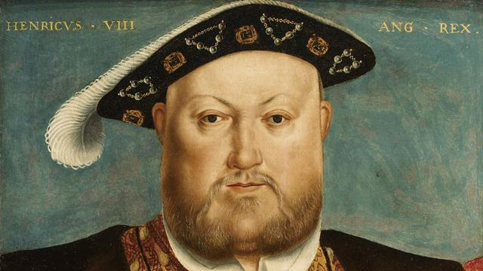
King of England
When Henry VII died in 1509, this popular eighteen-year-old prince, known for his love of hunting and dancing, became King Henry VIII. Soon after he obtained the papal dispensation required to allow him to marry his brother's widow, Catherine of Aragon.

In the first years of his reign Henry VIII effectively relied on Thomas Wolsey to rule for him, and by 1515 Henry had elevated him to the highest role in government: Lord Chancellor.

In 1521 Pope Leo X conferred the title of Defender of the Faith on Henry for his book 'Assertio Septem Sacramentorum', which affirmed the supremacy of the Pope in the face of the reforming ideals of the German theologian, Martin Luther.

Military might
Henry VIII's early military campaigns began when he joined Pope Julius II's Holy League against France in 1511. Wolsey proved himself to be an outstanding minister in his organisation of the first French campaign and while the Scots saw this war as an opportunity to invade England, they were defeated at Flodden in 1513. However war with France ultimately proved expensive and unsuccessful.

Henry VIII is known as the 'father of the Royal Navy.' When he became king there were five royal warships. By his death he had built up a navy of around 50 ships. He refitted several vessels with the latest guns including the Mary Rose, which sank in 1545.

Henry also built the first naval dock in Britain at Portsmouth and in 1546 he established the Navy Board. This set up the administrative machinery for the control of the fleet.

A male heir
Henry was acutely aware of the importance of securing a male heir during his reign. He was worried that he had only one surviving child, Mary, to show for his marriage to Catherine, who was now in her 40s. So the king asked Cardinal Wolsey to appeal to Pope Clement VII for an annulment and it soon became clear he wanted to marry Anne Boleyn, who had been a lady-in-waiting to his first wife.

But, unwilling to anger Catherine of Aragon's nephew – the most powerful ruler in Europe, the Holy Roman Emperor Charles V – the Pope refused. Thomas Wolsey's ascendancy was cut short by this failure.

In 1533, Henry VIII broke with the church and married the now pregnant Anne Boleyn in a secret ceremony. Henry was excommunicated by the Pope. The English reformation had begun.

Head of the Church
After Wolsey's downfall, Thomas Cromwell became Henry's chief minister and earned the confidence of the King by helping him to break with Rome and establish Henry VIII as head of the Church of England. This act also brought him much needed wealth through the dissolution of the well-funded monasteries. Over four years Cromwell ordered that 800 monasteries be disbanded and their lands and treasures taken for the crown.

The cultural and social impact was significant, as much of the land was sold to the gentry and churches and monasteries were gutted and destroyed. Henry's personal religious beliefs remained Catholic, despite the growing number of people at court and in the nation who had adopted Protestantism.

Jane Seymour
Bound to Obey and Serve

BORN: c. 1509; MARRIED: 30 MAY 1536; DIED: 24 OCTOBER 1537

There has probably been more interest in the wives of Henry VIII than in the King himself, although it is impossible not to wonder about the man that brought these six women together in history. Their lives were all unique, yet all had fates ultimately decided by the same man. Two were divorced, with one getting a much better deal than the other. Two were beheaded, one falsely accused, the other probably not. One died shortly after giving birth to the male heir Henry so desperately longed for. One survived as his widow.

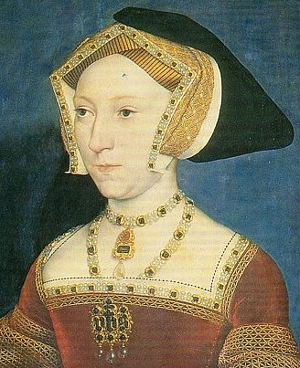
Jane Seymour may have first come to court in the service of Queen Catherine, but then was moved to wait on Anne Boleyn as she rose in the King's favor and eventually became his second wife.

In September 1535, the King stayed at the Seymour family home in Wiltshire, England. It may have been there that the king "noticed" Jane. But, it isn't until February of 1536 that there is evidence of Henry's new love for Jane.

By that point, Henry's disinterest in Anne was obvious and Jane was likely pegged to be her replacement as Queen.

Opinion is divided as to how Jane felt about being the new object of Henry's affections. Some see Jane's calm and gentle demeanor as evidence that she didn't really understand the position as political pawn she was playing for her family. Others see it as a mask for her fear. Seeing how Henry's two previous Queens had been treated once they fell from favor, Jane probably had some trepidation, although Anne Boleyn's final fate had not been sealed at that time.

One other view was that Jane fell into her role quite willingly and actively sought to entice the King and flaunt her favor even in front of the current Queen.

However Jane actually felt, we will never know. Henry's feelings were pretty clear though. Within 24 hours of Anne Boleyn's execution, Jane Seymour and Henry VIII were formally betrothed. On the 30th of May, they were married. Unlike Henry's previous two Queens, Jane never had a coronation. Perhaps the King was waiting to Jane to 'prove' herself by giving him a son.

Less than two months after Henry and Jane's marriage, the Duke of Richmond, Henry Fitzroy died at the age of 17. Fitzroy was the King's bastard son by his mistress Elizabeth Blount.

It wasn't until early 1537 that Jane became pregnant. During her pregnancy, Jane's every whim was indulged by the King, convinced that Jane, whom he felt to be his first 'true wife', carried his long hoped for son. In October, a prince was born at Hampton Court Palace and was christened on 15th of October. The baby was named Edward. Mary, daughter of Catherine of Aragon, was godmother and Elizabeth, daughter of Anne Boleyn, also played a role in the ceremony.

There has been much written over whether or not Jane gave birth to Edward by caesarean section. It seems unlikely that if she had, she would have lived as long as she did after the birth. Jane attended her son's christening, although she was weak. She died on October 24th, just two weeks after her son was born.

Henry had already been preparing his own tomb at St. George's Chapel at Windsor Castle, which was where Jane was buried. In the end, she would be the only of Henry's six wives to be buried with him.

