PrepUS History
Unit 7 – Changing America
WWI Weapons Reading Questions

Combat in World War I
By the spring of 1917, World War I had devastated Europe. Old-fashioned strategies and new technologies resulted in terrible destruction. Many Americans believed, however, that their troops would make a difference and quickly bring the war to an end.

To protect themselves from artillery, troops began digging trenches. On the Western Front - where German troops fought French, British, and Belgian forces - the troops dug a network of trenches that stretched from the English Channel to the Swiss border. Both sides used barbed wire and a new weapon, the machine gun, to guard against the enemy. Attacks usually began with a massive artillery barrage. Soldiers then raced across the rough landscape toward enemy trenches. Troops used any weapon available to kill the enemy. The new style of fighting, which both sides eventually utilized, resulted in the loss of hundreds of thousands of men and a stalemate on the Western Front. Offensive and defensive moves by the Allies and the Germans failed to be particularly successful.

New Technology
Breaking through enemy lines required new technologies. The Germans first used poison gas in 1915, and the Allies soon followed. Gas caused vomiting, blindness, and suffocation. Both sides developed gas masks to counter fumes. In 1916 the British introduced the armored tank, which could crush barbed wire and cross trenches. But there were still too few of the slow, unreliable machines to revolutionize warfare.

World War I also marked the first use of aircraft in war. Early in the war, the Germans used giant rigid balloons called zeppelins to drop bombs on British warships in the North Sea. At first, airplanes were used to spy on enemy troops and ships. Then the Allies equipped them with machine guns and rockets to attack the German zeppelin fleet. Other aircraft carried small bombs to drop on enemy lines. As technology advanced, airplanes shot down other airplanes in battles known as dogfights. But early military aircraft were difficult to fly and easy to destroy. A combat pilot had an average life expectancy of about two weeks.

During WWI, the soldiers in the trenches used a wide variety of weapons, including:

rifles and pistols
machine guns
artillery
bayonets
torpedoes
flamethrowers
mustard gas
chlorine gas
smokeless gunpowder

As well as using them in the trenches, some of these weapons were used by tanks, U boats, Zeppelins and planes. In the trenches, the weapon carried by all British soldiers was the bolt-action rifle (below). It was possible for the soldier to fire 15 rounds per minute and could kill someone up to 1,400 meters away. French soldiers used the bayonet.
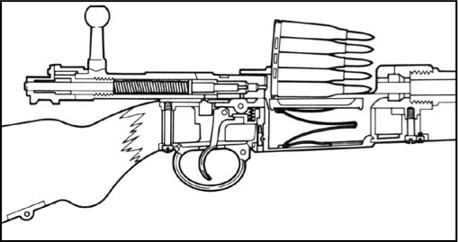

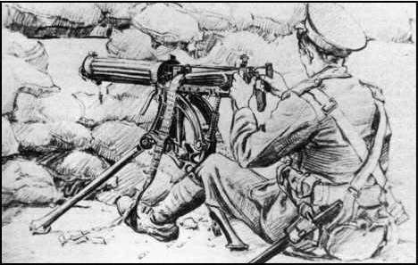
Unlike today, machine guns were not the main weapons of soldiers. They needed 4-6 men to man them in 1914 and had to be positioned on a flat surface. They could fire up to 400 rounds per minute and had the firepower of 100 guns.
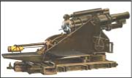

Artillery is the word used to describe large-caliber mounted field guns. The caliber is the diameter of the barrel. The picture to the left is an example of the heavy artillery that was used in the trenches. The stalemate meant they needed long-range weapons that could deliver devastating blows to the enemy. They needed crews of up to 12 men to work them; the shells weighed up to 900lb –very heavy.

This war was also the first to use chlorine and mustard gas. The German army was the first to use chlorine in 1915 at Ypres. French soldiers had not come across this before and assumed that it was a smoke screen. It has a distinctive smell – a mixture of pepper and pineapple – and they only realized they were being gassed when they started to have chest pains and a burning sensation in their throats! Death is painful – you suffocate!
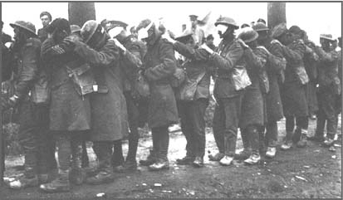
The problem with using chlorine is, weather conditions must be right before it is used. WHY?
Afterwards, Allied forces discovered that urine-soaked cotton pads neutralized the chlorine. However, they found it difficult to fight like this!!

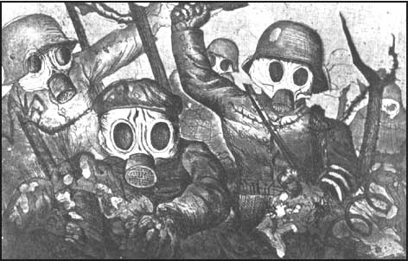
Mustard gas was the most deadly biological weapon that was used in the trenches. It was odorless and took 12 hours to take effect! It was also very powerful, only small amounts needed to be added to shells to be effective and it remained active for several weeks when it landed in the soil!

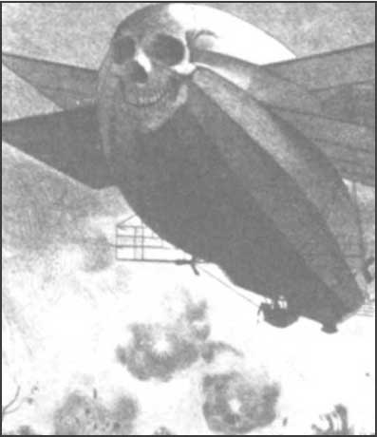
The nastiest thing about mustard gas is that it made the skin blister, the eyes sore and the victim would start to vomit. It would cause internal and external bleeding, and would target the lungs. It could take up to 5 weeks to die!

War Machines
The Zeppelin, or blimp as it is also known, is an airship and the Germans used it during the early part of the war in bombing raids. These airships weighed 12 tons and contained over 400,000 cubic feet of hydrogen. They were propelled along by 2 Daimler engines, which enabled the craft to travel at speeds of up to 136mph and heights of 4250 meters! They usually carried machine guns and around 4,400lb of bombs! They carried out many raids and were eventually abandoned as they were easy targets for artillery.
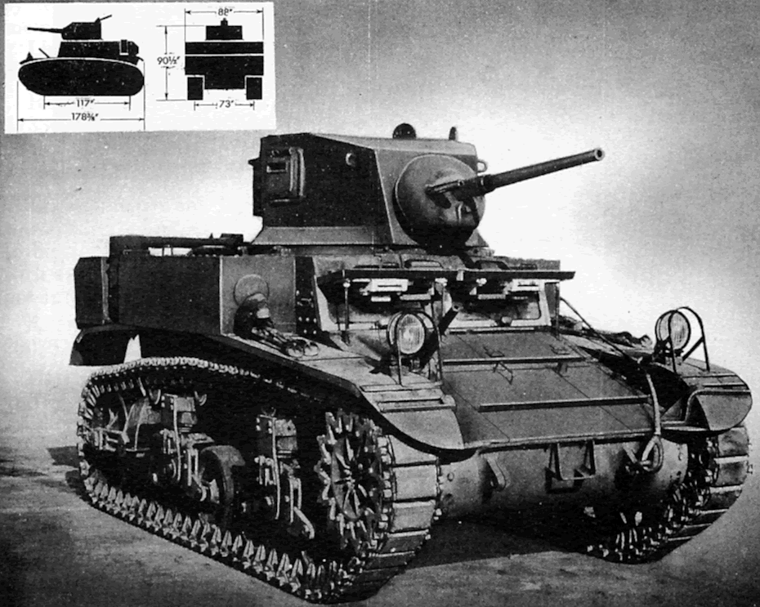
Tanks also started to be used in warfare in this war, since armored cars could not cope with the terrain. The first tank was nicknamed “Little Willie”, it had a Daimler engine, a caterpillar track and needed a crew of 3. Its maximum speed was 3mph and it was unable to cross trenches. Not a success for the Allies.

The more modern tank was not completed until several weeks before the end of the war. It was called the Fiat Tipo! It could fit a maximum of 10 men, had the first revolving turret and could reach speeds of 4mph!

This war also had another first: planes started to be used to deliver bombs. Planes became fighter aircraft armed with machine guns, bombs, and even cannons. They were even used for reconnaissance work. Pilots were even known to fight enemy aircraft in the air, in “dogfights” to protect the men on the ground.
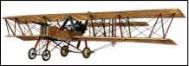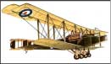

1. What weapon did most British soldiers carry in WWI? How effective was it?

2. What is a bayonet? Why do you think that the bayonet became an old-fashioned weapon during this war?

3. Why were machine guns and heavy artillery both effective weapons and difficult to use in WWI?

4. What are chlorine and mustard gas? Why would chlorine need certain weather conditions?

5. Fill in the following table about chlorine and mustard gas:

type of gas | smell | effects | how long to die
chlorine gas
mustard gas

6. What is a Zeppelin? Why do you think they were easy targets?

7. Why were tanks unsuccessful war machines in WWI?

8. How did this war change the way men fought in battle?

