Modern European History
Unit 7 – Nation-Building and War
The Great War, 1914–1918

Marching Toward War
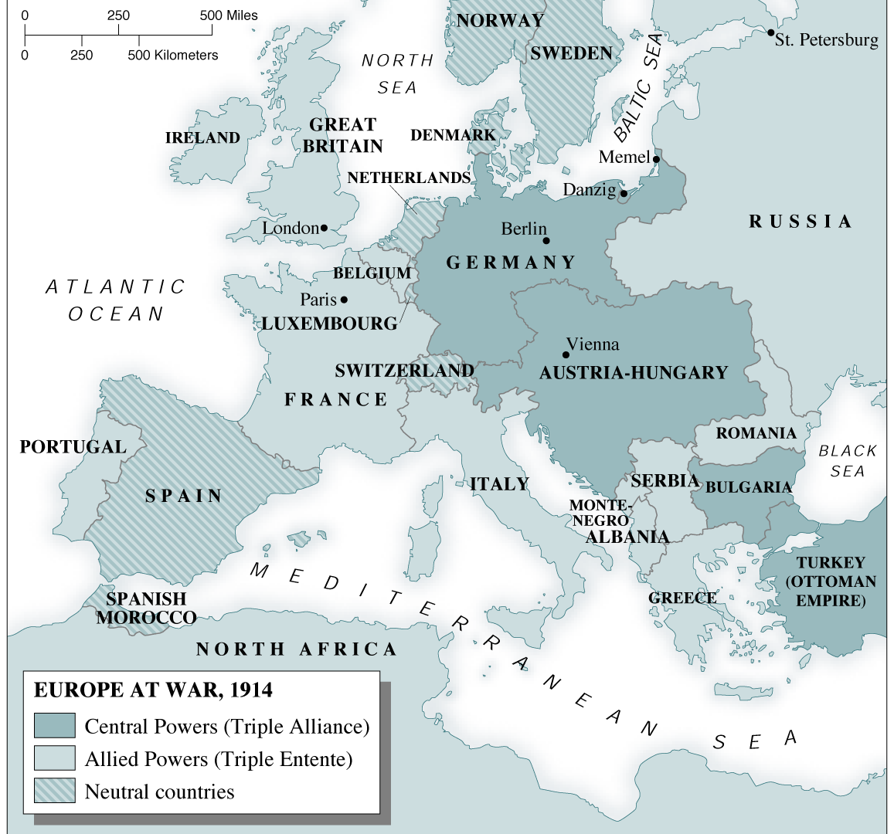
At the turn of the 20th century, the nations of Europe had been largely at peace with one another for nearly 30 years. This was no accident. Efforts to outlaw war and achieve a permanent peace had been gaining momentum in Europe since the middle of the 19th century. By 1900, hundreds of peace organizations were active. In addition, peace congresses convened regularly between 1843 and 1907. Some Europeans believed that progress had made war a thing of the past. Yet in a little more than a decade, a massive war would engulf Europe and spread across the globe.

Rising Tensions in Europe
While peace and harmony characterized much of Europe at the beginning of the 1900s, there were less visible—and darker—forces at work as well. Below the surface of peace and goodwill, Europe witnessed several gradual developments that would ultimately help propel the continent into war.

The Rise of Nationalism
One such development was the growth of nationalism, or a deep devotion to one’s nation. Nationalism can serve as a unifying force within a country. However, it also can cause intense competition among nations, with each seeking to overpower the other. By the turn of the 20th century, a fierce rivalry indeed had developed among Europe’s Great Powers. Those nations were Germany, Austria-Hungary, Great Britain, Russia, Italy, and France.

This increasing rivalry among European nations stemmed from several sources. Competition for materials and markets was one. Territorial disputes were another. France, for example, had never gotten over the loss of Alsace-Lorraine to Germany in the Franco-Prussian War (1870). Austria-Hungary and Russia both tried to dominate in the Balkans, a region in southeast Europe. Within the Balkans, the intense nationalism of Serbs, Bulgarians, Romanians, and other ethnic groups led to demands for independence.

Imperialism and Militarism
Another force that helped set the stage for war in Europe was imperialism. The nations of Europe competed fiercely for colonies in Africa and Asia. The quest for colonies sometimes pushed European nations to the brink of war. As European countries continued to compete for overseas empires, their sense of rivalry and mistrust of one another deepened.

Yet another troubling development throughout the early years of the 20th century was the rise of a dangerous European arms race. The nations of Europe believed that to be truly great, they needed to have a powerful military. By 1914, all the Great Powers except Britain had large standing armies. In addition, military experts stressed the importance of being able to quickly mobilize, or organize and move troops in case of a war. Generals in each country developed highly detailed plans for such a mobilization.

The policy of glorifying military power and keeping an army prepared for war was known as militarism. Having a large and strong standing army made citizens feel patriotic. However, it also frightened some people. As early as 1895, Frédéric Passy, a prominent peace activist, expressed a concern that many shared:

The entire able-bodied population are preparing to massacre one another; though no one, it is true, wants to attack, and everybody protests his love of peace and determination to maintain it, yet the whole world feels that it only requires some unforeseen incident, some unpreventable accident, for the spark to fall in a flash . . . and blow all Europe sky-high.
FRÉDÉRIC PASSY, quoted in Nobel: The Man and His Prizes

Tangled Alliances
Growing rivalries and mutual mistrust had led to the creation of several military alliances among the Great Powers as early as the 1870s. This alliance system had been designed to keep peace in Europe. But it would instead help push the continent into war.

Bismarck Forges Early Pacts
Between 1864 and 1871, Prussia’s blood-and-iron chancellor, Otto von Bismarck, freely used war to unify Germany. After 1871, however, Bismarck declared Germany to be a “satisfied power.” He then turned his energies to maintaining peace in Europe.

Bismarck saw France as the greatest threat to peace. He believed that France still wanted revenge for its defeat in the Franco-Prussian War. Bismarck’s first goal, therefore, was to isolate France. “As long as it is without allies,” Bismarck stressed, “France poses no danger to us.” In 1879, Bismarck formed the Dual Alliance between Germany and Austria-Hungary. Three years later, Italy joined the two countries, forming the Triple Alliance. In 1881, Bismarck took yet another possible ally away from France by making a treaty with Russia.

Shifting Alliances Threaten Peace
In 1890, Germany’s foreign policy changed dramatically. That year, Kaiser Wilhelm II—who two years earlier had become ruler of Germany—forced Bismarck to resign. A proud and stubborn man, Wilhelm II did not wish to share power with anyone. Besides wanting to assert his own power, the new kaiser was eager to show the world just how mighty Germany had become. The army was his greatest pride. “I and the army were born for one another,” Wilhelm declared shortly after taking power.

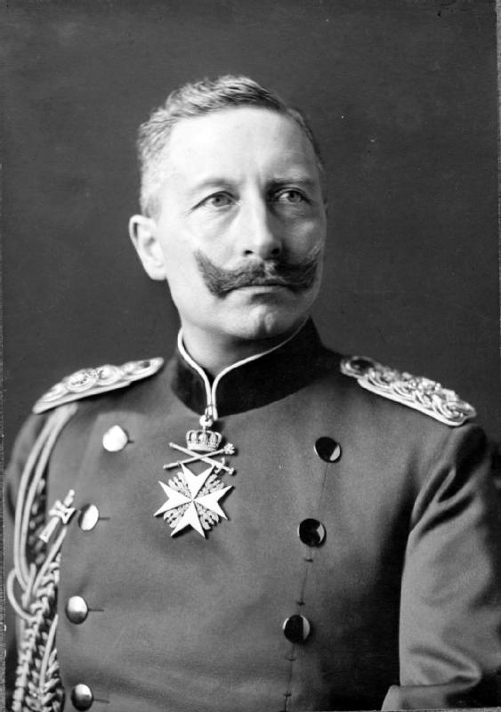
Kaiser Wilhelm II, 1859–1941
Wilhelm II was related to the leaders of two nations he eventually would engage in war. Wilhelm, George V of Great Britain, and Nicholas II of Russia were all cousins.

The kaiser thought a great deal of himself and his place in history. Once, when a doctor told him he had a small cold, Wilhelm reportedly responded, “No, it is a big cold. Everything about me must be big.”

He also could be sly and deceitful. After forcing the popular Bismarck to resign, Wilhelm pretended to be upset. Most people, however, including Bismarck, were not fooled.

Wilhelm let his nation’s treaty with Russia lapse in 1890. Russia responded by forming a defensive military alliance with France in 1892 and 1894. Such an alliance had been Bismarck’s fear. War with either Russia or France would make Germany the enemy of both. Germany would then be forced to fight a two-front war, or a war on both its eastern and western borders.

Next, Wilhelm began a tremendous shipbuilding program in an effort to make the German navy equal to that of the mighty British fleet. Alarmed, Great Britain formed an entente, or alliance, with France. In 1907, Britain made another entente, this time with both France and Russia. The Triple Entente, as it was called, did not bind Britain to fight with France and Russia. However, it did almost certainly ensure that Britain would not fight against them.

By 1907, two rival camps existed in Europe. On one side was the Triple Alliance - Germany, Austria-Hungary, and Italy. On the other side was the Triple Entente - Great Britain, France, and Russia. A dispute between two rival powers could draw all the nations of Europe into war.

Crisis in the Balkans
Nowhere was that dispute more likely to occur than on the Balkan Peninsula. This mountainous peninsula in the southeastern corner of Europe was home to an assortment of ethnic groups. With a long history of nationalist uprisings and ethnic clashes, the Balkans was known as the “powder keg” of Europe.

A Restless Region
By the early 1900s, the Ottoman Empire, which included the Balkan region, was in rapid decline. While some Balkan groups struggled to free themselves from the Ottoman Turks, others already had succeeded in breaking away from their Turkish rulers. These peoples had formed new nations, including Bulgaria, Greece, Montenegro, Romania, and Serbia.

Nationalism was a powerful force in these countries. Each group longed to extend its borders. Serbia, for example, had a large Slavic population. It hoped to absorb all the Slavs on the Balkan Peninsula. Russia, itself a mostly Slavic nation, supported Serbian nationalism. However, Serbia’s powerful northern neighbor, Austria-Hungary, opposed such an effort. Austria feared that efforts to create a Slavic state would stir rebellion among its Slavic population.

In 1908, Austria annexed, or took over, Bosnia and Herzegovina. These were two Balkan areas with large Slavic populations. Serbian leaders, who had sought to rule these provinces, were outraged. In the years that followed, tensions between Serbia and Austria steadily rose. The Serbs continually vowed to take Bosnia and Herzegovina away from Austria. In response, Austria-Hungary vowed to crush any Serbian effort to undermine its authority in the Balkans.

The Armenian Genocide
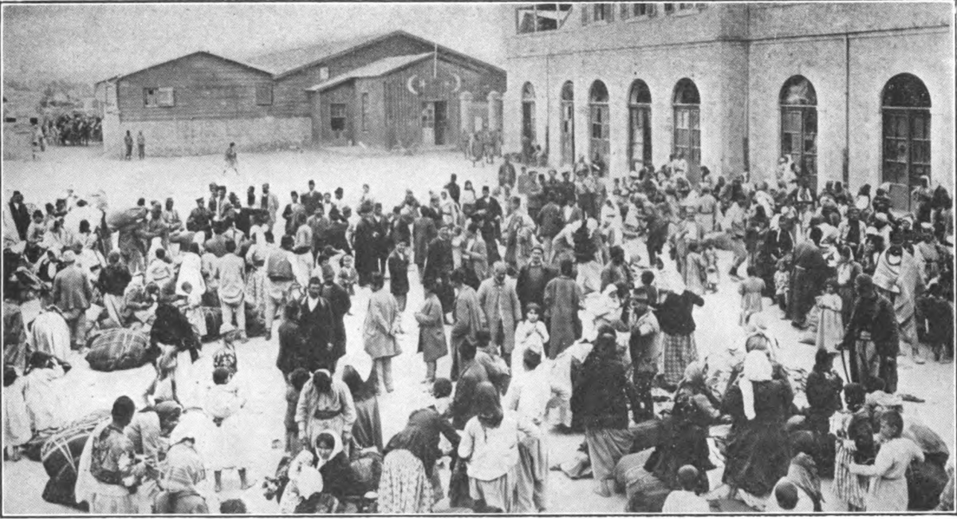
One group in southeastern Europe that suffered greatly for its independence efforts was the Armenians. By the 1880s, the roughly 2.5 million Armenians in the Ottoman Empire had begun to demand their freedom. As a result, relations between the group and its Turkish rulers grew strained.

Throughout the 1890s, Turkish troops killed tens of thousands of Armenians. When World War I erupted in 1914, the Armenians pledged their support to the Turks’ enemies. In response, the Turkish government deported nearly 2 million Armenians. Along the way, more than 600,000 died of starvation or were killed by Turkish soldiers.

A Shot Rings Throughout Europe
Into this poisoned atmosphere of mutual dislike and mistrust stepped the heir to the Austro-Hungarian throne, Archduke Franz Ferdinand, and his wife, Sophie. On June 28, 1914, the couple paid a state visit to Sarajevo, the capital of Bosnia. It would be their last. The royal pair was shot at point-blank range as they rode through the streets of Sarajevo in an open car. The killer was Gavrilo Princip, a 19-year-old Serbian and member of the Black Hand. The Black Hand was a secret society committed to ridding Bosnia of Austrian rule.

Because the assassin was a Serbian, Austria decided to use the murders as an excuse to punish Serbia. On July 23, Austria presented Serbia with an ultimatum containing numerous demands. Serbia knew that refusing the ultimatum would lead to war against the more powerful Austria. Therefore, Serbian leaders agreed to most of Austria’s demands. They offered to have several others settled by an international conference.

Austria, however, was in no mood to negotiate. The nation’s leaders, it seemed, had already settled on war. On July 28, Austria rejected Serbia’s offer and declared war. That same day, Russia, an ally of Serbia with its largely Slavic population, took action. Russian leaders ordered the mobilization of troops toward the Austrian border.

Leaders all over Europe suddenly took notice. The fragile European stability seemed ready to collapse into armed conflict. The British foreign minister, the Italian government, and even Kaiser Wilhelm himself urged Austria and Russia to negotiate. But it was too late. The machinery of war had been set in motion.

Answer each of the following questions thoroughly and in complete sentences.

1. What were the three forces at work in Europe that helped set the stage for war? Which played the greatest role in helping to prompt the outbreak of war?

_____________________________________________________________________________________

_____________________________________________________________________________________

_____________________________________________________________________________________

_____________________________________________________________________________________

_____________________________________________________________________________________

_____________________________________________________________________________________

_____________________________________________________________________________________

2. Who were the members of the Triple Alliance? the Triple Entente?

_____________________________________________________________________________________

_____________________________________________________________________________________

_____________________________________________________________________________________

_____________________________________________________________________________________

_____________________________________________________________________________________

_____________________________________________________________________________________

_____________________________________________________________________________________

3. What single event set in motion the start of World War I?

_____________________________________________________________________________________

_____________________________________________________________________________________

_____________________________________________________________________________________

_____________________________________________________________________________________

_____________________________________________________________________________________

_____________________________________________________________________________________

_____________________________________________________________________________________

_____________________________________________________________________________________

Europe Plunges into War
By 1914, Europe was divided into two rival camps. One alliance, the Triple Entente, included Great Britain, France, and Russia. The other, known as the Triple Alliance, included Germany, Austria-Hungary, and Italy. Austria-Hungary’s declaration of war against Serbia set off a chain reaction within the alliance system. The countries of Europe followed through on their pledges to support one another. As a result, nearly all of Europe soon joined what would be the largest, most destructive war the world had yet seen.

The Great War Begins
In response to Austria’s declaration of war, Russia, Serbia’s ally, began moving its army toward the Russian-Austrian border. Expecting Germany to join Austria, Russia also mobilized along the German border. To Germany, Russia’s mobilization amounted to a declaration of war. On August 1, the German government declared war on Russia.

Russia looked to its ally France for help. Germany, however, did not even wait for France to react. Two days after declaring war on Russia, Germany also declared war on France. Soon afterward, Great Britain declared war on Germany. Much of Europe was now locked in battle.

Nations Take Sides
By mid-August 1914, the battle lines were clearly drawn. On one side were Germany and Austria-Hungary. They were known as the Central Powers because of their location in the heart of Europe. Bulgaria and the Ottoman Empire would later join the Central Powers in the hopes of regaining lost territories.

On the other side were Great Britain, France, and Russia. Together, they were known as the Allied Powers or the Allies. Japan joined the Allies within weeks. Italy joined later. Italy had been a member of the Triple Alliance with Germany and Austria-Hungary. However, the Italians joined the other side after accusing their former partners of unjustly starting the war.

In the late summer of 1914, millions of soldiers marched happily off to battle, convinced that the war would be short. Only a few people foresaw the horror ahead. One of them was Britain’s foreign minister, Sir Edward Grey. Staring out over London at nightfall, Grey said sadly to a friend, “The lamps are going out all over Europe. We shall not see them lit again in our lifetime.”

A Bloody Stalemate
It did not take long for Sir Edward Grey’s prediction to ring true. As the summer of 1914 turned to fall, the war turned into a long and bloody stalemate, or deadlock, along the battlefields of France. This deadlocked region in northern France became known as the Western Front.

The Conflict Grinds Along
Facing a war on two fronts, Germany had developed a battle strategy known as the Schlieffen Plan, named after its designer, General Alfred Graf von Schlieffen. The plan called for attacking and defeating France in the west and then rushing east to fight Russia. The Germans felt they could carry out such a plan because Russia lagged behind the rest of Europe in its railroad system and thus would take longer to supply its front lines. Nonetheless, speed was vital to the Schlieffen Plan. German leaders knew they needed to win a quick victory over France.

Early on, it appeared that Germany would do just that. By early September, German forces had swept into France and reached the outskirts of Paris. A major German victory appeared just days away. On September 5, however, the Allies regrouped and attacked the Germans northeast of Paris, in the valley of the Marne River. Every available soldier was hurled into the struggle. When reinforcements were needed, more than 600 taxicabs rushed soldiers from Paris to the front. After four days of fighting, the German generals gave the order to retreat.

Although it was only the first major clash on the Western Front, the First Battle of the Marne was perhaps the single most important event of the war. The defeat of the Germans left the Schlieffen Plan in ruins. A quick victory in the west no longer seemed possible. In the east, Russian forces had already invaded Germany. Germany was going to have to fight a long war on two fronts. Realizing this, the German high command sent thousands of troops from France to aid its forces in the east. Meanwhile, the war on the Western Front settled into a stalemate.

War in the Trenches
By early 1915, opposing armies on the Western Front had dug miles of parallel trenches to protect themselves from enemy fire. This set the stage for what became known as trench warfare. In this type of warfare, soldiers fought each other from trenches. And armies traded huge losses of human life for pitifully small land gains.

Life in the trenches was pure misery. “The men slept in mud, washed in mud, ate mud, and dreamed mud,” wrote one soldier. The trenches swarmed with rats. Fresh food was nonexistent. Sleep was nearly impossible.

The space between the opposing trenches won the grim name “no man’s land.” When the officers ordered an attack, their men went over the top of their trenches into this bombed-out landscape. There, they usually met murderous rounds of machine-gun fire. Staying put, however, did not ensure one’s safety. Artillery fire brought death right into the trenches. “Shells of all calibers kept raining on our sector,” wrote one French soldier. “The trenches disappeared, filled with earth . . . the air was unbreathable. Our blinded, wounded, crawling, and shouting soldiers kept falling on top of us and died splashing us with blood. It was living hell.”

The Western Front had become a “terrain of death.” It stretched nearly 500 miles from the North Sea to the Swiss border. A British officer described it in a letter:

Imagine a broad belt, ten miles or so in width, stretching from the Channel to the German frontier near Basle, which is positively littered with the bodies of men and scarified with their rude graves; in which farms, villages and cottages are shapeless heaps of blackened masonry; in which fields, roads and trees are pitted and torn and twisted by shells and disfigured by dead horses, cattle, sheep and goats, scattered in every attitude of repulsive distortion and dismemberment. VALENTINE FLEMING, quoted in The First World War

Military strategists were at a loss. New tools of war—machine guns, poison gas, armored tanks, larger artillery—had not delivered the fast-moving war they had expected. All this new technology did was kill greater numbers of people more effectively.

The slaughter reached a peak in 1916. In February, the Germans launched a massive attack against the French near Verdun. Each side lost more than 300,000 men. In July, the British army tried to relieve the pressure on the French. British forces attacked the Germans northwest of Verdun, in the valley of the Somme River. In the first day of battle alone, more than 20,000 British soldiers were killed. By the time the Battle of the Somme ended in November, each side had suffered more than half a million casualties.

What did the warring sides gain? Near Verdun, the Germans advanced about four miles. In the Somme valley, the British gained about five miles.

The New Weapons of War

Poison Gas
Soldiers wore masks to protect themselves from poison gas. Gas was introduced by the Germans but used by both sides. Some gases caused blindness or severe blisters, others death by choking.

Machine Gun
The machine gun, which fires ammunition automatically, was much improved by the time of World War I. The gun could wipe out waves of attackers and thus made it difficult for forces to advance.
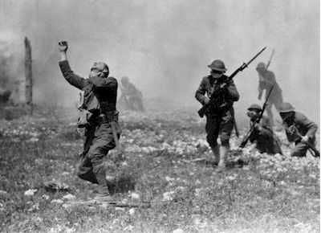
Tank
The tank was an armored combat vehicle that moved on chain tracks— and thus could cross many types of terrain. It was introduced by the British in 1916 at the Battle of the Somme.

Submarine
In 1914, the Germans introduced the submarine as an effective warship. The submarine’s primary weapon against ships was the torpedo, an underwater missile.

The Battle on the Eastern Front
Even as the war on the Western Front claimed thousands of lives, both sides were sending millions more men to fight on the Eastern Front. This area was a stretch of battlefield along the German and Russian border. Here, Russians and Serbs battled Germans and Austro-Hungarians. The war in the east was a more mobile war than that in the west. Here too, however, slaughter and stalemate were common.

Early Fighting
At the beginning of the war, Russian forces had launched an attack into both Austria and Germany. At the end of August, Germany counterattacked near the town of Tannenberg. During the four-day battle, the Germans crushed the invading Russian army and drove it into full retreat. More than 30,000 Russian soldiers were killed.

Russia fared somewhat better against the Austrians. Russian forces defeated the Austrians twice in September 1914, driving deep into their country. Not until December of that year did the Austrian army manage to turn the tide. Austria defeated the Russians and eventually pushed them out of Austria-Hungary.

Russia Struggles
By 1916, Russia’s war effort was near collapse. Unlike the nations of western Europe, Russia had yet to become industrialized. As a result, the Russian army was continually short on food, guns, ammunition, clothes, boots, and blankets. Moreover, the Allied supply shipments to Russia were sharply limited by German control of the Baltic Sea, combined with Germany’s relentless submarine campaign in the North Sea and beyond. In the south, the Ottomans still controlled the straits leading from the Mediterranean to the Black Sea.

The Frozen Front
For soldiers on the Eastern Front, the overall misery of warfare was compounded by deadly winters. “Every day hundreds froze to death,” noted one Austro-Hungarian officer during a brutal spell.

Russian troops suffered too, mainly due to their lack of food and clothing. “I am at my post all the time—frozen [and] soaked . . . ,” lamented one soldier. “We walk barefoot or in rope-soled shoes. It’s incredible that soldiers of the Russian army are in rope-soled shoes!”

The Russian army had only one asset—its numbers. Throughout the war the Russian army suffered a staggering number of battlefield losses. Yet the army continually rebuilt its ranks from the country’s enormous population. For more than three years, the battered Russian army managed to tie up hundreds of thousands of German troops in the east. As a result, Germany could not hurl its full fighting force at the west.

Germany and her allies, however, were concerned with more than just the Eastern or Western Front. As the war raged on, fighting spread beyond Europe to Africa, as well as to Southwest and Southeast Asia. In the years after it began, the massive European conflict indeed became a world war.

Answer each of the following questions thoroughly and in complete sentences.

4. Which countries comprised the Central Powers? Which countries comprised the Allies?

_____________________________________________________________________________________

_____________________________________________________________________________________

_____________________________________________________________________________________

_____________________________________________________________________________________

_____________________________________________________________________________________

_____________________________________________________________________________________

_____________________________________________________________________________________

_____________________________________________________________________________________

5. What were the characteristics of trench warfare?

_____________________________________________________________________________________

_____________________________________________________________________________________

_____________________________________________________________________________________

_____________________________________________________________________________________

_____________________________________________________________________________________

_____________________________________________________________________________________

_____________________________________________________________________________________

_____________________________________________________________________________________

6. What factors contributed to Russia’s war difficulties?

_____________________________________________________________________________________

_____________________________________________________________________________________

_____________________________________________________________________________________

_____________________________________________________________________________________

_____________________________________________________________________________________

_____________________________________________________________________________________

_____________________________________________________________________________________

_____________________________________________________________________________________

7. How was war on the Western and Eastern Fronts different? How was it the same?

_____________________________________________________________________________________

_____________________________________________________________________________________

_____________________________________________________________________________________

_____________________________________________________________________________________

_____________________________________________________________________________________

_____________________________________________________________________________________

_____________________________________________________________________________________

_____________________________________________________________________________________

8. Why did the Schlieffen Plan ultimately collapse? Cite specific details from the text.

_____________________________________________________________________________________

_____________________________________________________________________________________

_____________________________________________________________________________________

_____________________________________________________________________________________

_____________________________________________________________________________________

_____________________________________________________________________________________

_____________________________________________________________________________________

_____________________________________________________________________________________

