Basic US History
Unit 8 - WWII
Home Truths: A Real-Life Private Ryan, Fritz Niland Came Back to a Devastated Family
People Magazine, September 07, 1998
By Nick Charles

Just days before, Sgt. Frederick “Fritz” Niland had been crouched in a foxhole, fighting with what remained of his 130-man company after helping to liberate a French town from Hitler’s grasp. But on July 13, 1944, the company having been removed to England to rest up for a forthcoming assault in Holland, the paratrooper was sitting in his barracks, lamenting how more than two-thirds of his outfit had been wounded or killed in the D-Day offensive that began on June 6. That’s when Father Francis Sampson arrived. “We’ve got to talk,” said the chaplain.
Sampson’s news couldn’t have been worse. Niland, 24, already knew that his three older brothers were believed to have been killed in battle—two in the assault on Normandy and a third in the South Pacific. Now he was being sent home to the States, in keeping with an edict by President Franklin D. Roosevelt that no family should suffer the loss of more than two sons. Though reeling from the personal loss, the sergeant objected. “No,” he insisted, “I’m staying here with my boys.” “Well,” replied Sampson, “you can bring that up with General Eisenhower or the President, but you’re going home.”
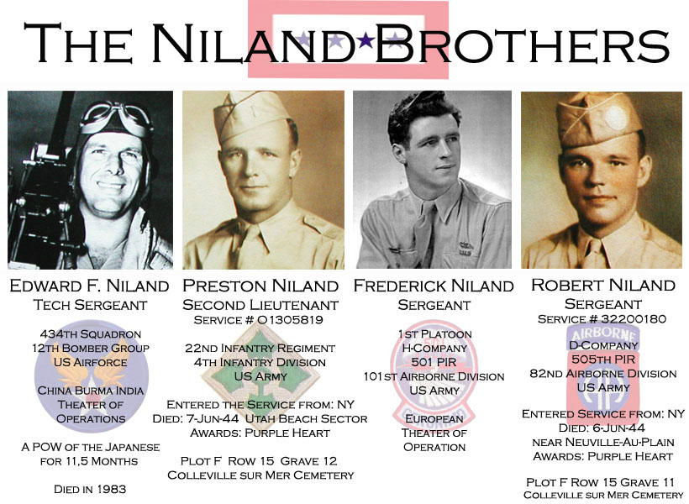
The parallels between Fritz Niland’s story and that of Pvt. James F. Ryan in Steven Spielberg’s acclaimed film Saving Private Ryan are inescapable. Starring Tom Hanks and Matt Damon, the movie follows a unit fresh from the horror of D-Day as it searches for a soldier whose three brothers have fallen in battle. Historian Stephen Ambrose, a consultant on the film and author of a D-Day account, Band of Brothers, says the Nilands’ story was one of many that could have inspired Private Ryan—though Spielberg and others say it did not. Sadly, says Ambrose, “there were probably hundreds of cases of multiple brothers being killed in the war.”
Learning of the Niland family through Ambrose, Spielberg invited some of Fritz’s surviving relatives—the World War II veteran himself died of a heart attack in 1983—to the July 21 Hollywood premiere of the film, providing them with hotel rooms, limo service and personally signed hardcover books of the movie’s story. “The Niland family definitely stands out as far as this film goes,” says Bonnie Curtis, a coproducer of the film. “But their story is about a thousand times more dramatic and wonderful than ours.”
Fritz Niland was the youngest in a family of four boys and two girls born in Tonawanda, N.Y., to steel-mill manager Mike Niland, once a Spanish-American War Rough Rider with Theodore Roosevelt, and his wife, Augusta. Fritz was eager to follow his older brothers’ lead in 1941, when the U.S. declared war on Japan after Pearl Harbor. Edward, seven years older than Fritz, became an Army Air Corps gunner; Preston, five years older, a paratrooper; and Robert, one year older, a mortar sergeant. The family was proud of them all. But on June 6, 1944, the Nilands received a telegram saying Edward had been missing in action over Burma since May 20, when his B-25 bomber was hit. That same day—D Day—Robert was killed in France. Less than 24 hours later, Preston was also shot dead.
Fritz, still in France when he heard Robert had been killed, tried with Chaplain Sampson’s help to locate his brother’s body at one of the makeshift cemeteries scattered throughout the countryside. “They drove all through the day, but they couldn’t find him anywhere,” says Fritz’s daughter Cate Remme, 44, a playground safety specialist in Anchorage. At one of the last known cemeteries, according to Remme, Sampson, not knowing Fritz had another brother in Europe, passed along what he thought was good news: “ ‘The only Niland here is a Preston Niland.’ That’s how my dad found out that his other brother had been killed.”
Fritz’s parents were relieved to see him home safely, but reminders of the family’s devastation were constant. Augusta refused to touch the bedrooms of her slain sons, and Fritz himself never entered them. Hoping Edward would be found, they left a chair at the dinner table for him. “My grandfather had a dream Ed was alive,” says Pete Niland, 49, Edward’s son and a director of housing at the University of Buffalo. “He dreamed the plane crashed, and Ed stepped out. He asked if Ed was all right, and my father said, ‘Yeah, I’m all right, Dad.’ “ Almost a year later, Edward escaped from a Japanese prison camp and was rescued by British troops.
Fritz, meanwhile, had been made an MP at a Buffalo train station, a job he considered demeaning. On the bright side, he began dating Marilyn Hartnett Bart, whom he knew from high school and went on to marry in 1947. With money from the GI Bill, Niland graduated from Georgetown University in 1953 with a degree in oral surgery and opened a practice in Niagara Falls, N.Y. Determined to put the war behind him, he declined to attend military reunions. “For him, there wasn’t anything to celebrate,” says Remme. Moving the family around in the ‘60s—Washington, D.C., for five years, Guam for a year and finally San Francisco in 1969—Niland began to suffer bouts of depression. He died in 1983, a year before Edward.
With help from her only sister, Mary, 43, and their mother, who would die in 1989, Remme tried to get Niland buried in San Francisco’s Presidio National Cemetery, then in a military cemetery in Alaska, where she lived with her husband, David, 51, a flight-dispatch manager. After several calls, Remme ran out of patience. “I was on the phone one day and this captain was saying, ‘Sorry, no room.’ And I replied, ‘You know, Captain, my father and his brothers would have made room for you on a certain flight to France one night—that is, if you would have had the guts to get on the plane.’ “ A half hour later a man showed up at her house with all the necessary paperwork.
Remme, the mother of two daughters, is impressed with Saving Private Ryan and thinks her father would be too. “He would have been proud that all the men were honored instead of just Private Ryan,” says Remme. In fact, one of the last times Remme saw her father, he asked that when he died and the family paid tribute to him, they also remember the men he fought beside. “ ‘Make sure you honor all the men,’ “ she recalls him saying. “So that’s what we did at his funeral. We read off all the names of Company H.”
Use complete sentences with correct spelling and grammar to answer each of the following questions.

1. How many men in Sgt. Niland’s outfit were wounded or killed in the D-Day offensive?

______________________________________________________________________________

______________________________________________________________________________

______________________________________________________________________________
2. Why was the army planning to send Sgt. Niland home?

______________________________________________________________________________

______________________________________________________________________________

______________________________________________________________________________

3. What did director Steven Spielberg do for Sgt. Niland’s family?

______________________________________________________________________________

______________________________________________________________________________

______________________________________________________________________________

4. What was Sgt. Niland’s father’s military experience?

______________________________________________________________________________

______________________________________________________________________________

______________________________________________________________________________

5. How did Sgt. Niland find out about his brother Preston’s death?

______________________________________________________________________________

______________________________________________________________________________

______________________________________________________________________________

6. How did Sgt. Niland’s parents react to their sons’ deaths?

______________________________________________________________________________

______________________________________________________________________________

______________________________________________________________________________

7. What did Cate Remme (Sgt. Niland’s daughter) say to get him buried in a military cemetery?

______________________________________________________________________________

______________________________________________________________________________

______________________________________________________________________________

8. What did Sgt. Niland’s family do at his funeral to honor his request to have all the men he fought with honored as well?

______________________________________________________________________________

______________________________________________________________________________

______________________________________________________________________________

